 |  |  | Operating instructions | 

Work equipment – Equipment – Apparatus - Device

Sharp-edged objects
Razor blades, pasteur pipettes, scalpels, broken glass


Dangers for humans and the environment
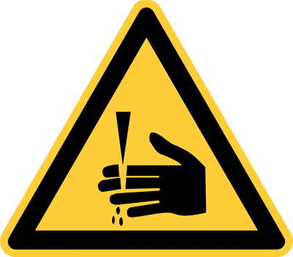 |  | - Risk of injury due to glass breakage  - Risk of cuts

Protective measures and rules of conduct
General information
- Pasteur pipettes should always be kept down with the tip in order to avoid any contact of the absorbed liquid with the rubber vacuum cleaner.
- Used Pasteur pipettes and glass breakage must be collected in appropriate glass waste containers.
- Glass breakage may only be picked up with a shovel and broom.
- Razor blades have two sharp sides! Razor blades are only on the surfaces attack, never on the edges!
- Objects that can cause cuts must not be disposed of in household waste containers so as not to endanger cleaning personnel.
- When transporting sharp-edged objects, avoid fast walking and uncontrolled, sweeping movements. Sharp-edged objects must be transported with care and attention.

Personal Protective Equipment
 | Personal protective measures  - During laboratory work, always wear a laboratory coat.  - Depending on the requirements and working materials, gloves or goggles must be worn. |  |  |  |  | - pE

Accidents and First Aid
 | For cuts:  For wound care (contact with blood), clean gloves should be worn for self-protection.  Smaller cuts usually require no treatment, but it is recommended to bleed the wound and then rinse with clean water.  If a cut does not stop bleeding despite the bandage or is very bleeding, if the wound is deep or wide apart, you should consult a doctor.  In the case of larger or severely bleeding cuts, apply pressure bandage and, if necessary, notify the rescue. Store affected body part high.  Injured person should sit or lie down on the floor, so that injuries can be avoided in case of a possible fainting.  If larger pieces of glass or objects are stuck in the wound, they should be left in the wound to prevent heavy bleeding. Gently cover the injury with a sterile bandage and seek medical attention.  Small splinters or objects that have penetrated only superficially can be removed carefully with tweezers.

Tests – Maintenance - Disposal
- Glass break may only be picked up with a shovel and broom.
- Objects that can cause cuts must not be disposed of in household waste containers so as not to endanger the cleaning staff.
- For safe disposal, appropriate objects (shaving razors, shards, Pasteur pipettes) must be collected in closed, cut-resistant containers (together with the container).

Signatures
Supervisor: Signature:

Town: Date:

