 |  |  | Operating instructions | 

Work equipment – Equipment – Apparatus - Device

Working with a rotating tool
Milling, grinding, drilling, cutting, cutting, polishing

Dangers for humans and the environment
 |  | - Injuries to fingers, hands, eyes, face by rotating tools, flying tool parts, or workpiece parts.

Protective measures and rules of conduct
 | - Visual inspection before use for obvious defects.  - Pay attention to the intended use of the tools.  - Do not exceed the permitted speed.  - Organize tools safely and store and transport.  - Regular inspection of the tools.  - Remove damaged tools from use or repair them professionally.  - Do not wear pointed or sharp tools loosely in clothing.  - Wear eye protection and work behind a visor. |  |  |  |  | - pE

Faults and dangers
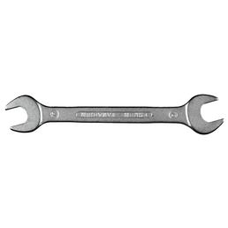 | - Set the work, eliminate the problem properly.

Accidents and First Aid
 | - Gashes: Alert first responder, ambulance or doctor. Inform Supervisor  (if necessary entry in the association book).  - burns: cool wound, see doctor.)

Tests – Maintenance - Disposal
- Defects on the tools: Inform supervisor.
- Have maintenance, repair and maintenance work carried out by qualified persons

Signatures
Supervisor: Signature:

Town: Date:

