 |  |  | Operating instructions | 

Work equipment – Equipment – Apparatus - Device
Woodworking machinery

Dangers for humans and the environment
- Dangers exist due to moving machine parts, tools and workpieces as well as fine dust.
- Missing or defective safety devices are a danger.
- Woodworking machines may be used by young people over 16 years of age under the supervision of a qualified person only for educational purposes.

Protective measures and rules of conduct
  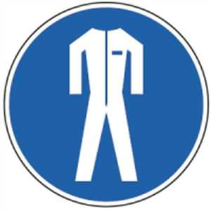  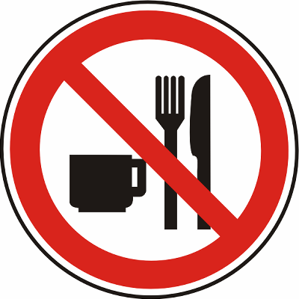  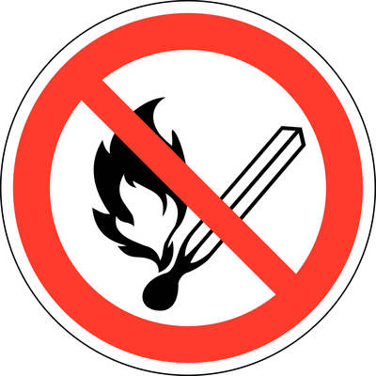 | - The operating instructions of the manufacturer must be observed!  - Avoid tilting the workpiece when the workpiece is fed to the band saw blade.  - Dress band saw blade to the part required for cutting.  - Contact with the band saw blade must be avoided  - Use personal protective equipment (including skin protection).  - Wear tight-fitting work clothes.  - Do not remove splinters, chips and waste by hand, but with suitable tools.  - Do not use damaged band saw blades.  - Observe belt tension and retighten saw blades if necessary.  - It is forbidden to wear protective gloves (danger of getting into the rotating blade).  - To wear ear protection.  - If there is a risk of eye injuries, the goggles must be worn.  - Switch off the machine even during short interruptions and cover the saw blade behind |  |  |  |  | pE

Faults and dangers
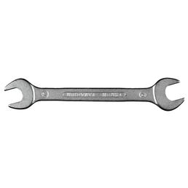 | • Any defects found must be reported immediately to the supervisor / supervisor after the machine has been secured.

Accidents and First Aid
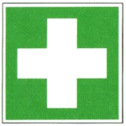 | In case of accidents, first aid should be provided (bleeding, immobilizing injured limbs, giving separated limbs in plastic bag, shock absorption) and reporting the accident. For the first aid service first aiders / first aiders apply. Keep calm and respond to queries.

Tests – Maintenance - Disposal
- Repairs may only be carried out by authorized persons.

Signatures
Supervisor: Signature:

Town: Date:

