 |  |  | Operating instructions | 

Work - Equipment - Apparatus -Device
Waste Oil

Dangers for humans and the environment
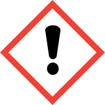  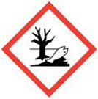 | Harmful if swallowed or in contact with skin (H302, 312).  Toxic to aquatic life with long lasting effects (H411).  highly hazardous to water (WGK 3)

Protective measures and rules of conduct
 |  | Ensure good ventilation of the room. Do not inhale vapors.  Do not eat and drink in the room.  Smoking, fire and open light prohibited (P210).  Keep container tightly closed (P404).  Avoid release to the environment (P273).  Avoid contact with skin, eyes and clothing.  Wear protective gowns, protective goggles and protective gloves (P280).  If exposed or concerned: Get medical advice / attention (P308, 313). |  |  | - pE

Disruptions and Dangers
 |  | Collect spilled or spilled waste oils and emulsions with binder and place in  Collect closed container. Do not empty into drains.  Immediately change soaked clothing.  In case of large quantities leaked waste oil or emulsions call fire department. In case of fire, call the fire department

Accidents and First Aid
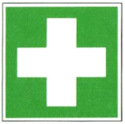 |  | Take off contaminated clothing  after inhalation:  Fresh air supply, in case of indisposition consult a doctor  after eye contact:  Rinse with plenty of water for several minutes with the eyelid open, consult an ophthalmologist  after skin contact:  wash off with plenty of water

Tests - Maintenance - Disposal
Collect used oils and used emulsions according to the conditions of acceptance (keep containers closed). Dispose of in time via SDU. Do not overfill container.
Waste oils or emulsions taken up with binder to the nearest collection point for equipment contaminated with oil as special waste.
Mark container with special waste label completely.
Maintain storage, keep containers, removal and filling points clean.

Signatures
Supervisor: Signature:

Town: Date:

