 |  |  | Operating instructions | 

Work - Equipment - Apparatus -Device
Tris(hydroxymethyl)-aminomethane

Dangers for humans and the environment
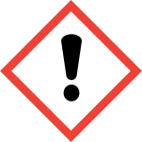 | Signal word: Attention!  Hazard statements (H-phrases)  H315 Causes skin irritation.  H319 Causes serious eye irritation.  H335 May cause respiratory irritation.  Safety instructions (P-phrases)  P280 Use prescribed personal protective equipment.  P302 + P352 After contact with skin: Wash with plenty of soap and water.  P305 + P351 + P338 Contact with eyes: Rinse cautiously with water for several minutes. Remove contact lenses, if possible. Continue rinsing.


Protective measures and rules of conduct
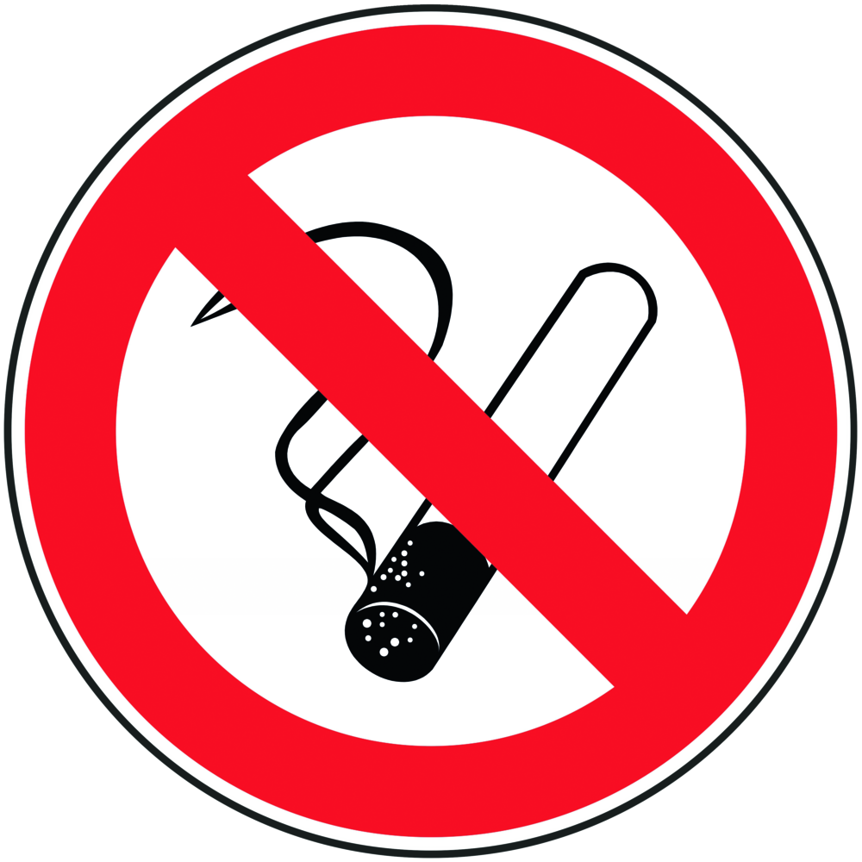 |  | General information  Eating, drinking or smoking is prohibited in all laboratory facilities!  Avoid contact with eyes and skin  Avoid dust formation. Working under the trigger. |  |  |  | - pE
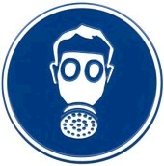
Personal protective measures
Eye protection: Tightly fitting safety goggles.
Hand protection: nitrile rubber; Thickness: 0.11mm
Body protection: Lab coat
Respiratory protection: Required if dusts are generated. Working under the trigger
Respirator: Particulate filter FFP2



Use and storage
Use:
Only work in the trigger!
Do not inhale dust. Avoid dust formation. Ensure adequate ventilation - Work in the fume hood.
Avoid skin and eye contact.
Change contaminated clothing immediately.
Storage:
Store tightly closed and dry. Protect from direct sunlight.
Recommended procedure
Weigh out and dissolve under the deduction!
Transfer and transport
Avoid dust formation!

Disruptions and Dangers
 |  | In case of fire:  Suitable extinguishing media: CO2, extinguishing powder or water spray.  In case of fire, use respirator mask that is independent from outside air.  After shedding: Avoid inhalation of dusts. Avoid substance contact. For  provide adequate ventilation.  Take up dry and have it disposed of by the university's chemical disposal department. Purify with water. Avoid dust generation.  Environmental precautions: Do not empty into drains.

Accidents and First Aid
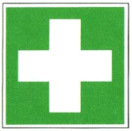 |  | First responders: pay attention to self-protection!  Symptoms may be delayed.  Remove clothing that has been contaminated with TRIS.  After inhalation: fresh air. Get a doctor.  After skin contact: Wash off with plenty of water. Consult a doctor.  After eye contact: Rinse out with plenty of water and consult an ophthalmologist.  Ingestion: Rinse mouth. Drink water (maximum 2 glasses), consult a doctor.  Most important symptoms and effects, both acute and delayed: irritation, coughing, dyspnoea, nausea, vomiting, agitation, spasms, cyanosis, risk of cardiovascular collapse.

Tests - Maintenance - Disposal
Remaining emptied containers and unusable TRIS due to chemical disposal of the university
can be recycled.

Signatures
Supervisor: SIgnature:

Town: Date:

