 |  |  | Operating instructions | 

Work - Equipment - Apparatus -Device
Toluol

Dangers for humans and the environment
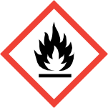  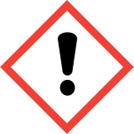  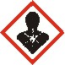 | Signal word Danger!  Hazard statements (H-phrases)  H225 Highly flammable liquid and vapor.  H304 May be fatal if swallowed and enters airways.  H315 Causes skin irritation.  H336 May cause drowsiness and dizziness.  H361d Suspected of damaging the unborn child.  H373 May cause damage to organs through prolonged or repeated exposure.  Safety instructions (P-phrases)  P210 Keep away from heat / sparks / open flames / hot surfaces. Do not smoke.  P261 Avoid breathing dust / fume / gas / mist / vapors / spray.  P281 Use prescribed personal protective equipment.  P301 + P310 IF SWALLOWED: Immediately call a POISON CENTER or doctor / physician.  P331 Do NOT induce vomiting.

Protective measures and rules of conduct
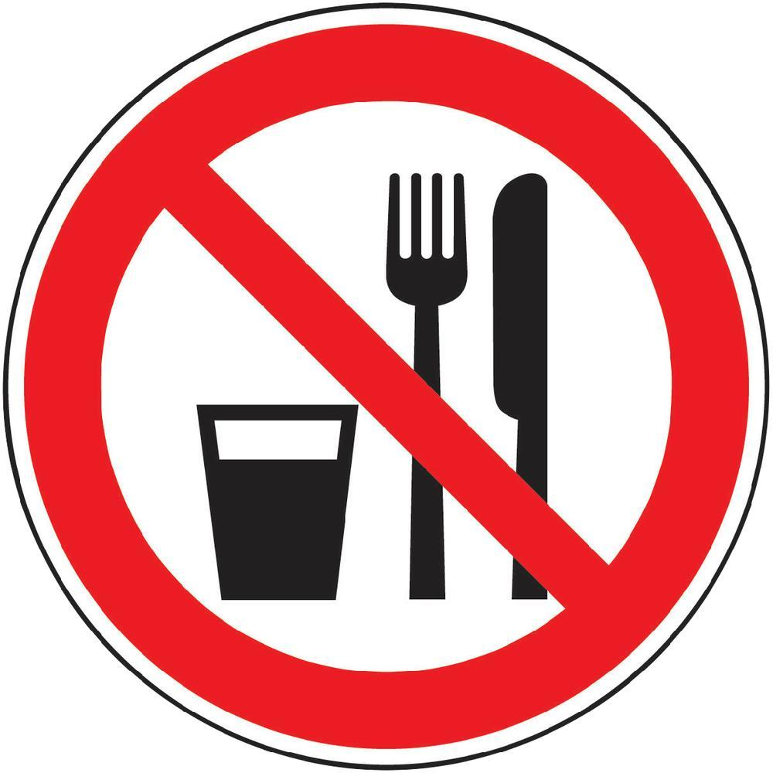    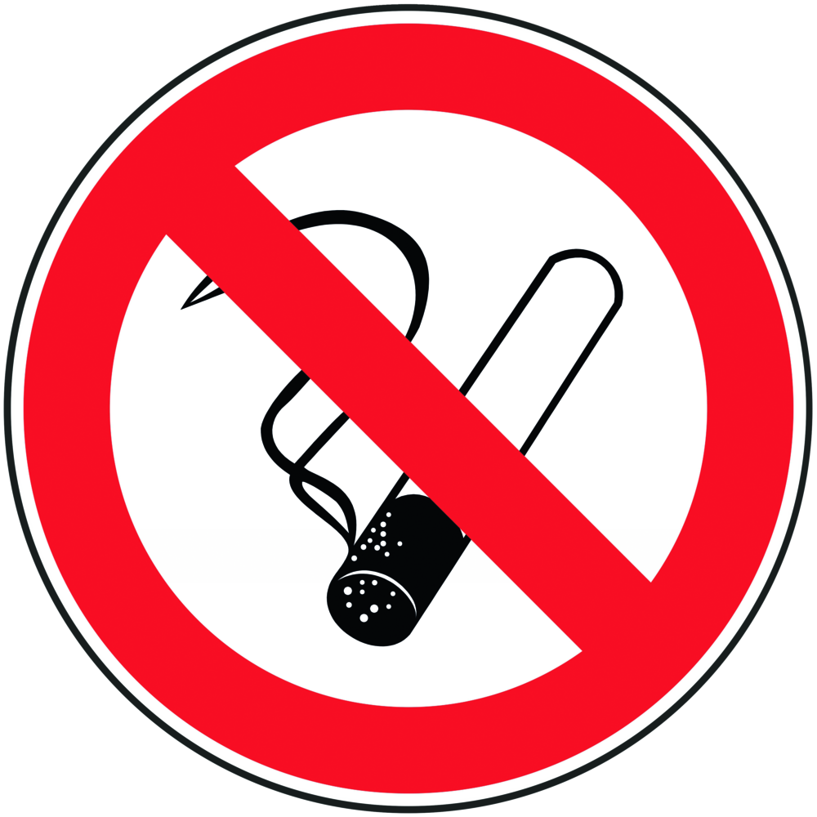 |  | General information  Eating, drinking or smoking is prohibited in all laboratory facilities!  Avoid contact with eyes and skin.  Avoid open flames or sparks!  Avoid electrostatic charging!  Personal protective measures    Eye / face protection  Face shield and goggles.  skin protection  Working with gloves. Gloves must be examined before use.  Use a suitable extraction method (without touching the outer glove surface) to avoid skin contact with this product.  Material: fluoro rubber  Minimum layer thickness: 0.7 mm  Breakthrough time: 480 min  Protective gloves made of nitrile rubber as short-term splash protection.  Layer thickness: 0.4 mm  Breakthrough time:> 10 min  body protection  The type of protective equipment must vary depending on the concentration and amount of dangerous material be selected in the workplace.  During laboratory work, always wear a laboratory coat.  respiratory protection  Work under the deduction !!  Do not inhale substance. Avoid development of vapors / aerosols.  If, according to the hazard assessment, an air-purifying respiratory protection is required, a half mask filter class ABEK (as included in the MUI emergency kit) must be used in addition to the technical measures. |  |  |  | - pE
Use and storage
Store in a cool place. Keep container tightly closed in a dry, well-ventilated place
store. Close open containers carefully and store upright to prevent leakage.

Transfer and transport
The transport of liquids in bottles (from about 200 ml) must be done with the aid of a carrying basket. When refilling, pay attention to appropriate protective equipment! Work under the trigger!

Disruptions and Dangers
 |  | Use personal protective equipment. Do not inhale vapors / mist / gas. Ensure adequate ventilation. Remove all sources of ignition. Bring people to safety. Beware of accumulating vapors that can form explosive concentrations. Vapors can accumulate in low-lying areas.  In case of fire:  Suitable extinguishing agents  Use water spray, alcohol-resistant foam, dry chemical or carbon dioxide.  Special hazards arising from the substance or mixture  Carbon oxides  Advice for firefighters  In case of fire, wear self-contained breathing apparatus, if necessary.  If spilled:  Do not inhale vapors.  Absorb with liquid-binding material. Dispose of.  Clean up affected area.  Vapors heavier than air.  Environmental precautions:  Prevent further leakage or spillage if safe to do so.  Do not empty into drains. An entry in the environment is to be avoided.

Accidents and First Aid
 |  | General information  Consult a doctor. Show this safety data sheet to the attending physician.  After inhalation  If inhaled, remove affected person to fresh air. In respiratory arrest, artificial respiration. Consult a doctor.  After skin contact  Wash with soap and a lot of water. Consult a doctor.  After eye contact  Rinse thoroughly with plenty of water for at least 15 minutes and consult a doctor.  After swallowing  DO NOT induce vomiting. Never give anything by mouth to an unconscious person. Rinse mouth with water. Consult a doctor.

Tests - Maintenance - Disposal
As a halogen-free, organic solvent waste to the chemical disposal supply.

Signatures
Supervisor: Signature:

Town: Date:

