 |  |  | Operating instructions | 

Work equipment – Equipment – Apparatus - Device
Table and stand drill

Dangers for humans and the environment
 |  | - Dangers due to cuts due to chips!  - Dangers due to handling of coolants and lubricants!  - Dangers of eyes and bodily injury due to worn material!  - Dangers due to noise!  - Dangers due to workpieces being spun around!  - Danger of hand injury due to sheep edged surfaces or the removal of material!  - Danger by detecting clothes or hair!  - Risk of foot injuries due to falling workpieces!

Protective measures and rules of conduct
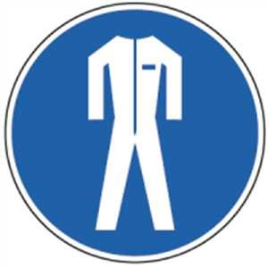 | behavior:  - The accident prevention regulations and the manufacturer's operating instructions must be observed!  - Check the machine for functionality before starting work!  - Clamp the workpiece and place it against the stop!  - Drill and workpiece change only when the machine is switched off!  - Remove chips with chip hooks or brooms!  - For long hair: wear hairnet or cap!!  - Tension and hold the workpiece properly during grinding  - Do not wear gloves when drilling!  - Do not wet the environment with coolant!  - Clean the machine after completing work and dispose of chips in the chip container

Faults and dangers
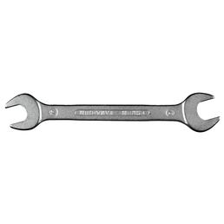 | - Switch off the machine immediately!  - Secure the machine against unintentional restart!

Accidents and First Aid
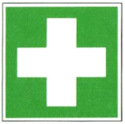 | - Carry out emergency measures at the scene of the accident  - Call ambulance / doctor  - Notify supervisors  - Emergency call: 144

Tests – Maintenance - Disposal
- Check the function and safety features of the machine before each use
- Cleaning and maintenance work only when the machine is switched off
- Observe the manufacturer's specifications regarding maintenance and care
- Have repairs carried out by qualified persons only

Signatures
Supervisor : Signature:
Place: Date:

