 |  |  | Operating instructions | 

Work - Equipment - Apparatus -Device
Sulfuric acid 95-98 %

Dangers for humans and the environment
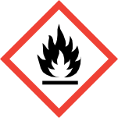  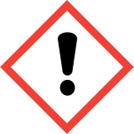 | Observe information of the safety data sheets!  Signal word Danger!  Statements  H314: Causes severe skin burns and eye damage.  H290 can be corrosive against Metal.  safety instructions  P280: Wear protective gloves / protective clothing / eye protection / face protection.  P301 + P330 + P331: IF SWALLOWED: rinse mouth. DO NOT induce vomiting.  P305 + P351 + P338: IF IN EYES: Rinse cautiously with water for several minutes. Remove any existing contact lenses if possible. Continue rinsing.  P309 + P310: IF exposed or unwell: Immediately  Call a POISON CENTER or doctor.

Protective measures and rules of conduct
  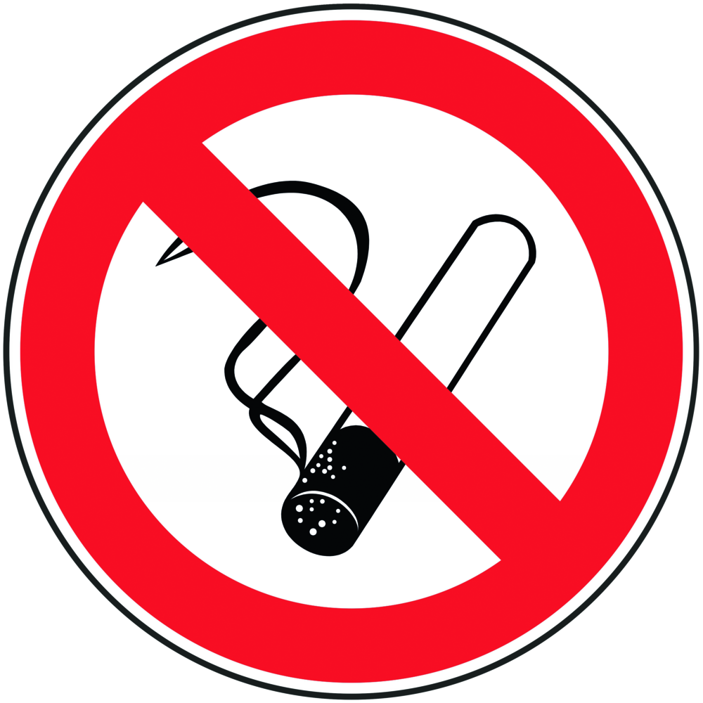 |  | General information  Eating, drinking or smoking is prohibited in all laboratory facilities!  Avoid contact with eyes and skin.  Keep away from sources of ignition.  Personal protective measures |  |  |  | - pE

Eye protection: Tightly fitting safety goggles.
Hand protection:
Full contact: Viton, thickness: 0.7 mm, splash guard: butyl rubber, thickness 0.5mm or
Natural latex, 0.6mm, value for permeation: Level ≥6
Body protection: Lab coat
Respiratory mask: Half mask filter class ABEK (as included in emergency kit MUI)

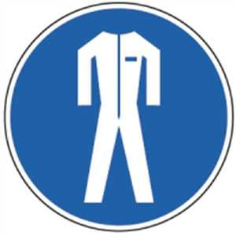

Use and storage
Use:
Keep away from open flames, hot surfaces and sources of ignition.
Take precautionary measures against electrostatic charging.
Change contaminated clothing immediately.
Storage:
Keep container tightly closed in a well-ventilated place.
Store at a temperature of + 15 ° C to + 25 ° C.

Disruptions and Dangers
 |  | In case of fire:  Suitable extinguishing media: water, carbon dioxide (CO2), foam, extinguishing powder. Fight larger fire with water spray or alcohol resistant foam.  Special hazards arising from the substance or mixture: Combustible. Vapors are heavier than air and spread over the floor. When heated, explosive mixtures with air are possible. In case of fire, acetic acid vapors can be released. In case of fire development of hazardous combustion gases and vapors possible. In case of fire, the following can be released: sulfur oxides (SOx), carbon monoxide and carbon dioxide.  Wear self-contained breathing apparatus.  After spilling: Do not breathe vapor / aerosol. Soak up with chemical absorbent and have it disposed of by the university's chemical disposal facility. Purify with water.

Accidents and First Aid
 |  | First responders: pay attention to self-protection!  Symptoms may be delayed.  Remove any clothing contaminated with sulfuric acid.  After inhalation: fresh air. Get a doctor.  After eye contact: Immediately hold the eye wide with both hands and rinse thoroughly under running water for at least 15 minutes. Get an ophthalmologist immediately. Protect the injured eye.  After skin contact: Wash off with plenty of water. Wash off immediately with water. Immediate medical attention is necessary, as untreated burns can cause severe wounds.  Ingestion: Drink water (maximum 2 glasses), avoid vomiting (danger of perforation). Call a doctor immediately. No neutralization experiments.  Most important symptoms and effects, both acute and delayed:  Risk of blindness. Irritation and corrosion, shortness of breath, cough! Vomiting, gastrointestinal discomfort.

Tests – Maintenance - Disposal
Dispose of emptied containers and unusable acetic acid by disposing of chemicals at the university.

Signatures
Supervisor: Signature:

Town: Date:

