 | Operating instructions | 

Disposal
Staining solution, ethidiumbromid-free

Contaminated resources
Halogenated organic solvents, washing liquids and mother liquors (for example coloring solutions, in particular ethidium bromide-containing solutions)

Contaminated solids
Aqueous solutions contaminated with halogenated compounds (e.g. staining solutions, esp. ethidium bromide) |  |  | - pE

Clippings
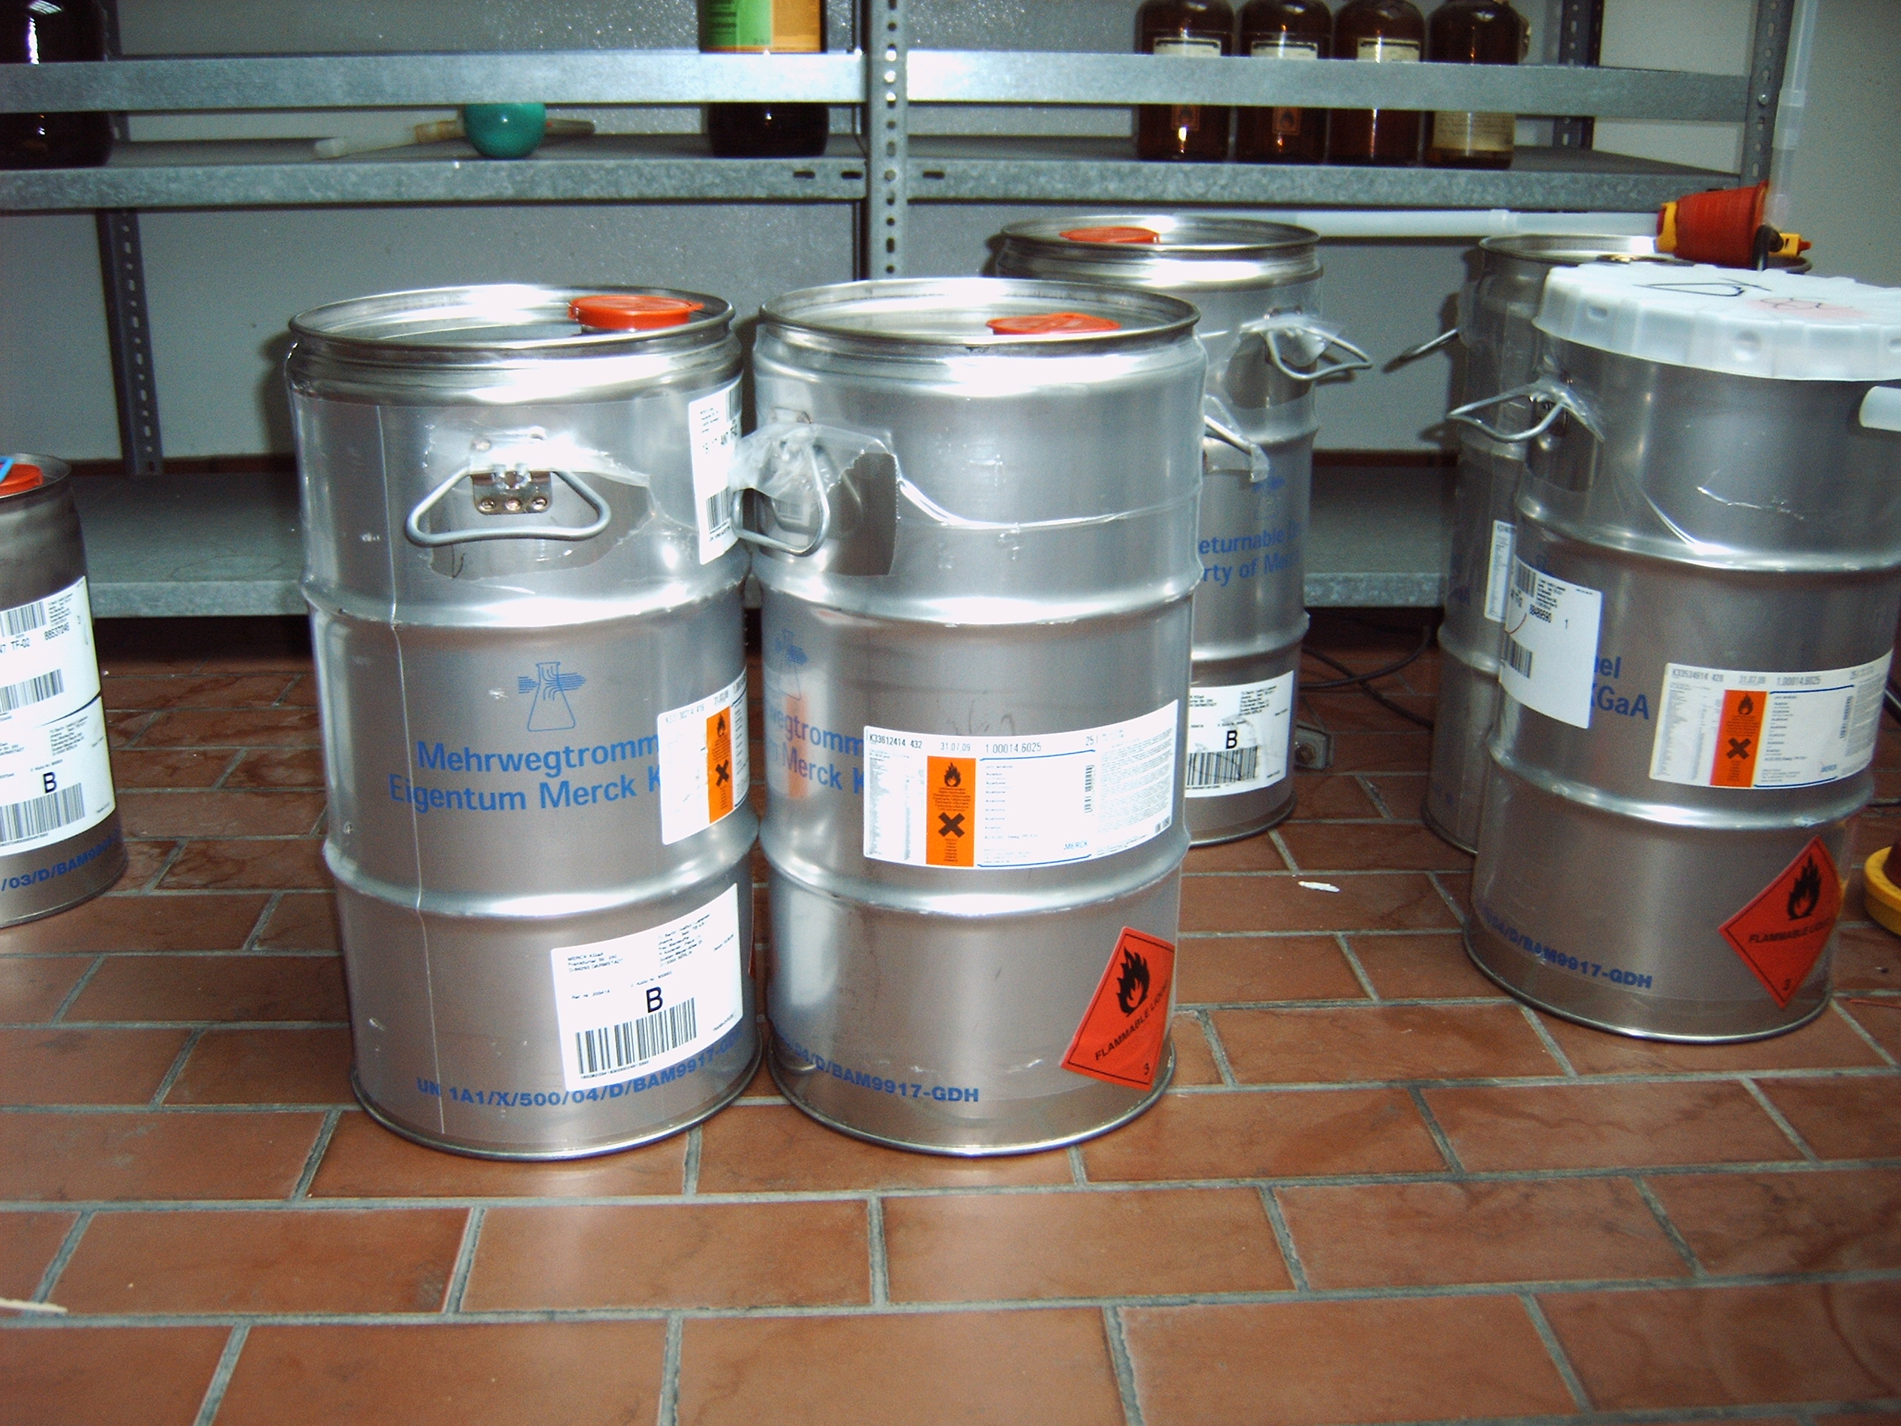
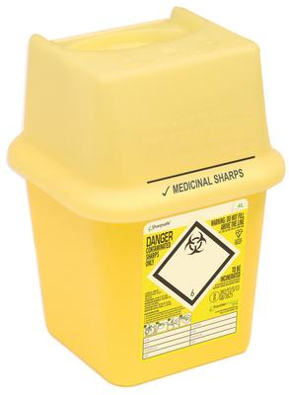
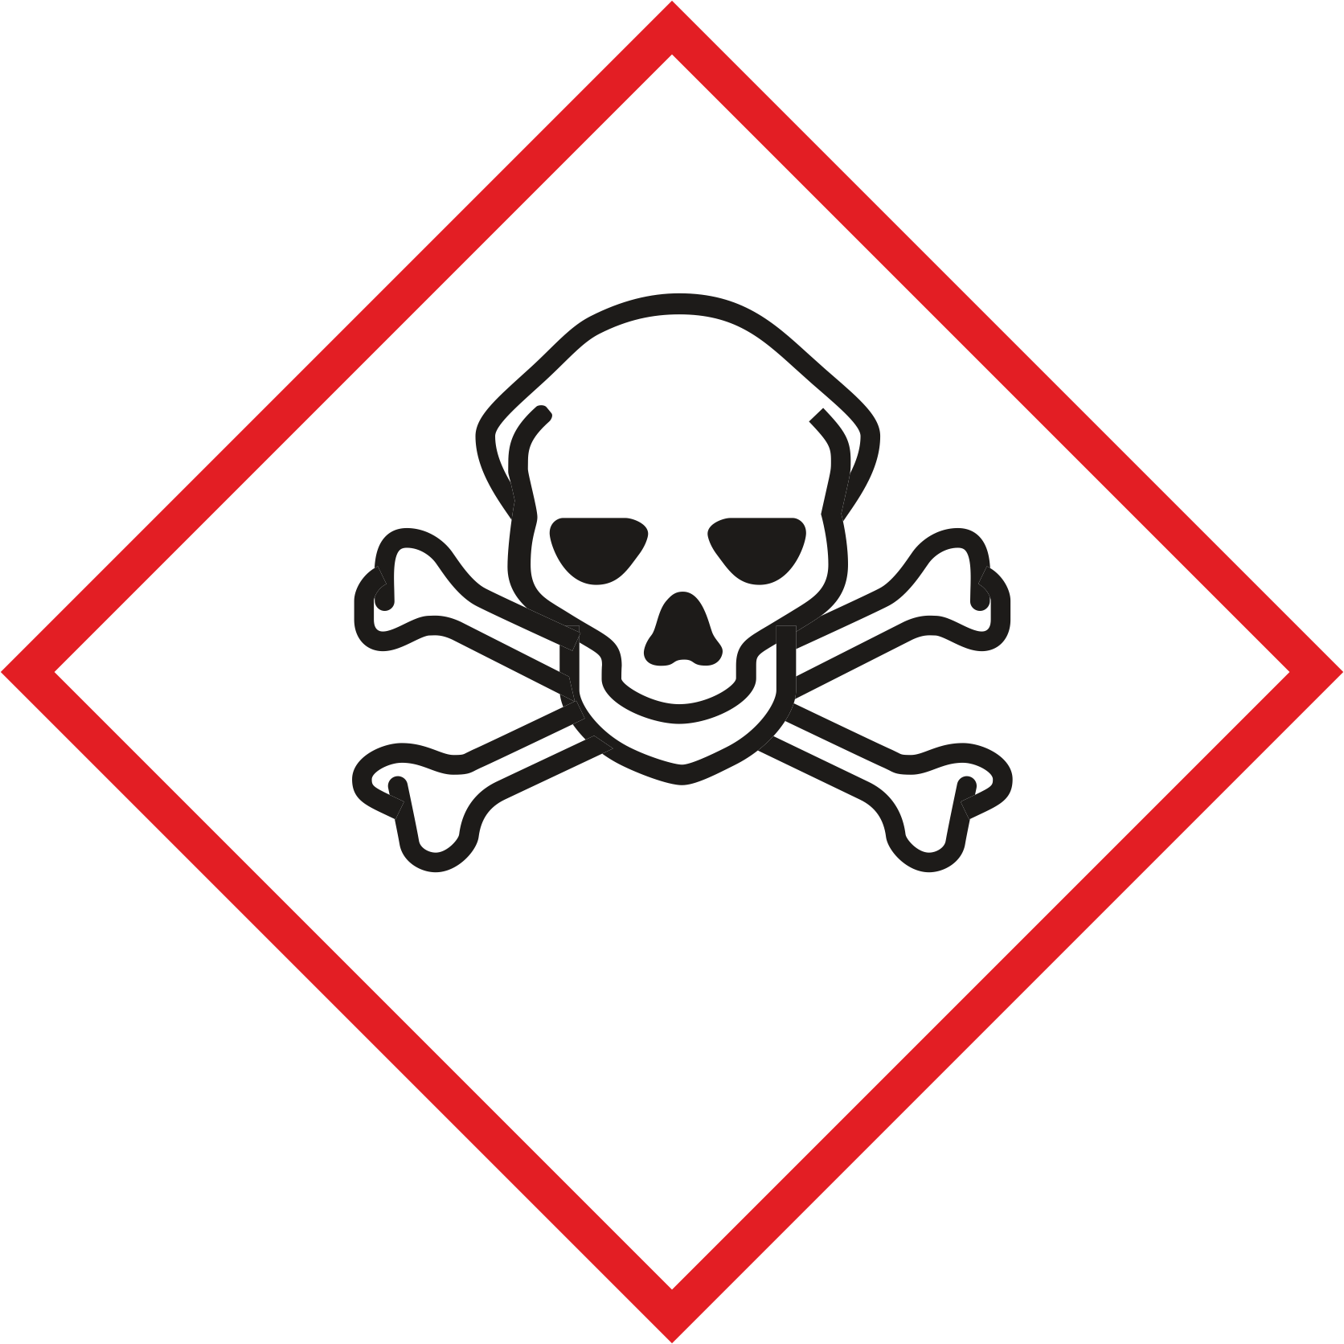
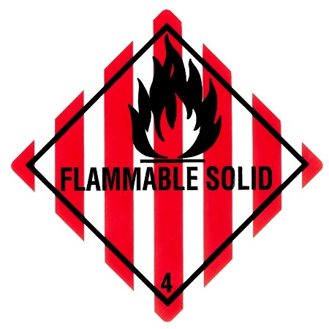
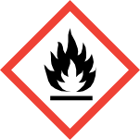

NOT to be collected together with this waste type:
- solid waste like silica gel (resource waste)
- organic oxidizing acids
- HG containing solutions, liquid waste
- Formalin solvents in concentrations above the odor threshold

Signatures
Supervisor: Signature:

Town: Date:

