 | Operating instructions | 

Disposal
Solvent halogen-containing

Contaminated resources
Halogenated organic solvents, washing liquids and mother liquors (all halogenated organic solvents, but also non- halogenated organic solvents with dissolved chlorine and other halogen compounds)
Contaminated solids
Halogenated Organic Solvents (e.g. dichloromethane, chloroform,..) |  |  | - pE

Clippings
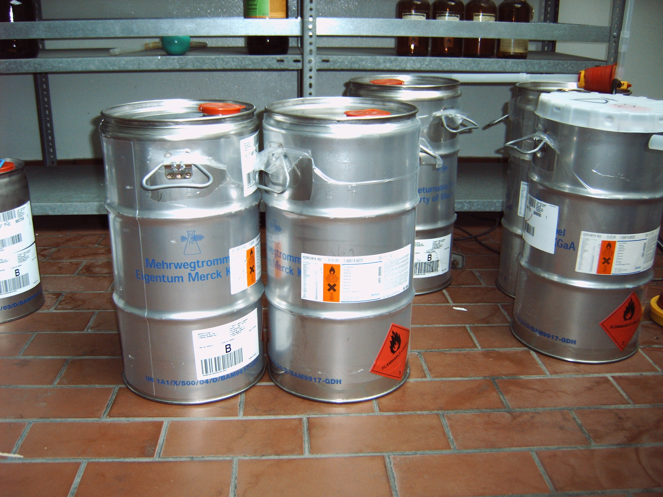
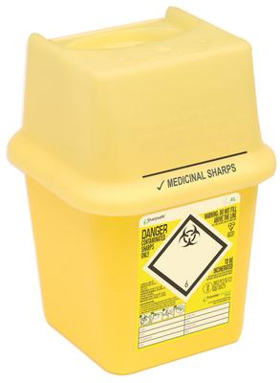
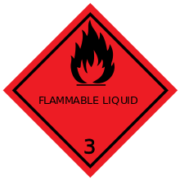
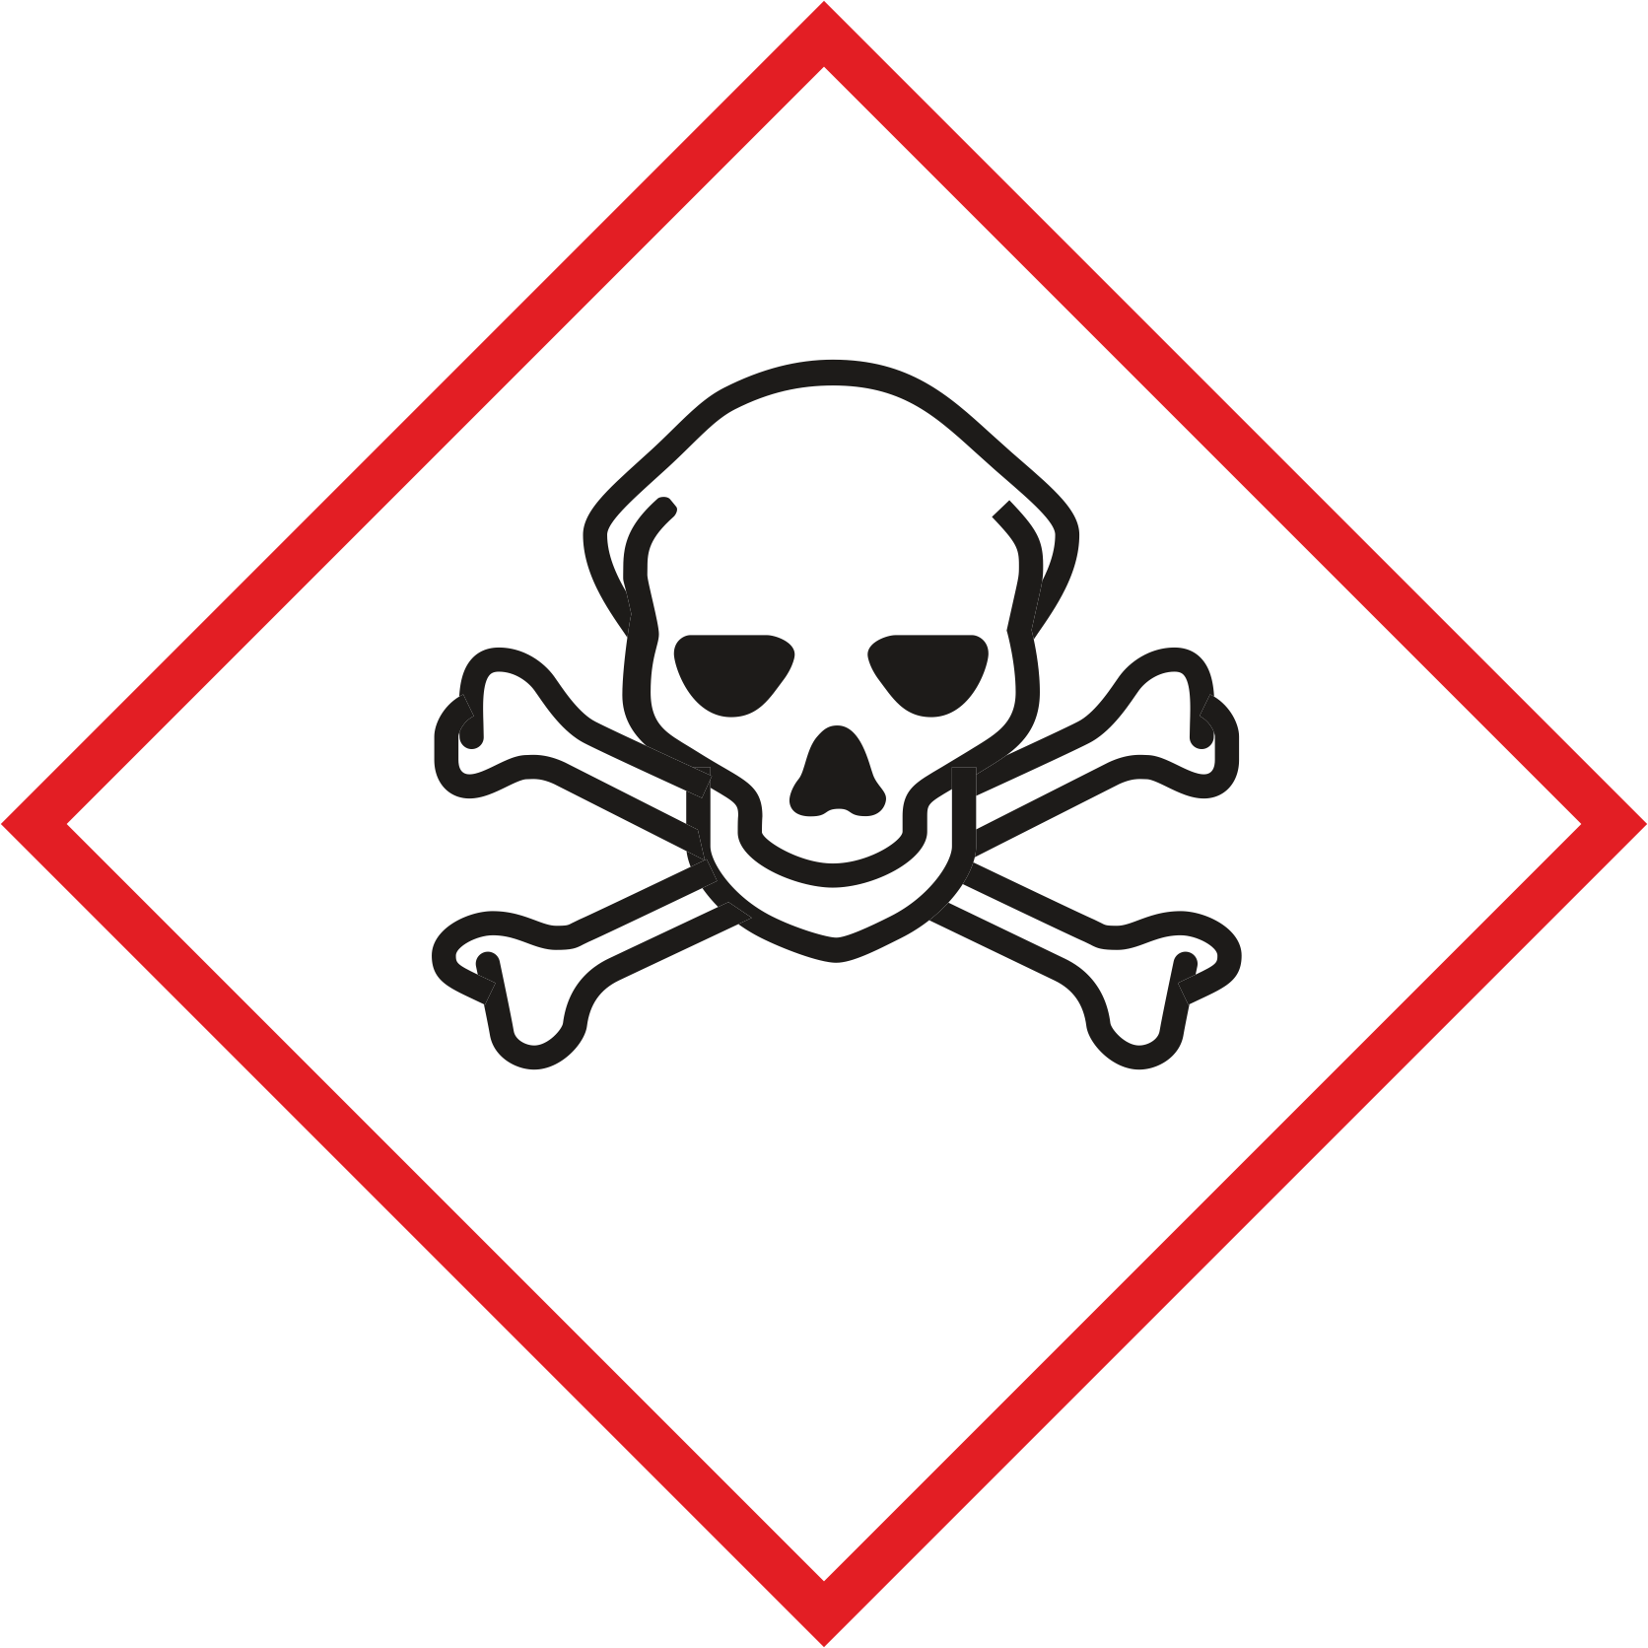
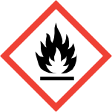

NOT to be collected together with this waste type:
- oxidizing compounds
- acids and bases
- non halogenated solvents

Signatures
Supervisor: Signature:

Town: Date:

