 |  |  | Operating instructions | 

Work equipment – Equipment – Apparatus - Device
Soldering Iron

Dangers for humans and the environment
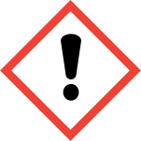  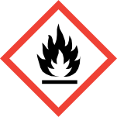  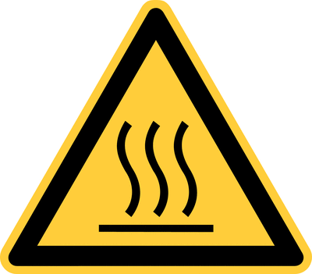  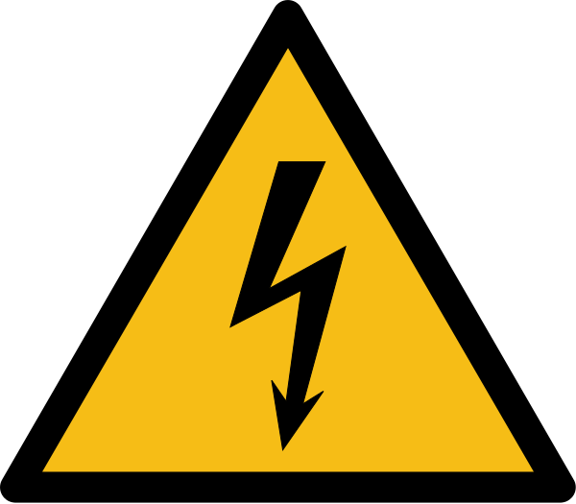  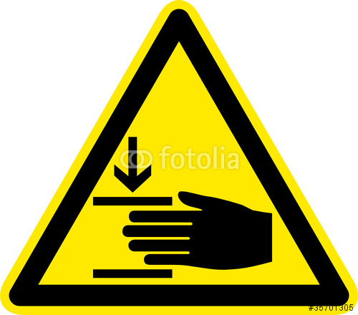 |  | - Danger due to high voltage  - Risk of burns  - Danger from soldering tin (see safety data sheet solder wire)  - Danger of liquid hot solder (eye protection required)  - Flux vapors irritate the nose, throat, and respiratory tract and may result in prolonged contact with allergic reactions (asthma)  - May cause sensitization by skin contact  - Risk of electric shock in contact with moisture  - When used in conjunction with adhesives, observe the warnings of the adhesive manufacturer  - Risk of electric shock in the event of contact with defective cables  - Observe proper handling of batteries (see operating instructions for batteries and accumulators)  - Protection class control unit WS 50: 1  - Protection class soldering iron WS 50: 3

Protective measures and rules of conduct
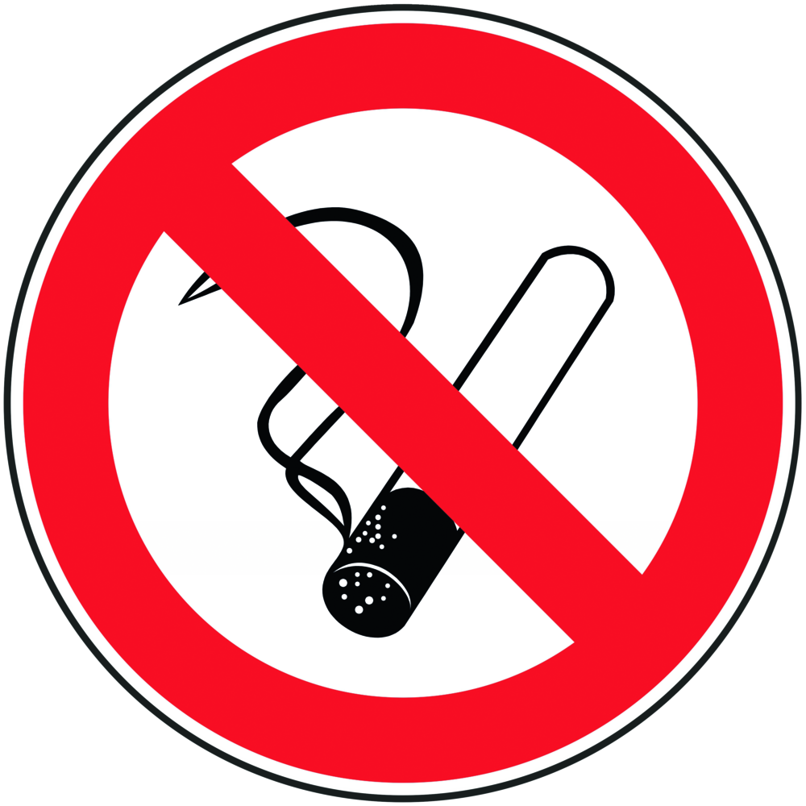    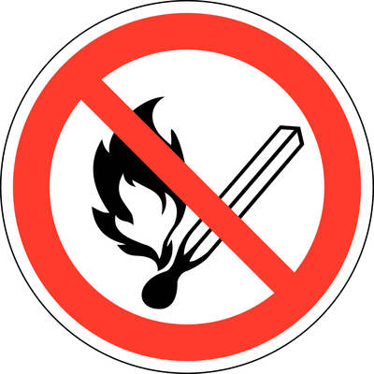 | General information  - Work in a well-ventilated workplace  - Avoid skin contact with soldering iron and solder  - No flammable objects near the hot soldering tool  - NEVER use in humid or wet environments, NEVER immerse in water  - Attention in case of faulty cables and plugs  - Avoid body contact with earthed parts (eg pipes, radiators, stoves and refrigerators)  - Keep other people away from their workplace  - For mains-operated device: Mains voltage 230V / 50H, power: 55W  - For battery-powered device: use only the designated battery type (4 x 1.5V AA batteries), never mix old and new batteries  - For battery operated equipment: make sure the tip is securely fastened  - For battery operated device: low power (450 ° C) in position I, higher power (510 ° C) in  - position II, soldering iron heats to required temperature within 15sec  - Do not overload the soldering tool (overvoltage, overpressure)  - Do not use the soldering tool for purposes for which it is not intended  - Wear appropriate protective clothing to protect yourself from burns  - Do not use the cable to pull the plug out of the socket  Personal protective measures  - Put on light protective clothing (lab coat), wrinkles in the protective clothing may lead to the implantation of spattered solder and thus possible fire formation.  - Safety glasses with side protection  - Work in a well ventilated workplace, if possible under a fume cupboard  Use  for reflowing metals to connect components by soldering, e.g. to connect the two ends of the two conductors of a thermal element (_ see instructions / notes on working with thermocouples)  Recommended procedure (research group internal recommendation)  Heats up quickly, always switch off the device between soldering processes to avoid unnecessary waste of energy and generation of soldering tin |  |  |  |  | - pE

Faults and dangers
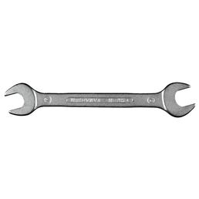 | - Regularly check all connected cables and hoses  - NEVER use in humid or wet environments, NEVER immerse in water

Accidents and First Aid
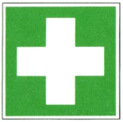 | - Inhalation of solder vapors: Rest, fresh air, if necessary consult a doctor  - Skin contact with liquid solder: immediately cool with running cold water, medical assistance  - Eye contact with solder: Thoroughly rinse eyes under distended eyelids under running water, remove contact lenses, consult doctor  - Ingestion of solder: medical assistance

Tests – Maintenance - Disposal
- Regularly check all connected cables and hoses
- Service work and repairs may only be carried out by a recognized specialist.
- Only use original Weller spare parts
- Pull the plug out of the socket before opening the device

Signatures
Supervisor: Signature:

Town: Date:

