Created: | Checked: | Approved: | Effective from:
Date/Signature | Date/Signature | Date/Signature | Date


Safety Measures, Rules of Conduct and
Hygiene Measures in the S2 Laboratory:

Responsible People and Important Contacts

Company Doctor: Dr. Riccabona 0664/521 05 61
Emergency Doctor/ Emergency Rescue: 144
Fire Brigade 122
Poison Control Centre +43(0)1/406 43 43

In accordance with the basic rules of good microbiological technique, the following is to be particularly adhered to:

- Access Regulations:

  - In the laboratory, protective clothing and sturdy, closed shoes are to be worn.

  - During work that includes contact with harmful substances, suitable protective gloves are to be worn.

  - When working in areas with UV light sources, face protection and closed clothing is to be worn; direct exposure of eyes, skin or mucous membranes to the effect of radiation must always be avoided.

  - In microbiology, virology or cell biology, inexperienced employees must be especially comprehensively instructed, carefully guided and supervised.

  - In the case of work with human-pathogenic pathogens, against which an effective inoculating agent is available, all employees should be inoculated, if they are not already immune, and immunity is to be regularly checked in a suitable way.

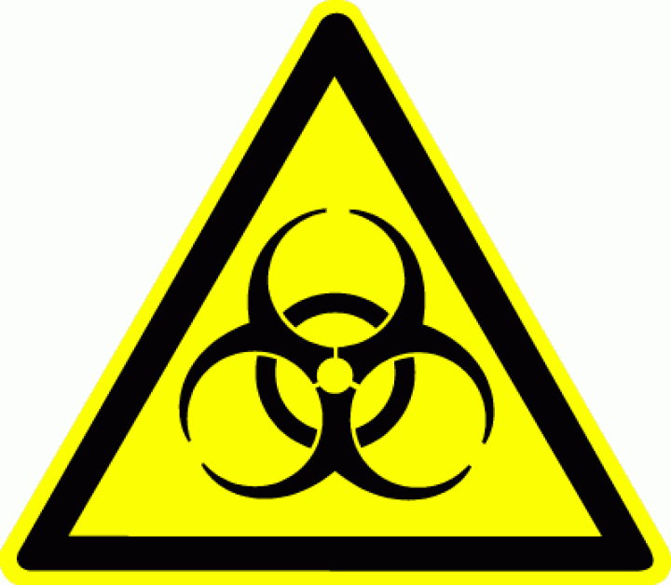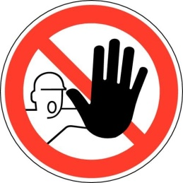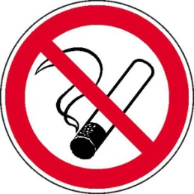

- Only people who have demonstrably been instructed about the necessary and project-specific safety measures, before starting their activity and then at yearly intervals, workplace-specifically and based upon the work manual, in a language understandable to the employees, and who have the express permission of the Laboratory Director to work in the laboratory may work in the rooms designated as "Genetic Work Area S2". This applies to everybody, even if they are not involved with the actual genetic work.

- Visitors normally have no access to Genetic Work Area S2. In necessary exceptional cases, prior explanation of possible risks and the applicable safety measures are necessary. An employee must always be present at the same time. Before guests are entrusted with practical tasks, they are to be made familiar with the regulations applicable in the laboratory by the Laboratory Director or employees whom the Laboratory Director has instructed to do this on their behalf.

- Cleaning and maintenance personnel are only permitted to work in the laboratory rooms if they have been authorised and instructed about possible hazards.

2. Working Regulations:

- Before starting work, each employee of the laboratory is to be informed about the location and function of disinfectants, eye douches, first-aid facilities, fire-extinguishing equipment and about escape and rescue routes.

- The rooms of the genetic facility are to be kept tidy and clean. Only the devices and materials that are actually required should be on the work tables. The stocks are to be stored in the storage spaces provided for them.

- The use of the desk workplaces in the laboratories is to be restricted to the logging of the experiments. Neither genetic work nor office activities apart from logging may be carried out at the desk workplaces.

- The windows and doors of the work rooms must be kept closed during the performance of genetic work. Windows must only be opened for the purpose of ventilation if no genetic work is being carried out and the correct functioning of existing biological safety cabinets or exhaust hoods is not impaired by the movement of air.

- Pipetting aids are to be used.

- Syringes, canulas, blades, needles, lancets etc. must only be used if absolutely necessary. For disposal, they are to be gathered in piercing-resistant, autoclavable containers and autoclaved.

- In the case of all work, it must be ensured that no avoidable aerosols occur. Aerosol formation is to be expected e.g. when pouring, stirring, applying high pressure, inoculating, shaking, pipetting, centrifuging and work with ultrasound.

- It is recommended to still inactivate all used materials (e.g. culture bottles, pipets) in the workbench with e.g. 5% sodium hypochlorite in a suitable vessel.

Possible Measures for Preventing Aerosol Formation:

- Use closed vessels or encapsulated work processes
- Before the opening of the vessels, wait long enough for the aerosols to fall away
- Avoid formation of bubbles
- Keep within low falling heights when pouring and pipeting (allow the liquid to flow down the wall of the vessel as slowly as possible)
- Do not blow out pipets, do not spray the contents of syringes / canulas into the air
- Work in a biological safety cabinet

S2: All work with organisms in risk group 2 are to be carried out in a class 2 biological safety cabinet in order to rule out dangers from unavoidable aerosol formation.

- The operating instructions / user's manual of the individual devices (centrifuge/ autoclave/ biological safety cabinet) are to be directly affixed to the respective devices.

- Firmly closed, unbreakable, leak-proof and identified transport containers are to be used for the transportation of genetically modified organisms within the site.

- The storage of genetically modified organisms is to take place in a suitable form e.g. as liquid cultures with the addition of 15% glycerine in screw-sealable small plastic tubes in the deep freeze at -70°C or -20°C. These vessels are to be labelled with an identification number.

- Protective clothing (laboratory coat, single-use gloves, safety glasses) must be worn in the work area.

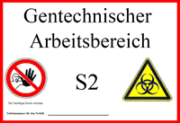
The laboratories are to be identified with signs as "Genetic Work Area S2", with the signs for "biohazard" and "entry forbidden to unauthorised persons". The access doors to the S2 area must always be kept locked.

3. Hygiene Measures

The instructions of the hygiene plan are binding for all workplaces at safety level 2 as part of the job control statement.

- All work surfaces are to be disinfected by scrubbing and wiping disinfection using disinfectant after completion of work.

Because of its high flammability, no 70% ethanol is to be used for the disinfection of surfaces larger than 1m². If larger surfaces must be disinfected, a non-alcoholic disinfectant is to be used.

- After completion of the work and before leaving the laboratory, hands must be disinfected with alcoholic disinfectants (before washing hands at least rub the hands with concentrated solution until the liquid has evaporated; application time), washed with soap and re-greased with skin protection cream. Single use towels are to be used for drying.

- Work tools and instruments are to be regularly cleaned:

- Centrifuges are to be disinfected by the respective user immediately if contaminated, but at least once a month, by wiping out the rotor space and disinfecting the rotors with disinfectant. The responsibilities for the individual areas should be set out in written form.

- The surfaces of the biological safety cabinet are to be disinfected with disinfectant by the respective user after every use, but at least once a month by wiping all surfaces and the collection basin in accordance with the operating instructions on the device.

- The incubator is to be disinfected and cleaned as required but at least once a month by wiping the inner surfaces with disinfectant. Before cleaning, the plug to the mains is to be pulled out and the device is to be brought to room temperature.

- Especially in the case of electrically powered devices and equipment in combination with naked flames / hot surfaces, the explosion protection conditions are to be adhered to when using chemical disinfectants (see also manufacturer's information).

4. Bans:

- Foodstuffs, drink, tobacco and cosmetics must not be kept with the rooms of the genetic laboratory. The lounge can be used for their storage.

- In the work rooms, it is not permitted to eat, drink, smoke or snort anything. The lounge/ break room must not be entered with protective clothing.

- Suction equipment (e.g. diaphragm or water-jet pumps) may only be used for liquids that may contain genetically modified organisms if suitable measures prevent such organisms from escaping.

5. Personal Protective Equipment:

- Protective clothing, which must be regularly washed every week, is to be worn in the genetic work area.

- Protective clothing and single-use gloves are to be taken off before leaving the genetic area, within that same area.

- Single-use gloves are to be disposed of after use. Contaminated gloves must be autoclaved as solid waste before disposal.

- To prevent contamination, the protective clothing is to be kept separately from street clothing.

6. Leakage or Spillage of Biological Materials:

If biological material is spilt, the affected area is to be secured.

Leaked or spilt biological material that may contain genetically modified organisms, must be inactivated straight away.

The following decontamination measures are to be taken:

- Put on protective gloves. Pick up leaked or spilt material with autoclaved material (e.g. paper towels) and autoclave. Then disinfect the contaminated area by wiping with disinfectant. If a vessel breaks the pieces of glass are to be disinfected and only then removed using protective gloves and suitable tools.

- The explosion protection conditions are to be adhered to when using chemical disinfectants where electrically powered devices and equipment are operated close to naked flames / hot surfaces (see also manufacturer's information). Before applying liquids also pull mains plug out.

- Take off protective clothing and/or items of street clothing and disinfect or autoclave them. Then wash items of clothing with disinfecting detergent additive.

- Disinfect contaminated areas of skin with sufficient quantity of disinfectant and, after waiting sufficiently long for it to take effect (see manufacturer's information), rinse with lots of water.

- After contact with the eye, the eye must be rinsed with flowing water for at least 5 minutes. In the case of injuries or chemical burns immediately consult the nearest doctor (eye clinic or occupational physician).

- Rinse mucous membranes with lots of water. If necessary, consult the nearest doctor or occupational physician.

- If, despite these immediate measures, further complaints arise, then the occupational physician or casualty department is to be consulted without delay.

Every accident is to be reported to the Laboratory Director, so that he/she can inform the Specialist Team for Safety and Health on the "Accident Report" form.

I hereby confirm that the points listed above have been explained to me, and that I have understood
them. I furthermore confirm that a copy of these instructions has been handed out to me.

Place and Date Employee's First Name and Surname

Employee's Signature

