 |  |  | Operating instructions | 

Technical Equipment – Devive – Machine - Tool
Shapers / ram planer

Environmetal and health Hazards
- Flying chips, moving tools, etc.
- Detecting the hair, clothing, jewelery, etc. by means of drive, guide or tool
- Cutting, piercing, etc. on tool, workpiece, chips
- Intensive skin contact with cutting oil leads to the destruction of the acid mantle, degreasing, dehydration and irritation of the skin as a precursor of skin diseases.
- Even minor skin injuries, e.g. due to metal particles, increase the risk of a coolant-related skin disease

Safety Precautions
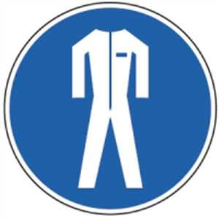       |  | - Check workstation for defects before starting work.  - Take skin protection measures if necessary.  - Cover long hair with a cap, hairnet or similar.  - Wear tight fitting work clothes with cuffs, roll up sleeves if necessary.  - Put down the wristwatch, finger rings, bracelets and loose necklaces, ties, scarves and more.  - Gloves must not be worn when bumping.  - Firmly clamp the chisel  - Wear safety glasses  - Do not endanger neighboring workplaces with flying chips or cutting oil (use protective device).  - Do not exceed the specified delivery.  - Clamp the workpiece firmly in the vice.  - To change workpieces, to measure, to clean, etc. Switch off the machine.  - Switch off the machine after use and secure it against unauthorized switching on.  Remove chips only with a brush or hand brush. |  |  |  | - pE

Malfunction and associated Risks
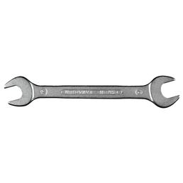 |  | - In case of damage or malfunction of the machine: Switch off and inform the instructor.  - Remove slipping hazards (eg due to chips or lubricants).  - Have the damage repaired by a specialist

First Aid

- Switch off the machine.
- Inform first responders
- Take care of injured persons.
- Emergency call: 144

Serving – Maintenance - Disposal
- After completing the work, dispose of chips in the marked collection container.
- Clean the machine at the end of work.
- Clean up the machine environment at the end of work.
- Damage to the machine may only be eliminated by authorized persons.

Signatures
Group leader / Supervisor: Signature:

Town: Date:

