 |  |  | Operating instructions | 

Work - Equipment - Facility – Device
Safety Goggles

Protection goals
 | Goggles are designed to endanger the eyes  - prevent splinters and fragments flying around (i.e. due to explosions, implosions, breakage and tearing) as well as splashing substances (i.e. during refilling and filling, through bumping, violent reactions, gas evolution, explosions, implosions).

Use and rules of conduct
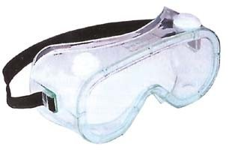    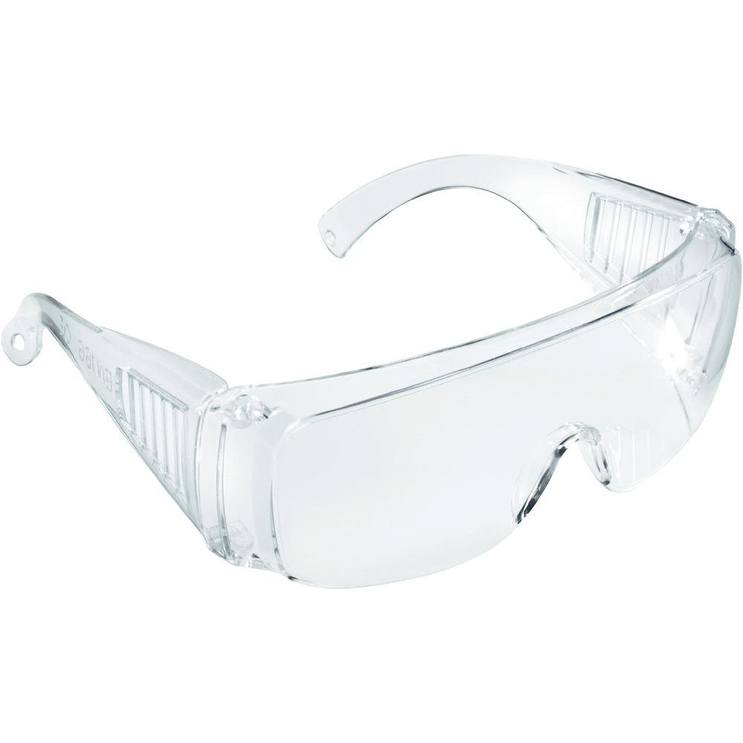 |  | - For all laboratory work, frame goggles with side protection are to be worn.  - Wear goggles when working with particularly hazardous substances (very toxic, carcinogenic, mutagenic, reproductive toxic, causing severe eye injuries).  - Wear goggles when transferring large quantities of corrosive substances.  - Do not place safety goggles on the laboratory bench due to the risk of contamination.  - If optically corrected lenses are required, appropriate safety goggles can be requested informally. If necessary, the supervisor should be informed of any deterioration in the visual strength that necessitates a new purchase of protective goggles.. |  |  |  | - pE

Behavior in case of defects
- If the glasses are scratched, have them replaced.
- Arrange for repairs if the frame is defective.
- Have lost side protection parts replaced.
- Have glasses that are not comfortable fit adjusted by a specialist.
- Consult an ophthalmologist if you have vision problems.

Storage, cleaning and care
- Always store goggles in clean packaging or case and keep them ready.
- If soiled, clean with mild detergent and warm water.
- (Never use acetone for cleaning!)
• (Never use acetone for cleaning!)

On and Off
- Pay attention to a good and secure fit when placing.

Signatures
Signature: Supervisor:

Town: Date:

