 |  |  | Operating instructions | 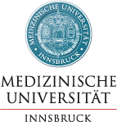

Work - Equipment - Apparatus -Device
Picrinic acid crist.

Dangers for humans and the environment
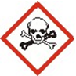 | R 1-4-23 / 25/25: Explosive when dry. Forms highly sensitive explosive metal compounds. Toxic by inhalation, in contact with skin and if swallowed.  Conditions to avoid: Heating (explosive decomposition). Distillation (danger of explosion).  Materials to avoid: alkali hydroxides, alkali metals, metals, metal salts, fluorine.  Hazardous decomposition products: nitrous gases, carbon monoxide. Stabilizers: water.  Further information: shock-sensitive; unsuitable materials: metals.  WGK 2 (water-polluting substances) (KBwS classification)  MAK 2,4,6-trinitrophenol: 0.1 mg / m3 (total dust), risk of skin absorption)  EC-value 2,4,6-trinitrophenol: 0,1 mg / m3 (total dust), H (risk of skin resorption)

Protective measures and rules of conduct
  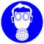  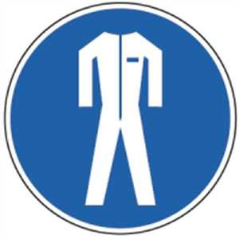 |  | Storage: Keep container tightly closed. Removed from ignition and heat sources. At room temperature (recommended: +15 to + 25 ° C). Only for experts. Observe national regulations.  Respiratory mask: Half mask filter class ABEK (as included in emergency kit MUI)  Hand protection and eye protection required. Appropriate protective clothing.  Change contaminated clothing and put it in the water. Preventive skin protection. Wash hands and face after work.  S 35-36 / 37-45_ Waste and containers must be disposed of in a secure manner. Wear suitable protective gloves and protective clothing. In the event of an accident or if you feel unwell, seek medical advice immediately (show the label where possible). |  |  |  | - pE

Disruptions and Dangers
 |  | In case of fire: suitable extinguishing agents: water, foam. Fabric is flammable. Blow and  Avoid friction. Without protective liquid Self-ignition possible.  Upon release: avoid substance contact. Procedure for cleaning / picking up: Keep moist. Carefully pick up. Dispose of. Clean up affected area.  Observe alarm, escape and rescue plans. Alert fire department.  Occupational Physician: Dr. med. Olaf Riccabona 0512/504 27527 0664/5210561  Emergency call: 144

Accidents and First Aid
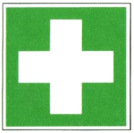 |  | Inhalation: fresh air. Possibly. Breath-giving or device ventilation.  Skin contact: wash off with plenty of water, dab with polyethylene glycol 400. Remove contaminated clothing immediately.  Eye contact: rinse with plenty of water with the eyelid wide open (at least 10 min.)  Ingestion: Drink plenty of water. Better physiological saline, induce vomiting. Call a doctor immediately. Laxane: paraffin oil (3 ml / kg). Sodium sulfate (1 tablespoon / 1/4 l of water). Activated carbon. No milk. No castor oil. No alcohol.  In case of respiratory arrest: immediately device ventilation, if necessary oxygen supply. Call a doctor immediately.

Tests - Maintenance - Disposal
There are no uniform provisions on the disposal of chemicals in the EC.
Hazardous waste

Signatures
Supervisor: Signature:

Town: Date:

