 |  |  | Operating instructions | 

Work equipment – Equipment – Apparatus - Device
Oven with drying function

Dangers for humans and the environment
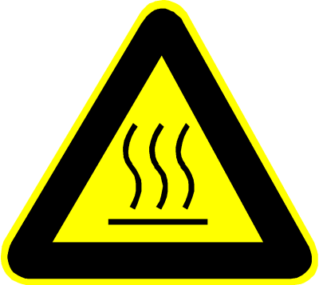  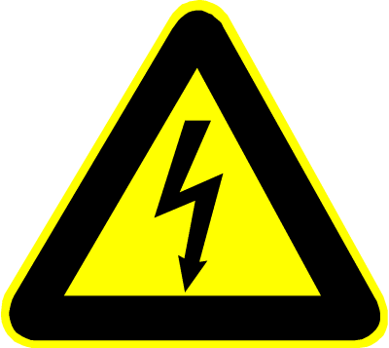 | - There are hazards due to:  - In the event of improper operation, safety and security measures may be taken. environmental hazards occur, e.g. if other than the expressly permitted products are filled.  - Risk of burns from touching hot surfaces, such as jars, materials,  - Risk of fire due to leaked or dropped hot material.  - Danger of scalding when extinguishing with water due to explosive formation of water vapor due to the usually very high temperatures.  - Danger of crushing fingers in the area of cover plates or, in the case of swiveling ovens,  - between oven and rack.

Protective measures and rules of conduct
   |  | Employees are to be made familiar with the operation of the stove, preferably by the manufacturer, before commissioning.  - Crucible furnaces may only be operated by technically suitable persons.  - Combustible material should be removed from the immediate vicinity of the stove (at least 800 mm).  - Never extinguish fires with water or foam.  - Only use materials whose properties and the like Melting temperatures are known.  - Operation with substances that may release explosive gases when warmed up is prohibited.  - Never use the oven without properly installed jars.  - Never use the oven to heat food.  - No intake of food or drink while working with the oven.  - Use suitable heat-resistant PPE to remove materials from the oven (protective gloves,  apron, goggles)  - Regularly check the safety devices for proper function.  - Provide adequate and proper ventilation (away from the person) at the workplace.  - Place the stove on a fireproof floor; Furnish the oven environment fireproof. |  |  |  | - pE

Faults and dangers
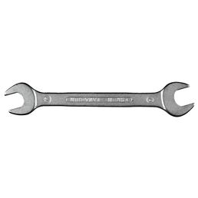 |  | • Never use the stove with damaged or missing covers. Inform superiors.  - Only carry out troubleshooting by persons who have been trained to do so. are entitled.  - Always follow the manufacturer's instructions for troubleshooting.

Accidents and First Aid
 |  | - In the event of burns, immediately cool affected areas with sufficiently cold water.  - Provide further 1.Aid as far as possible, if necessary visit doctor or call for help.  - Instruct emergency personnel and, if necessary, point out special risks.

Tests – Maintenance - Disposal
- Cleaning the stove with water or non-flammable cleaning agents.
- Before maintenance a. Repair work Disconnect the heater from the power supply and secure against reclosing.
- Electrical cables u. Check safety covers regularly for integrity.
- Only carry out maintenance work by persons who are suitable for this purpose.
- Only carry out work on electrical equipment by a qualified electrician
- Work on hydraulic or gas technology. Only equip people with special knowledge and experience in this field.
- It is essential to observe the manufacturer's maintenance instructions.

Signatures
Supervisor: Signature:

Town: Date:

