 |  |  | Operating instructions | 

Work equipment – Equipment – Apparatus - Device
Technical work equipment
(Sawing, filing, chiseling, cutting, turning, milling, drilling, grinding)

Dangers for humans and the environment
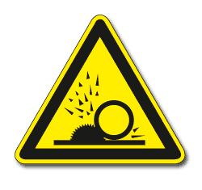  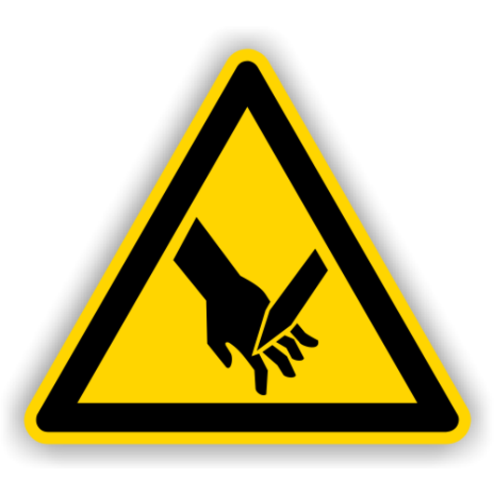  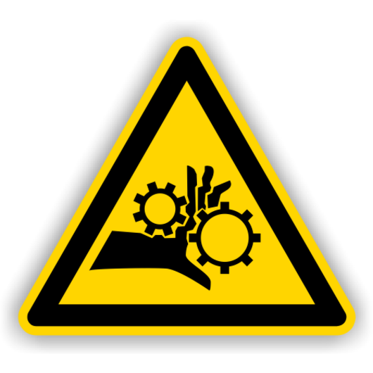 | - Danger of cutting and scrape injuries due to chips, sharp-edged  workpieces or contact or with the implement.  - Danger of hair, clothing, jewelery, etc. coming from the drive, spindle,  tool or workpiece.  - Risk of bodily injury or eye injury from flying parts  - Danger from out-of-control tool or workpiece.  - Danger from handling coolants and lubricants.  - Dangers due to inhalation of vapors and dusts.  - Risk of electric shock.

Protective measures and rules of conduct
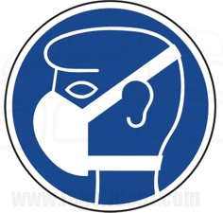 |  | - Required PSA wear: eye, ear, respiratory, laboratory coat.  - Only use work equipment as instructed by the responsible laboratory manager.  Wear tight fitting clothes.  - Closed, sturdy footwear.  - Tie open long hair to the back!  - Do not wear protective gloves when working!  - Place rings, chains, wristwatches before starting work.  - Do not touch the current device! Attention: device is running!  - Do not reach past the working implement (eg saw or drill spindle).  - Clamp the workpiece securely before starting work and fix it or fix it to the stop.  - For tool change, measuring, cleaning etc. Switch off the machine and wait for it to run out.  - Use tool only as intended.  - Use protective devices and do not remove or block them.  - When blowing off chips with compressed air, it is absolutely necessary to wear protective goggles with side protection.  - Never use in the direction of colleagues.  - Depending on the device, check the water level in the case of dusts. |  |  |  | - pE

Faults and dangers
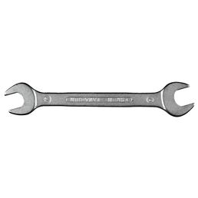 |  | When blowing away chips with compressed air, always use protective goggles with side protection and never in the direction of colleagues.  Depending on the device, check the water level in case of dusts.  If the implement breaks or is stuck, or if parts are spinning around: Immediately press the emergency stop button. Attention: Machine is running!  Immediately replace damaged tools and prevent reuse by others.  Only rectify faults at standstill.  Inform responsible laboratory, workshop or area manager.

Accidents and First Aid
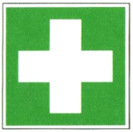 |  | First care for minor injuries.  In case of major injuries contact the doctor.

Tests – Maintenance - Disposal
Dispose of any residual material (eg shavings, rock waste ...) in the corresponding collection container.
Maintenance work or repairs are carried out exclusively by the respective specialist personnel or other trained persons.

Signatures
Supervisor: Signature:

Town: Date

