 |  |  | Operating instructions | 

Work equipment – Equipment – Apparatus - Device
Milling Machine

Dangers for humans and the environment
- Cutting injuries to the tool or chuck.
- Detecting clothing and hair by open drive or milling spindle.
- Danger of crushing by pull-in points.
- Injuries due to flying workpiece or tool parts or chips.
- High-speed and trailing drill.

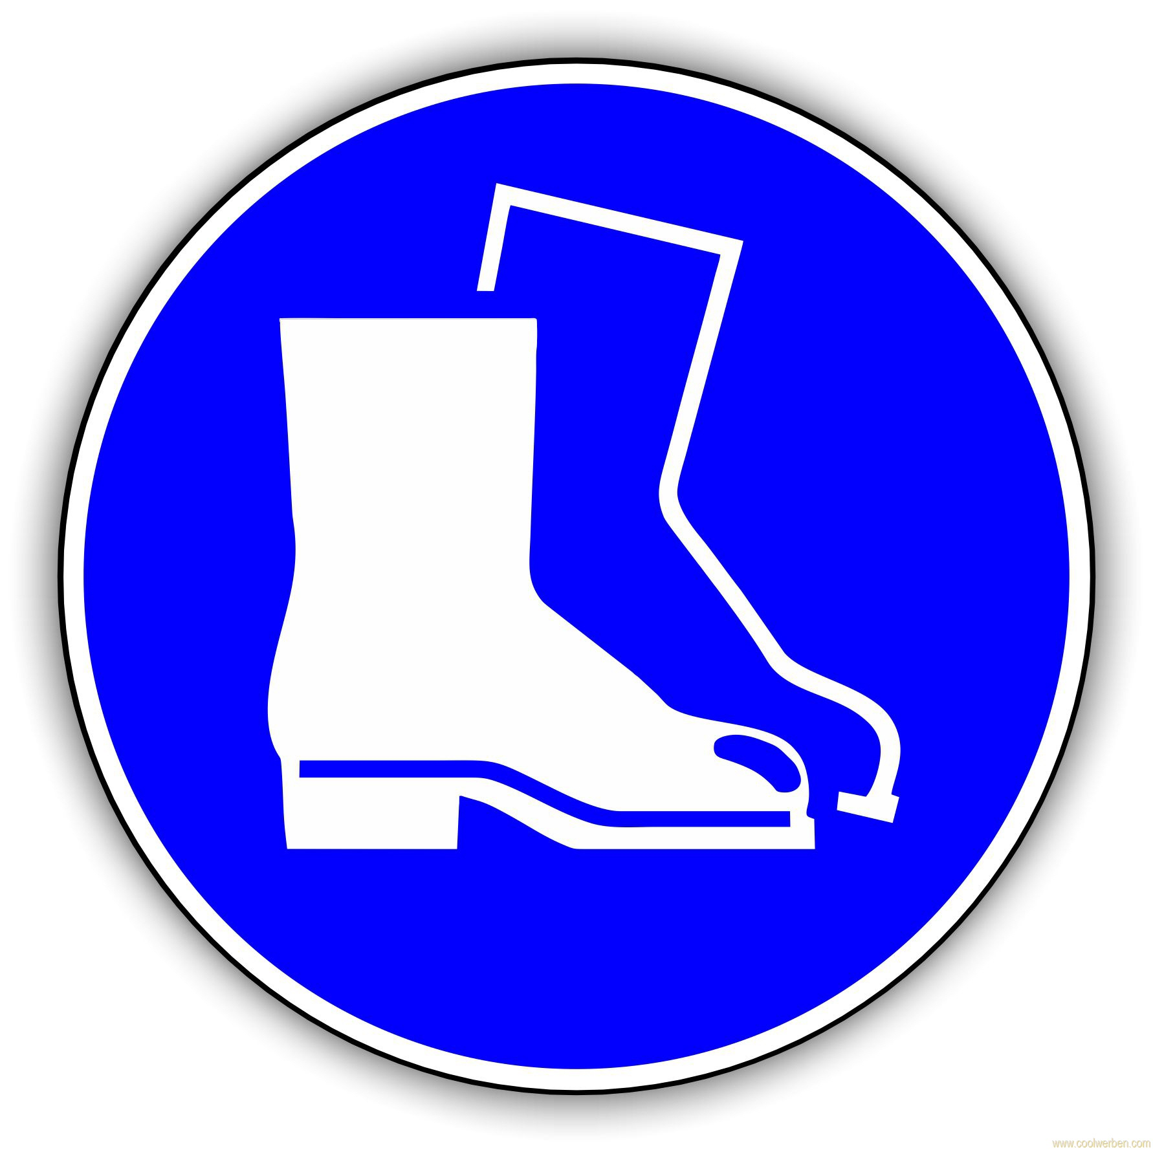
Protective measures and rules of conduct
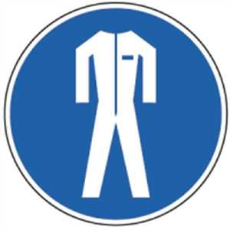  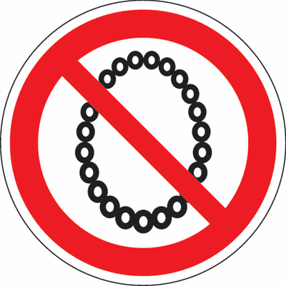   |  | Operation of the machine only after instruction.  - Wear tight-fitting work clothing, safety shoes, and safety goggles!  - For long hair wear a hairnet or a suitable cap!  - Wearing jewelery (rings, chains, watches, visible piercings) is prohibited  - The wearing of gloves is prohibited.  - Attention to follow-up of the machine after switching off.  - Firmly clamp workpiece and tool, make sure that the machine vice is firmly seated.  - Do not touch the cutter at the cutting edge and remove the wrench.  - Perform tool and workpiece changes as well as measuring activities only when the machine is at a standstill.  - Do not use compressed air for cleaning  - Only remove chips with a chip hook, broom, brush or industrial vacuum cleaner. NEVER with bare hands.  - Modifications to the protective devices are prohibited.

Faults and dangers
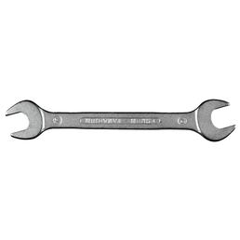 |  | - In the event of faults, abnormalities of the machine, breakage and setting of tools, switch off the machine immediately, secure it against commissioning and inform the supervisor.  - Only eliminate faults at standstill.

Accidents and First Aid
 |  | - Keep Calm  - Observe self-protection; Injured people recover, switch off the system  - Call first responder and, if necessary, emergency doctor. Emergency call: 144  - Provide first aid  - Inform supervisors  - An accident report must be made in the case of accidents and near-misses

Tests – Maintenance - Disposal
- The machine and the workplace are to be cleaned after use, tools and aids are to be put in the designated places.
- Repair and repair only by authorized and authorized persons.
- Observe the maintenance schedule of the manufacturer.

Signatures
Supervisor: Signature:

Town: Date:

