 |  |  | Operating instructions | 

Work equipment – Equipment – Apparatus - Device
Milling Machine-Metall

Dangers for humans and the environment
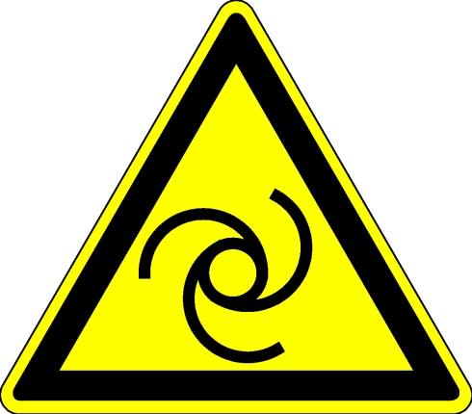  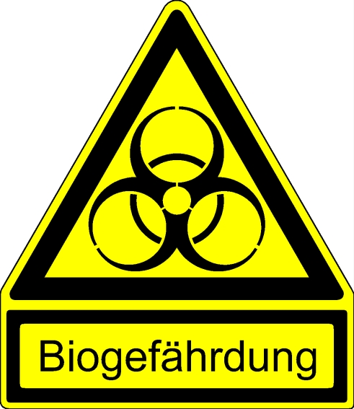 |  | - Risk of injury if used improperly (especially for eyes and hands)  - Danger of catching by high-speed, rotating machine parts  - Risk of injury from flying chips, tools and parts  - Risk of skin damage and allergies when handling coolant  - Hearing damage due to noise  - Danger of electric current, especially in case of damage to electricity of leading line

Protective measures and rules of conduct
  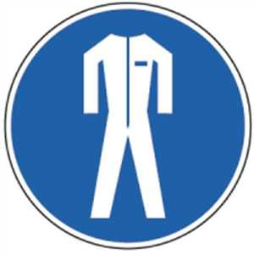   | - Before starting work, check that the machine is in a safe condition  - Firmly clamp the workpiece in the vice and remove the wrench  - Position protective devices in working position  - For tool change, measuring, cleaning etc. Switch off the machine  - Wear tight fitting clothes. Jewelry, e.g. Put down rings, chains, bracelets and watches.  - Secure longer hair with a hair tie, cap, or headscarf  - Wear safety glasses. Ear protection for noisy work  - Protective gloves are prohibited: danger of moving into the rotating parts  - Do not remove splinters, chips and waste by hand! Switch off the machine and use a chip hook, a hand brush or an approved industrial vacuum cleaner  - Wear tight fitting clothes  - Wearing gloves and jewelery is prohibited  - (Gloves only for material change, with secured, stationary machine)  - Use skin protection according to the operating instructions for cooling lubricant  - Safety shoes must be worn depending on the size of the workpieces  - Observe extended information for different turning techniques. |  |  |  |  | - pE

Faults and dangers
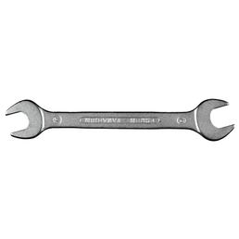 | - In case of malfunction or damage to machinery or protective equipment  - Switch off the machine and secure against unauthorized restarting.  - Have damage repaired by qualified personnel only.

Accidents and First Aid
 | - Switch off and secure the machine  - Inform first responders  - Provide immediate injury  - Emergency call: 144

Tests – Maintenance - Disposal
- Repair only by authorized and qualified persons
- For setup, maintenance and care work, disconnect or secure the machine from the mains
- After maintenance, the protective equipment must be checked
- Clean the machine after work
- Check the coolant regularly according to plan and replace if necessary (see
- Operating instructions for cooling lubricants)
- E-check every four years by a qualified electrician

Signatures
Supervisor: Signature:

Town: Date:

