 |  |  | Operating instructions | 

Work equipment – Equipment – Apparatus - Device
Microwave

Dangers for humans and the environment
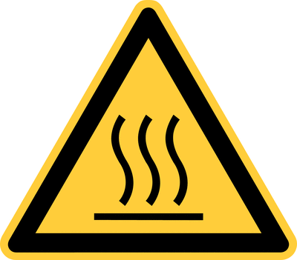  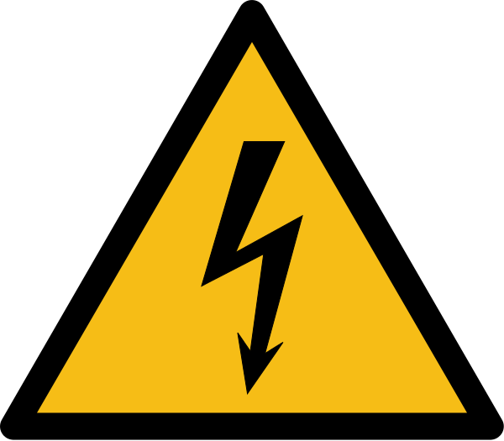 | - The general rules for handling electrical equipment apply (see  relevant operating instructions).  - Danger due to microwave radiation.  - Risk of scalding from hot surfaces or steam.  - Risk of scalding due to bumping.  - Danger of bursting with closed containers.  - Danger due to heating of solvents - Solvents can be dissolved within  seconds reach their boiling point!  - Fire hazard if excessive heating of solids (e.g., plastics) occurs.

Protective measures and rules of conduct
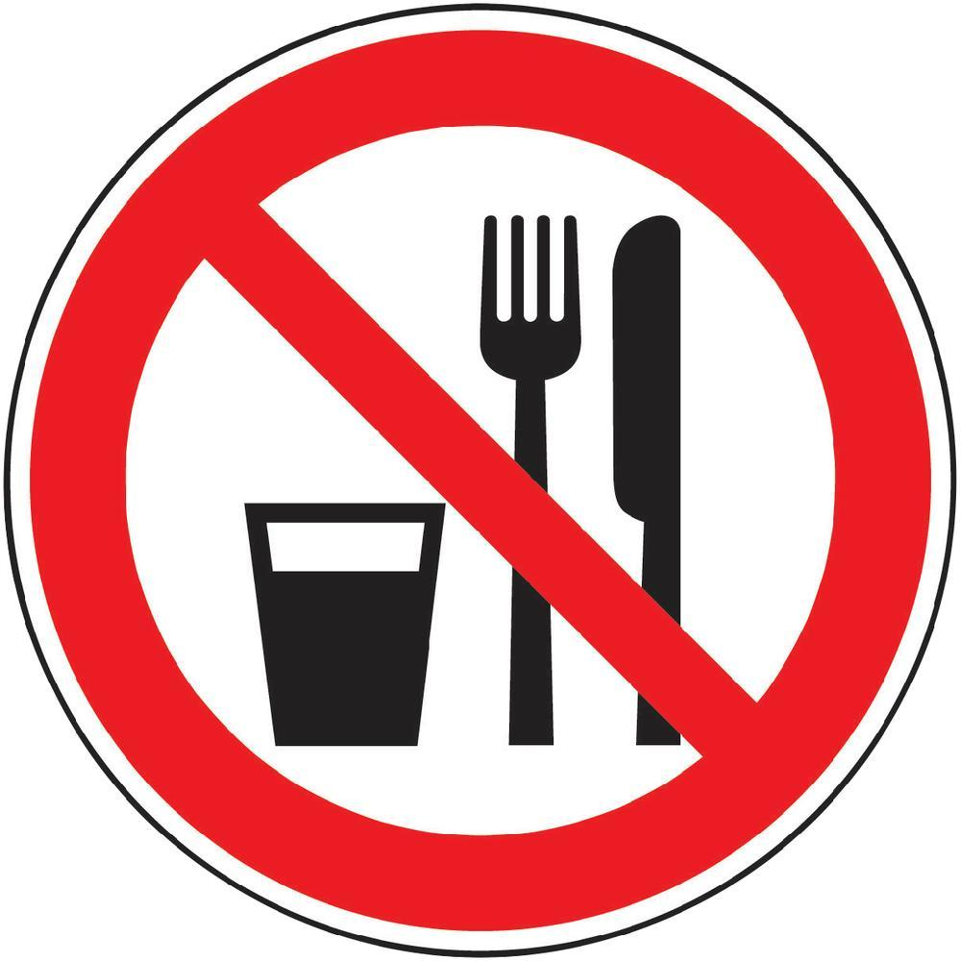  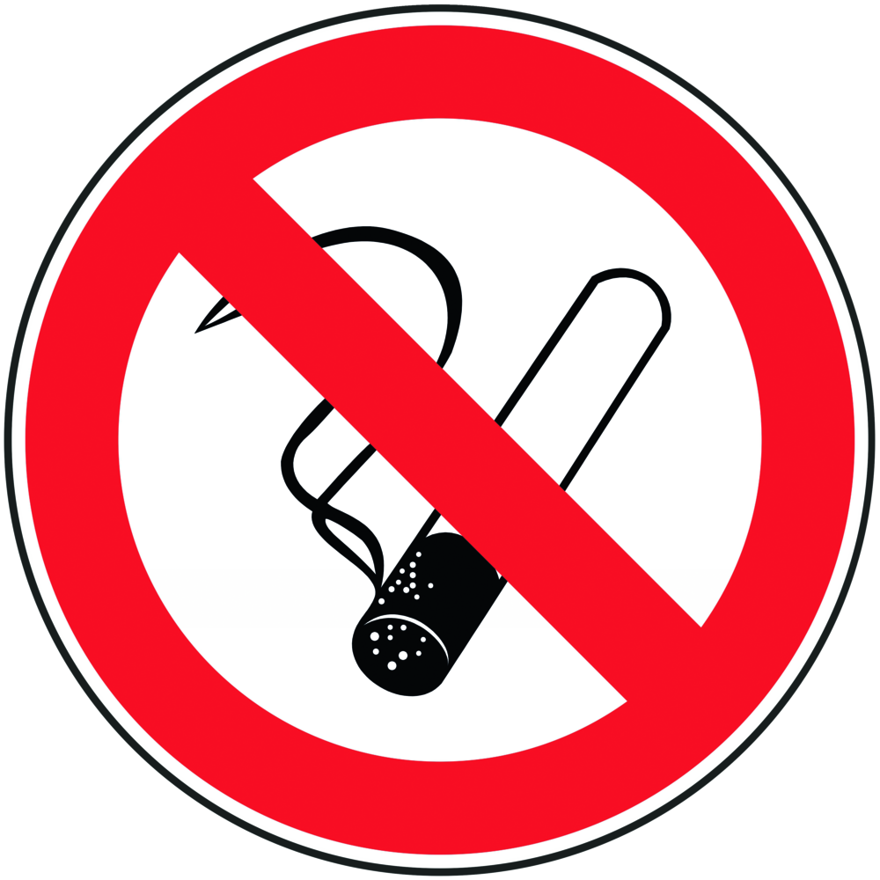 |  | General information  - Eating, drinking or smoking is prohibited in all laboratory facilities!  Personal protective measures |  |  |  | - pE
Put on protective clothing: lab coat, disposable gloves, safety goggles

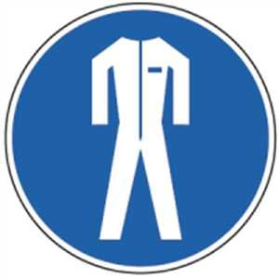

Behavior rules

- Install microwaves vibration-free.
- Only use the microwave oven as intended.
- Only operate the microwave oven if the door seal is clean and undamaged - danger
the emission of electromagnetic radiation!
- Use only suitable laboratory glassware and no closed containers.
- Do not introduce metal objects into the microwave
- Remove heated vessels from the microwave using a hot-hand or thermo-glove only.
- Observe the operating instructions of the manufacturer.
- Do not heat food in the microwave.
- Do not heat solvents or flammable substances in the microwave.
- Do not heat unknown substances in the microwave.
- Heat only small quantities in the microwave.
- Adjust heating capacity and duration to the substance to be heated
- Before using the microwave, inform yourself about it, whether when heating your substance
- Dangers can arise that you did not consider before.

Faults and dangers
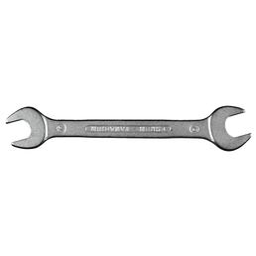 |  | - In the event of visible damage, do not operate the device.  - Damage to the door is damaged if the door seals are damaged  - Electromagnetic radiation can not be ruled out, therefore a microwave oven is allowed  not be used with damaged door seals.  - In the event of faults, pull out the mains plug and inform the responsible supervisor if possible.  - Repair and repair exclusively by a specialist workshop  Have customer service carried out.

Accidents and First Aid
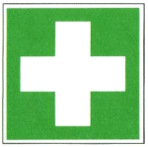 |  | First Aider: Pay attention to self-protection!  - If necessary, alert first responder, ambulance or doctor.  - In case of burns / scalds, cool with water (at least 10 min.). Face and Do not leave the eyes burned. If necessary, arrange for medical treatment.  - Inform supervisors.

Tests – Maintenance - Disposal
- Maintenance and repair work may only be carried out with the permission of the group leader
be performed.
- Repair and repair only by a specialist workshop / customer service let carry out.
- Disposal via waste collection points or specialist dealers.

Signatures
Supervisor: Signature:

Town: Date:

