 |  |  | Operating instructions | 

Work equipment – Equipment – Apparatus - Device
Microtome

Dangers for humans and the environment
  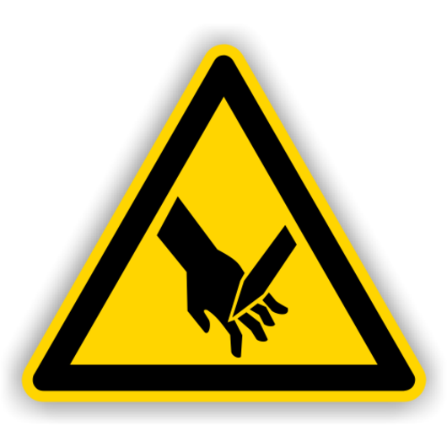  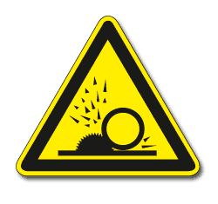 | - To be used only by trained persons  - Risk of cuts  - Danger from splintering objects

Protective measures and rules of conduct
 |  | General information  - Storage: in designated box with foam material, protection device and blade carriage lock must be noted  - The protective device must be closed at all times, unless the device is in immediate operation  - The blade carriage must be locked when the device is out of service  - For transport, the safety device must be locked and the blade carriage locked - otherwise there is a risk of injury  - The appliance must always be operated on the rubber pad  - Operation only according to the manufacturer's manual  - For blade replacement instructions, refer to the manufacturer's manual  - Special care is required when changing the blades  - Attention when using razor blades, especially when breaking the razor blades before blade replacement, only break at a predetermined point  - Attention when adjusting the razor blades  - Blades that are not used must be stored in a safe place  - Only dispose of blades in a suitable container  - Touch blades only to change and adjust  - Blurred blades should not be resharpened  - Do not cut too thick sample material  - Make only microscopically thin sections  - The micrometer screw must never be over-tightened  - The device may only be disassembled by knowledgeable persons into smaller parts  clean work  Personal protective measures  - Safety goggles |  |  |  | - pE
Use

- For making microscopic sections of woody or unmanufactured biological sample material
- Clamp the sample material in the holder and secure it with the screw (ATTENTION: Protective devices must be closed!)
- Adjust the distance to the blade with a micrometer screw so that only thin sections are cut
- Release the latch of the blade carriage
- Remove the guard from the blade
- Move the blade carriage towards the sample and gently slide the blade through the sample
- Remove the resulting thin section from the blade
- Move back the blade carriage
- Turn the micrometer screw clockwise to the desired thickness - each line on the micrometer gauge corresponds to 10μm
- Make a new cut
- After use, secure, package and transport as described above

Recommended approach (research group internal recommendation)

- Small and thin samples must be clamped and cut with the help of elderberry
- Use razor blades instead of cutter blades for thin specimens
- Blades can be used from both sides
- To remove the cuts, a moistened brush, a dissecting needle or a commercially available toothpick is recommended
- For detailed description, refer to the manufacturer's operating instructions

Faults and dangers
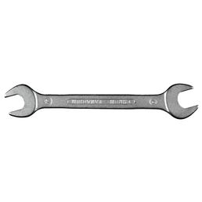 |  | - Risk of injury if the protective device is not closed  - Danger of injury if the blade carriage is not locked  - Risk of injury when replacing the blades  - Only qualified persons are allowed to carry out modifications and repairs on the device

Accidents and First Aid
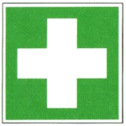 |  | - Rinse out an open wound, allow it to bleed as far as possible and immediately spray with disinfectant, if necessary top up the disinfectant and leave it to act for at least 30 minutes  - If necessary, alert first responder, ambulance or doctor. Inform supervisor (if necessary entry in the association book)

Tests – Maintenance - Disposal
- Maintenance and repair work may only be carried out with the written permission of the laboratory manager.
- Only spare parts that have the same material and design as the original parts may be used for maintenance
- Observe the manufacturer's repair and maintenance instructions

Signatures
Supervisor: Signature:

Town: Date:

