 |  |  | Operating instructions | 

Work - Equipment - Apparatus -Device
Methanole

Dangers for humans and the environment
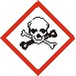  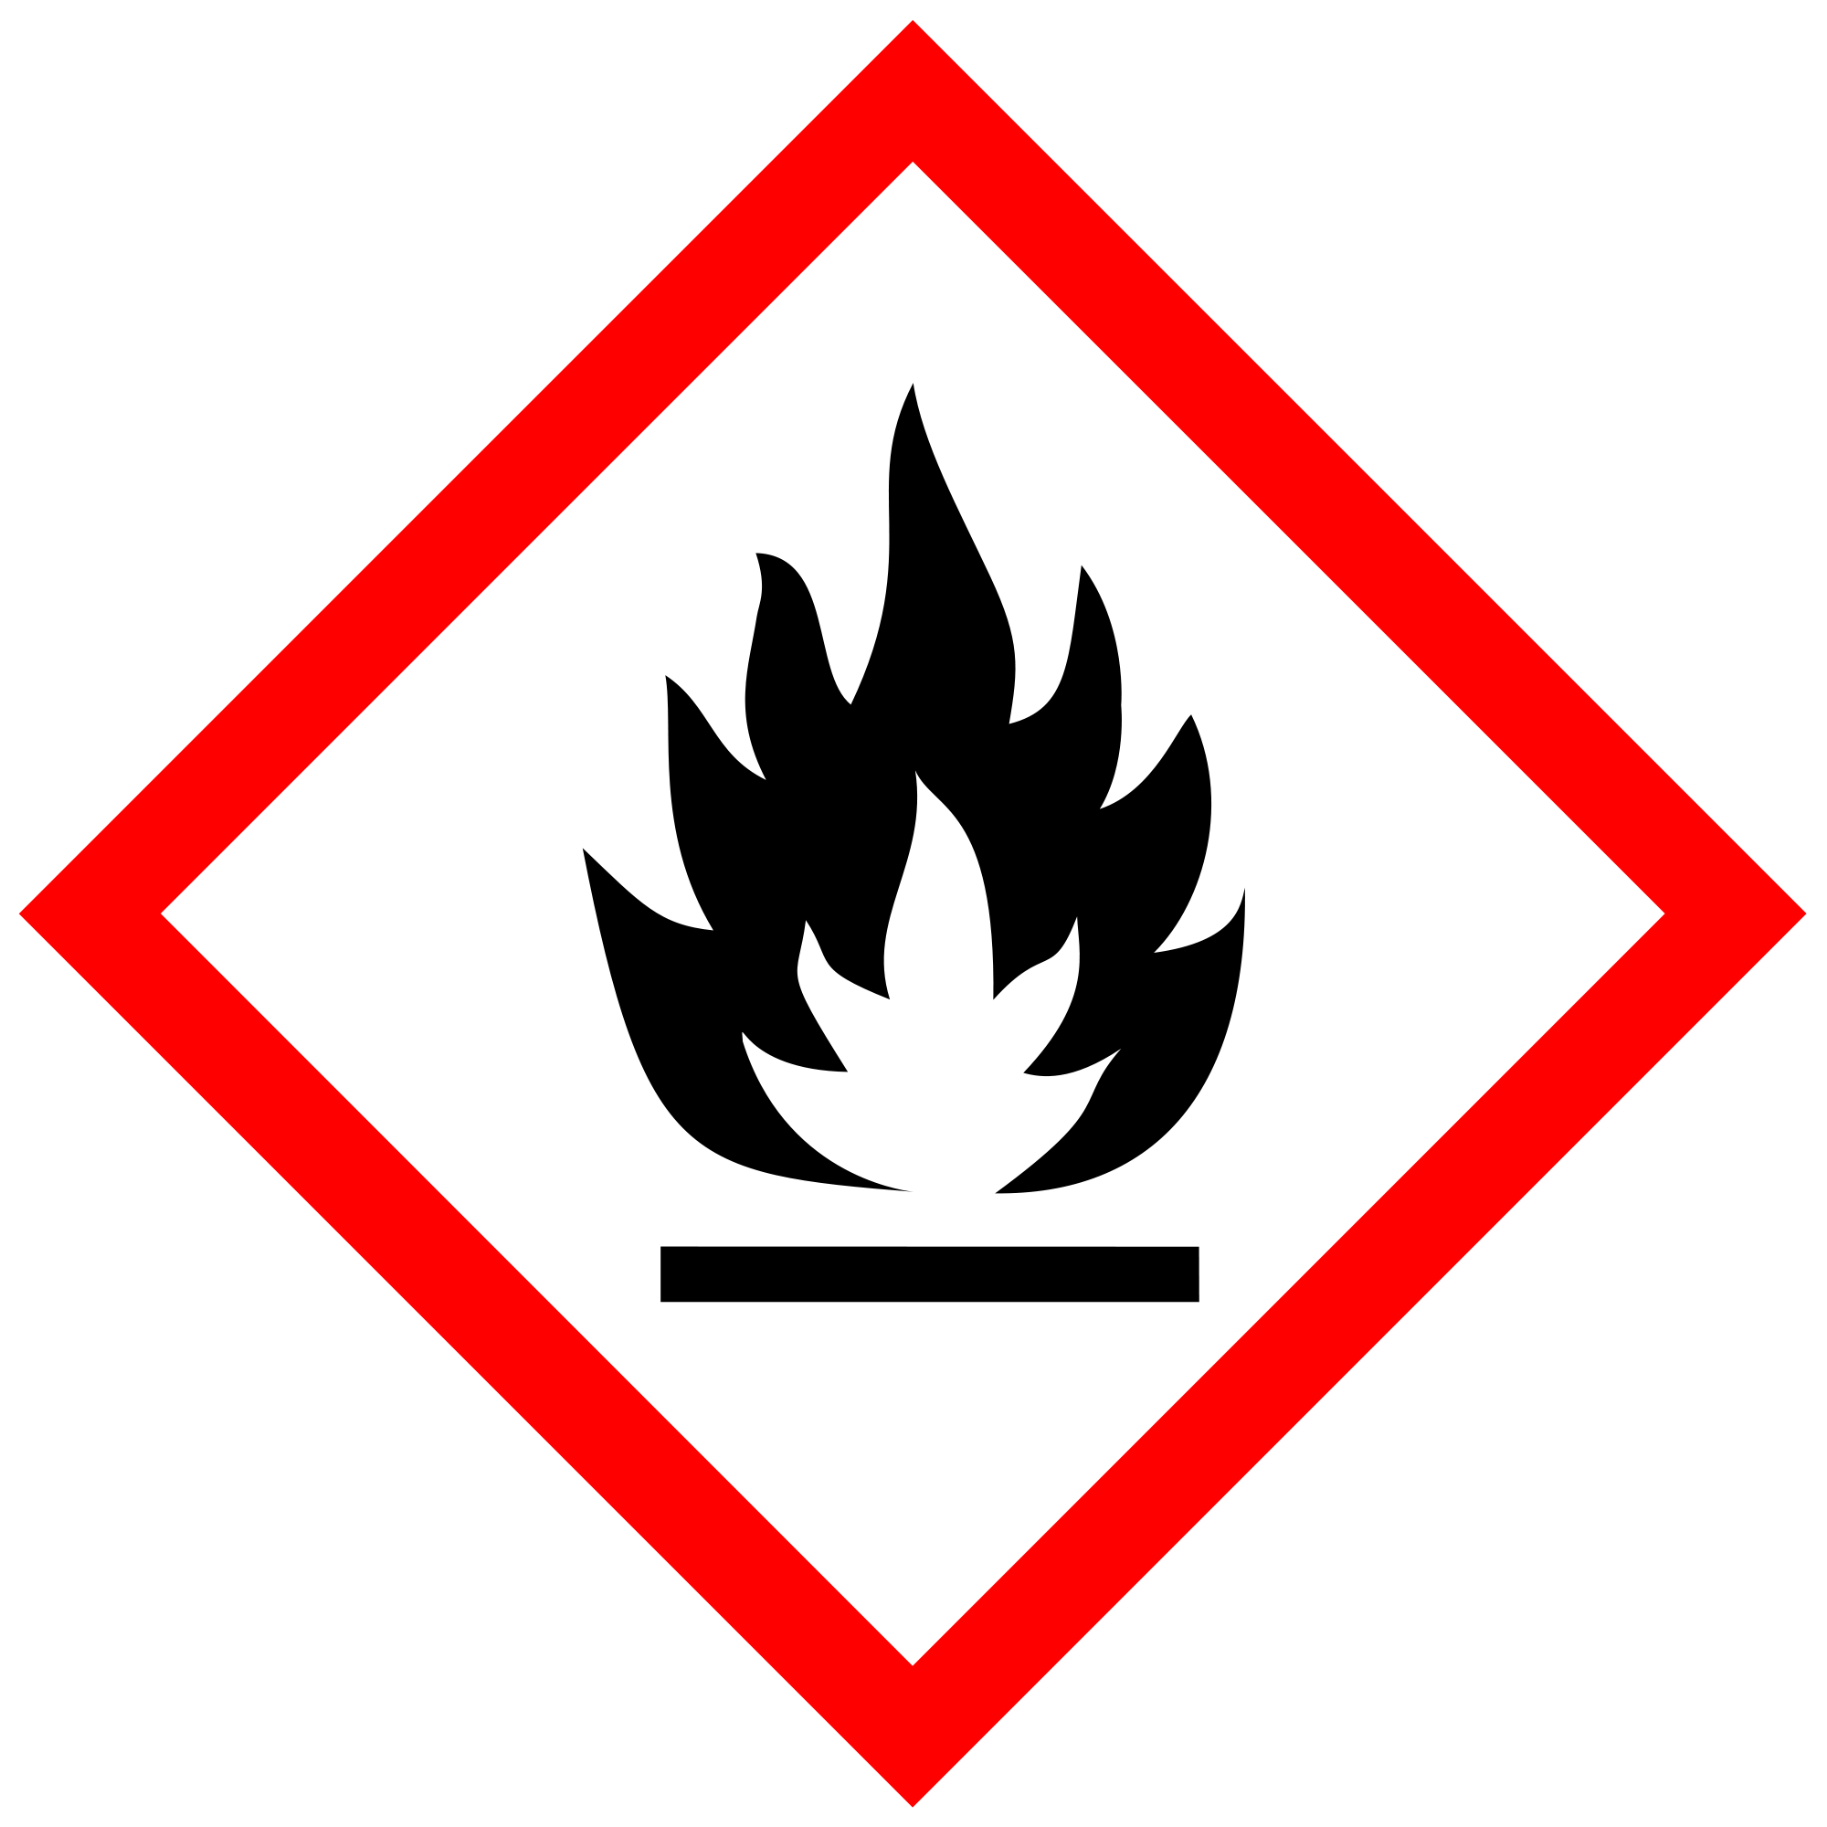  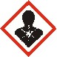 |  | Observe information of the safety data sheets  Signal word Danger  Hazard statements (H-phrases)  H225 Highly flammable liquid and vapor.  H301 Toxic if swallowed.  H311 Toxic in contact with skin.  H331 Toxic if inhaled.  H370 Causes damage to organs.  Safety instructions (P-phrases)  P210 Keep away from heat / sparks / open flames / hot surfaces. Do not smoke  P260 Do not breathe dust / fume / gas / mist / vapors / spray.  P280 Wear protective gloves / protective clothing.  P301 + P310 IF SWALLOWED: Immediately call a POISON CENTER or doctor / physician.  P311 Call a POISON CENTER or doctor.

Protective measures and rules of conduct
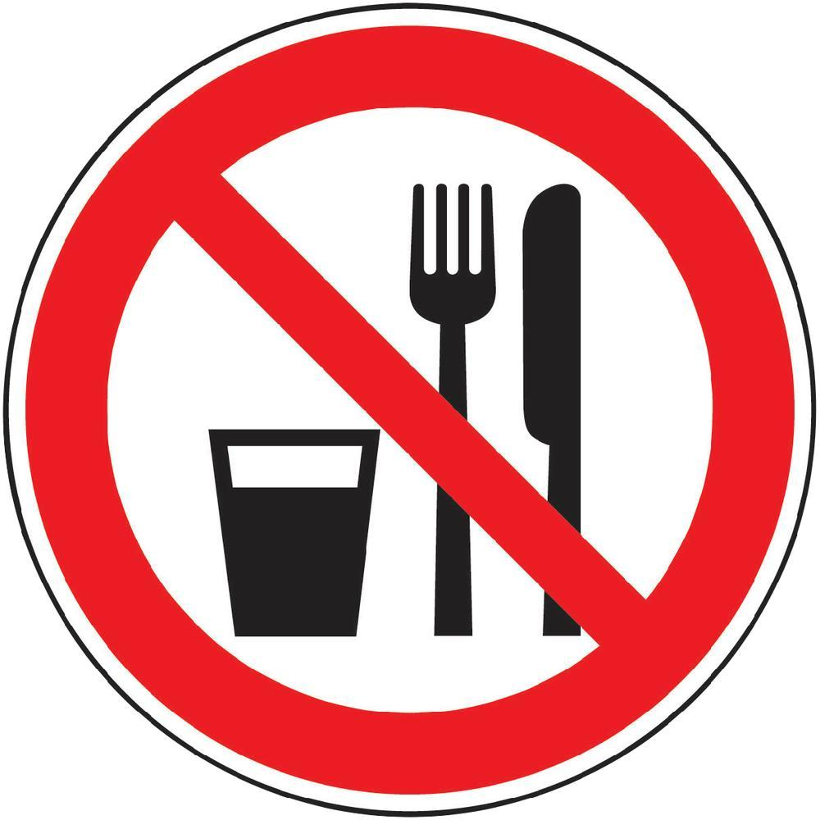  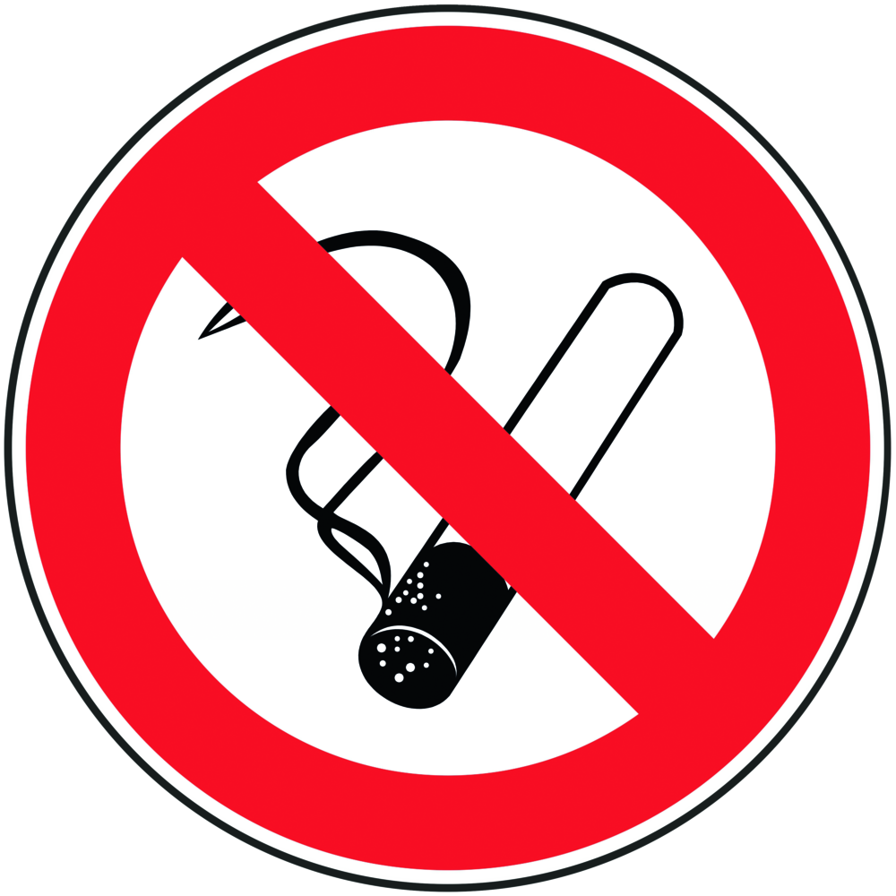 | General information  Eating, drinking or smoking is prohibited in all laboratory facilities!  Avoid contact with eyes and skin.  Open fire is strictly prohibited. Avoid open flames or sparks!  Avoid electrostatic charging!  Personal protective measures |  |  |  |  | - pE
Avoid contact with skin, eyes and clothes.

Wash hands before breaks and immediately after handling the product.
Eye / face protection
Face shield and goggles.
Skin protection
Working with gloves. Gloves must be examined before use.
Use a suitable extraction method (without the outer glove surface
to avoid skin contact with this product).
Full contact
Material: butyl rubber
Minimum layer thickness: 0.3 mm, Breakthrough time: 480 min


Splash contact
Material: nitrile rubber
Minimum layer thickness: 0.4 mm
Body protection
The type of protective equipment must vary depending on the concentration
and amount of dangerous material be selected in the workplace.
During laboratory work, always wear a laboratory coat.
Respiratory protection
Work under the deduction !!
If, according to the hazard assessment, an air-purifying respiratory protection is required, a half mask filter class ABEK (as included in the MUI emergency kit) must be used in addition to the technical measures.

Use and storage
Store locked in a cool place. Store away from oxidizing materials.
Keep container tightly closed in a dry, well-ventilated place. Opened containers
Close carefully and store upright to prevent leakage.

Transfer and transport
The transport of liquids in bottles (from about 200 ml) must be done with the aid of a carrying basket.
When refilling, pay attention to appropriate protective equipment! Work under the trigger!

Disruptions and Dangers
 | In case of fire:  Suitable extinguishing agents:  Use water spray, alcohol-resistant foam, dry chemical or carbon dioxide.  Special hazards arising from the substance or mixture Carbon oxides  Advice for firefighters:  In case of fire, wear self-contained breathing apparatus, if necessary.  If spilled:  Collect the spilled material with a spark-proof vacuum cleaner or sweep up and place in containers for disposal in accordance with local legislation.  Environmental precautions  Prevent further leakage or spillage if safe to do so. Do not empty into drains

Accidents and First Aid
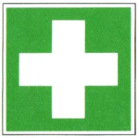 | General information  Consult a doctor. Show this safety data sheet to the attending physician.  After inhalation  If inhaled, remove affected person to fresh air. In respiratory arrest, artificial respiration. Consult a doctor.  After skin contact  Wash with soap and a lot of water. Immediately take the patient to a hospital.  Consult a doctor.  After eye contact  Rinse thoroughly with plenty of water for at least 15 minutes and consult a doctor.  After swallowing  DO NOT induce vomiting. Never give anything by mouth to an unconscious person  Infuse. Rinse mouth with water. Consult a doctor.

Tests - Maintenance - Disposal
Disposal via the chemicals logistics. Observe the corresponding marking!
Do not allow solvent to enter the wastewater. Dispose of leftovers and waste in a properly labeled container in accordance with the Chemicals Waste Disposal Regulations.

Signatures
Supervisor: Signature:

Town: Date:

