 |  |  | Operating instructions | 

Work equipment – Equipment – Apparatus - Device
Metall Punch

Dangers for humans and the environment
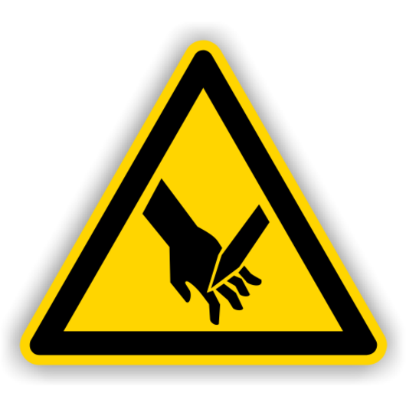 | - When setting up, operating and eliminating faults, there is a particular risk of injuries due to dangerous movements as well as electrical, hydraulic and pneumatic components of the punches and their additional equipment.  - There is also a risk when handling and transporting coil material and fixed strips as well as their grid strips or waste pieces.  - Further hazards are sharp-edged or pointed components, waste slugs that are not necessarily removed or tool splinters when the tool breaks.  - There is also a risk to health from noise.
Protective measures and rules of conduct
 |  | - When setting up the press and troubleshooting the tool  - Clear the press tables and remove all objects, tools and the like that are not directly needed for setting them out of the vicinity of the punch.  - Remove coil or strip material or its remnants from the tool. Push ram into bottom dead center.  - Install and remove tool. Pay particular attention to installation height and stroke. (These values ​​are indicated on the tool.)  - Fasten the tool to the ram with suitable clamping devices.  - Fasten lower tool with suitable clamping devices and screws "light". Pay special attention to the fact that there are no crushing and shearing points on the plunger, upper tool and clamping elements.  - Move plunger to top dead center. Firmly clamp the lower tool.  - drive test carriage.  - Activate protective devices on the tool, punching machine and, if applicable, automation device, set the intended operating mode using the selector switch. Then check all protective measures for effectiveness. |  |  |  | - pE

Faults and dangers
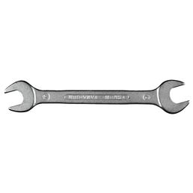 |  | - When setting up the press and troubleshooting the tool  - Clear the press tables and remove all objects, tools and the like that are not directly needed for setting them out of the vicinity of the punch.  - Remove coil or strip material or its remnants from the tool. Push ram into bottom dead  center.  - Disconnect the device from the circuit.  - Inform the responsible person immediately  - The device must be withdrawn from use until the fault has been eliminated

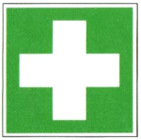
Accidents and First Aid
- Keep Calm.
- Involve first responders.
- Emergency call: 144
- Report accident and fill out accident report

Tests – Maintenance - Disposal
- Inform the workshop personnel of any defects in the machine immediately.
- Faults and damage to the machine may only be eliminated by authorized and qualified persons.
- Clean the machine at the end of work.
Signatures
Supervisor: Signature:

Town: Date:

