 |  |  | Operating instructions | 

Work equipment – Equipment – Apparatus - Device
Magnetic stirrer with heating plate

Dangers for humans and the environment
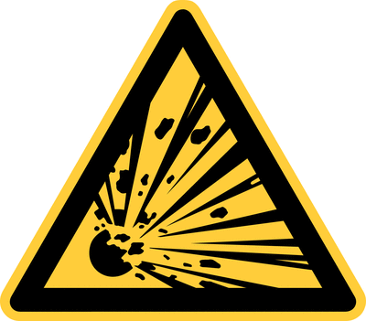  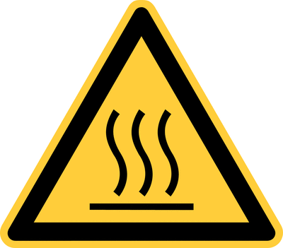  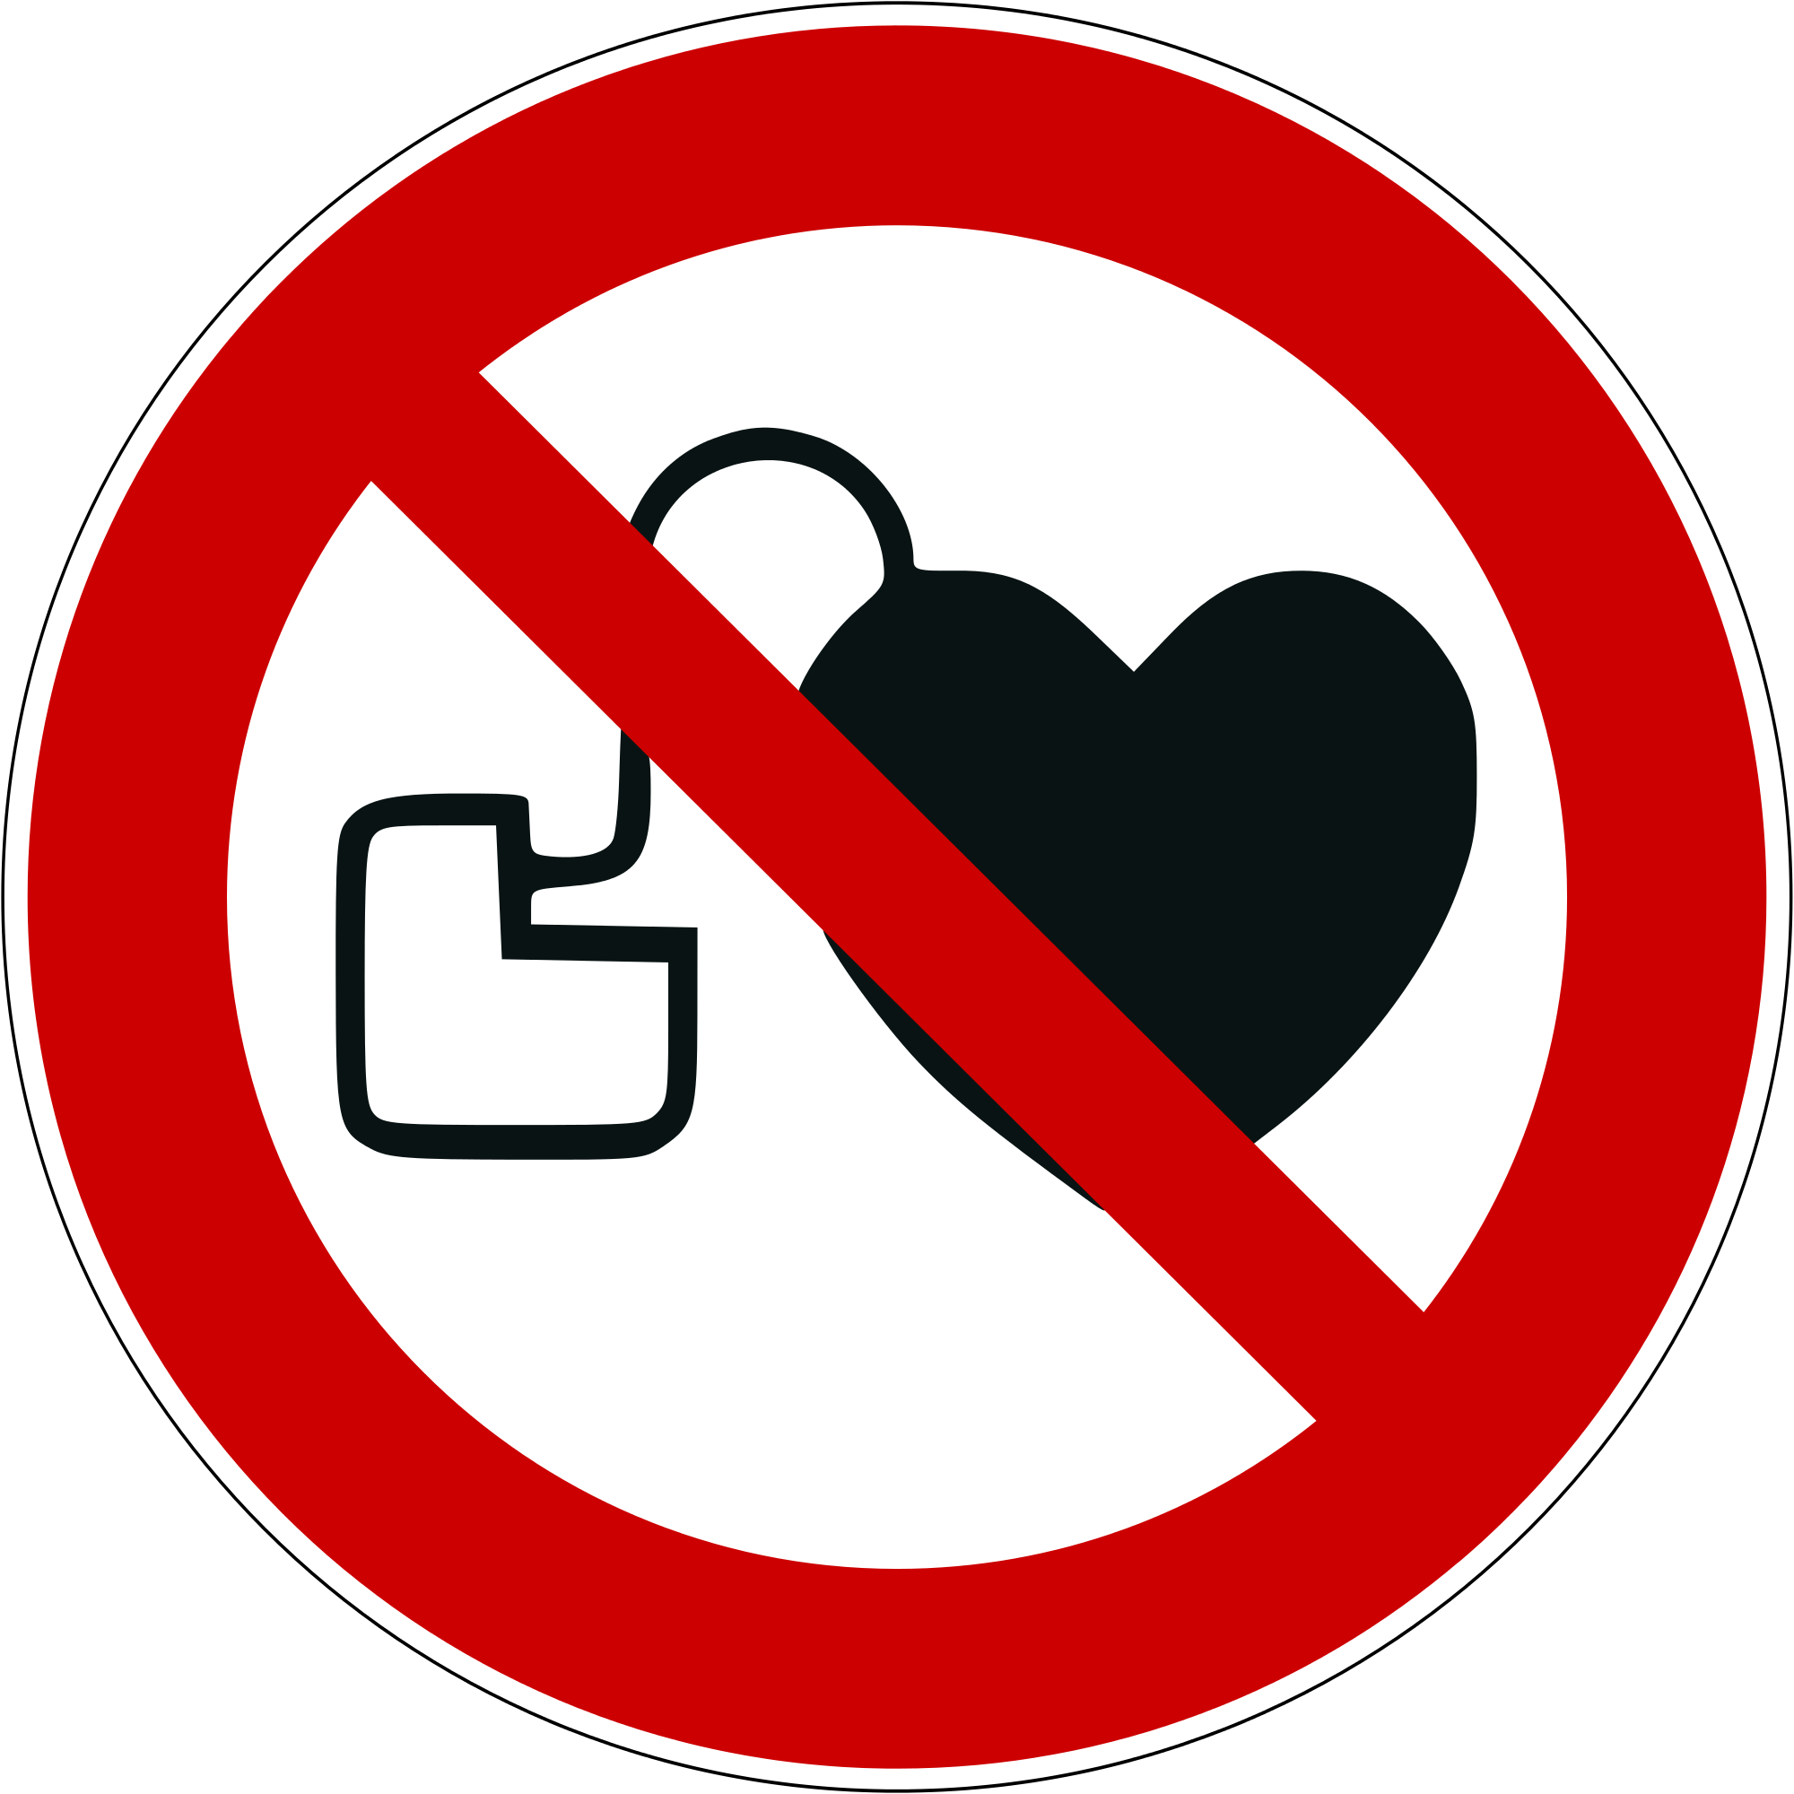 | - The general rules and dangers for handling electrical equipment apply (see relevant operating instructions).  - Dangers that are directly caused by the chemicals used are to be looked up in the respective safety data sheets or operating instructions for the chemical and method.  - Danger of burning on hot surfaces (hotplate may get over 300 ° C hot).  - Caution: Magnetism! Effects of the magnetic field are to be considered (pacemaker).  - Risk of electric shock.

Protective measures and rules of conduct
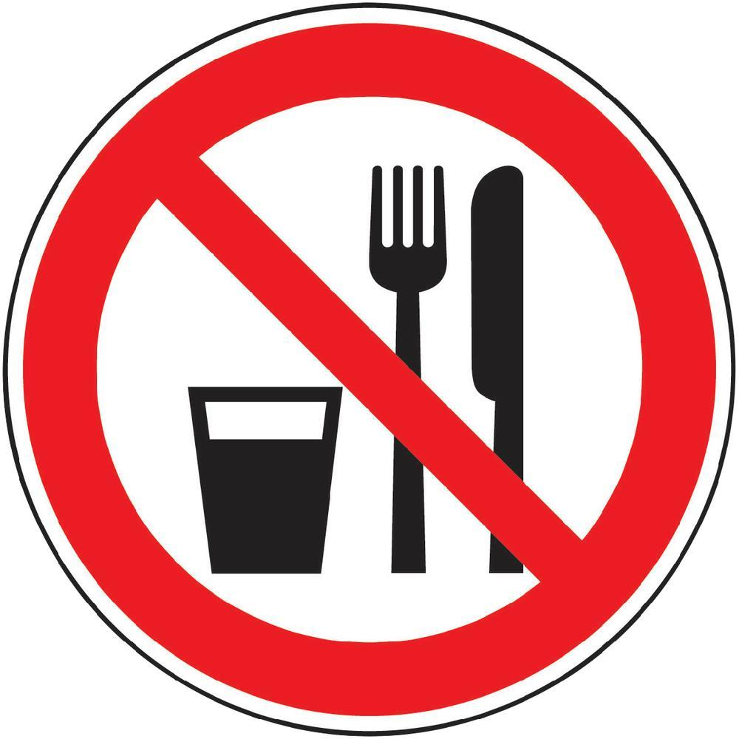  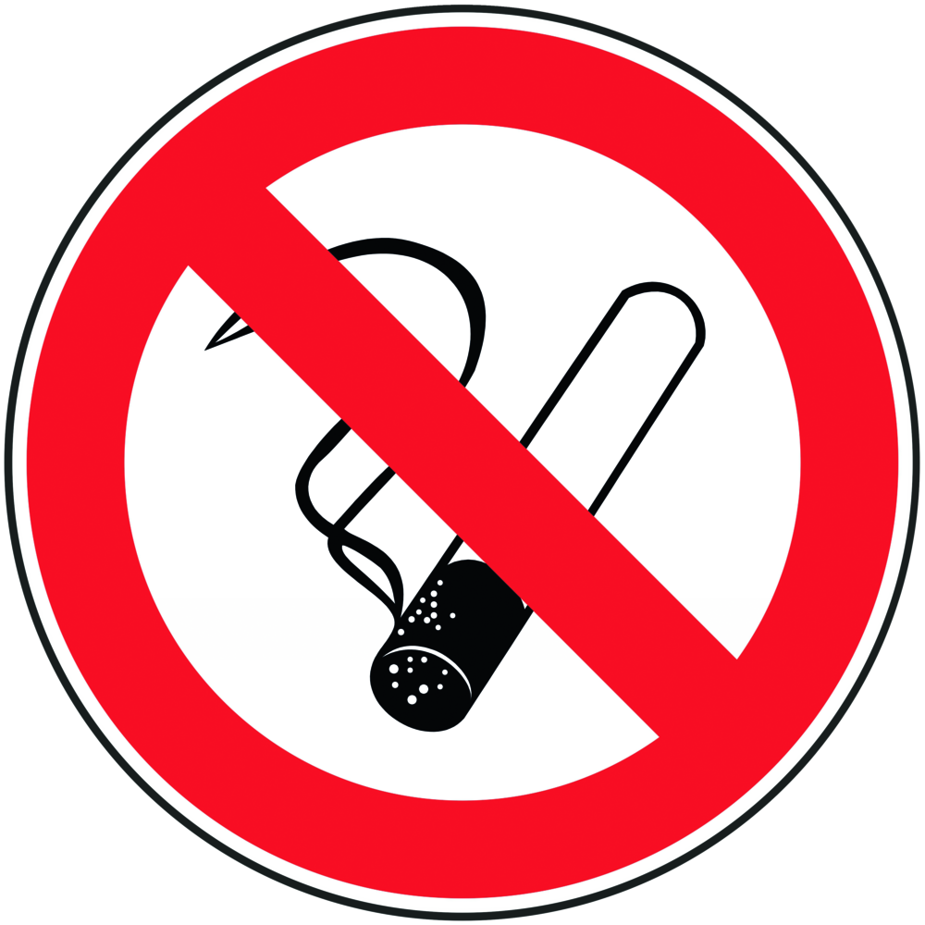 |  | General information  Eating, drinking or smoking is prohibited in all laboratory facilities!  Personal protective measures |  |  |  | - pE
• Put on protective clothing: lab coat, if necessary gloves and safety goggles
• Remove warmed liquids with thermal gloves.

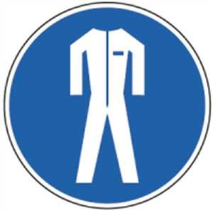

Use
• Before putting the device into operation, switch off the magnetic stirrer function
(set the rotary speed control knob to the left-hand stop), do not start stirring until the
stirrer with liquid and magnetic stirrer is already on the stirrer plate.
- Keep the mains cable away from the heating plate!
- Transport of the device only in the switched off and cooled state.

Faults and dangers
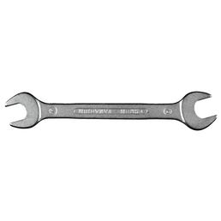 |  | - In the event of visible damage, do not operate the device.  - If faulty, unplug the power cord and inform the responsible manager.  - Repair and repair only by a specialist workshop  Have customer service carried out.

Accidents and First Aid
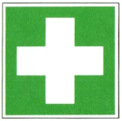 |  | First Aider: Pay attention to self - protection!  - If necessary, alert first responder, ambulance or doctor.  - Still burns for at least 10 minutes (running lukewarm water). If necessary, seek medical treatment.  - Inform the supervisor.

Tests – Maintenance - Disposal
- Maintenance and repair work may only be carried out with the permission of the group leader.
- Have repaired and repaired exclusively by a specialist workshop / customer service.
- Disposal via old material collection points or specialist dealers.

Signatures
Supervisor: Signature:

Town: Date:

