 |  |  | Operating instructions | 

Work - Equipment - Apparatus -Device
Liquid nitrogen (cryogenic)

Dangers for humans and the environment
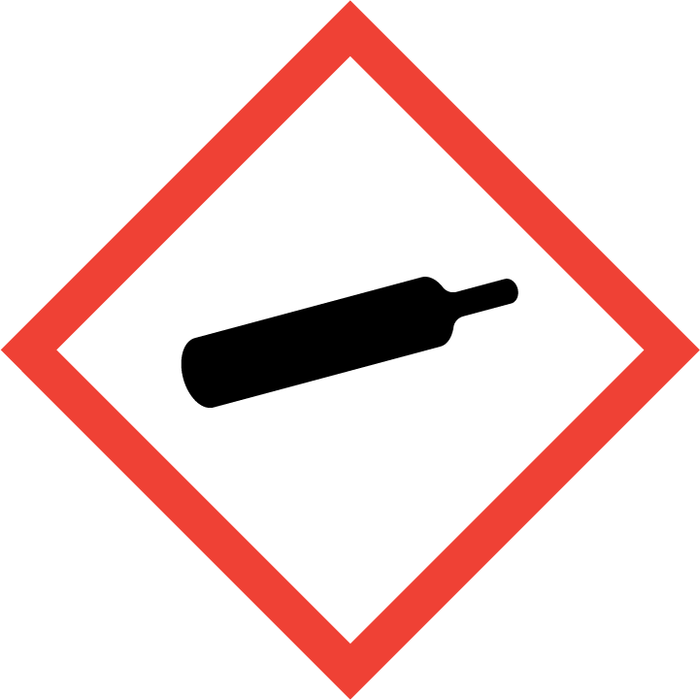  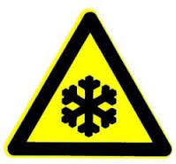  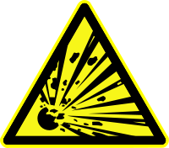 | Signal word: Attention!  Hazard statements (H-phrases)  H281: Contains cryogenic gas; can cause cold burns or injuries.  Suffocating in high concentrations.  Safety instructions (P-phrases)  P282: Wear protective gloves / face shield / eye protection with cold insulation.  P336 + P315: Thaw frozen areas of skin with lukewarm water. Do not rub affected area. Seek medical advice / medical attention immediately.  P403: Store in a well-ventilated place.  Contact with the fluid causes frostbite and serious eye damage. Vaporizing leads to accumulation in the air and thus suffocation (drowsiness, malaise, rise in blood pressure, respiratory distress)  • Leaky liquid forms cold mist in large quantities  • In open vessels atmospheric oxygen can condense (light blue color); liquid oxygen  forms explosive mixtures with organic substances (!)  • Vapors are heavier than air! Risk of accumulation in closed rooms and lower areas!  • Materials can become brittle or break due to the low temperature! When material bursts,  there is a general risk of splintering.

Protective measures and rules of conduct
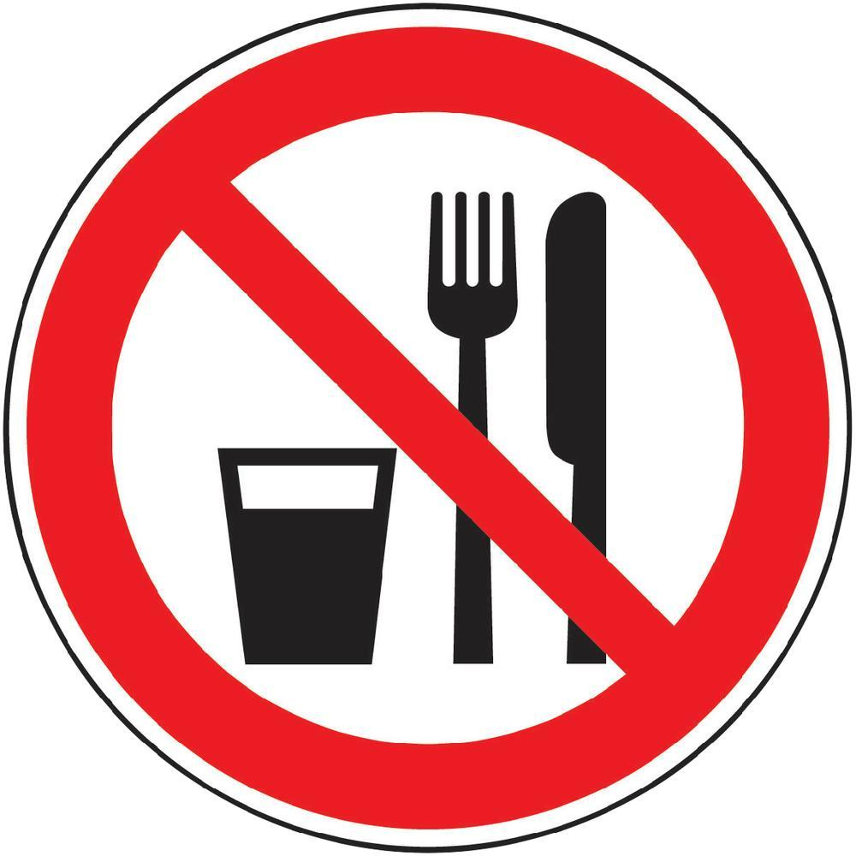  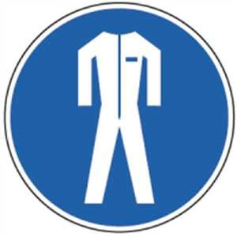  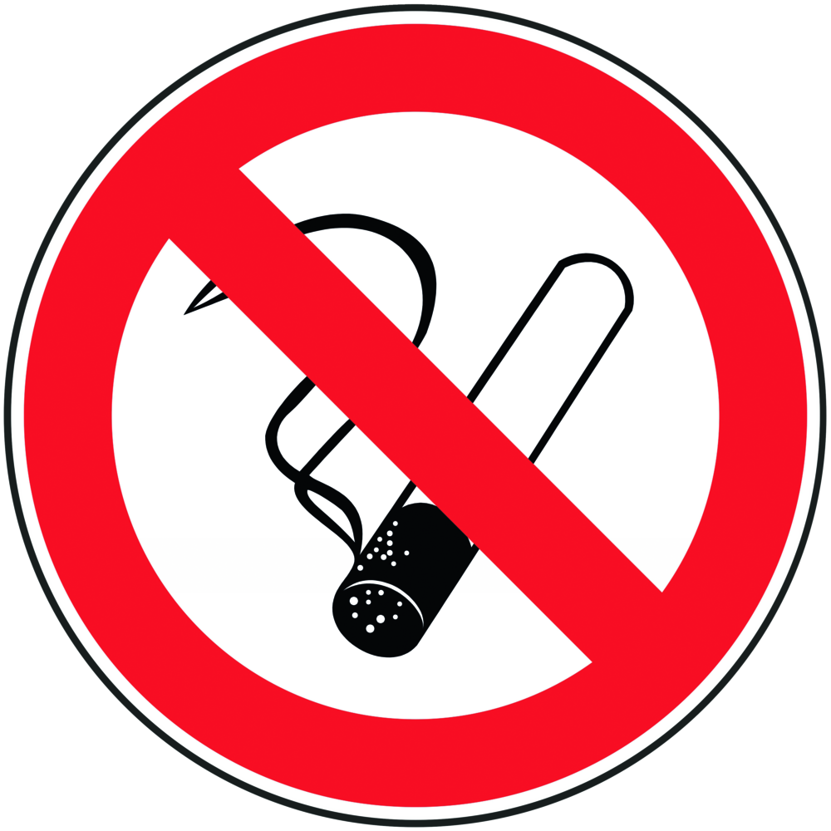 |  | General information  Cryogenic liquefied gas. Contact with the product (s) may cause cold burns or frostbite.  May be as toxic in high concentrations.  Eating, drinking or smoking is prohibited in all laboratory facilities!  Avoid contact with eyes and skin. There is a particular danger when liquid nitrogen touches materials with high thermal conductivity (eg. ring on the finger). Here is a significant risk of frostbite!  When transferring, ensure good ventilation! (i.e. door always read open)  Do not inhale gases / vapors!  Personal protective measures  Wear closed safety goggles (goggles)!  If there is a risk of splashing, use a face shield.  Protective Gloves (Cryogloves) intended for liquid nitrogen - never wear gloves of  absorbent material!  Wear closed shoes!  During laboratory work, always wear a laboratory coat. |  |  |  | - pE
.



Use and storage
Never leave vessels with liquefied nitrogen open!
Secure container against overturning!
Only fill containers with pressure!
Storage and transport only in suitable containers (Dewar containers) with pressure equalization
openings or overpressure protection
Keep container closed but not pressure tight, avoid spilling.
No plastic containers use cold embrittlement and danger of breakage.
Only use materials suitable for low temperatures (eg copper, austenitic steels)!

Recommended procedure (research group internal recommendation)
When removing liquid nitrogen from storage dewars in refrigerator compartment 010 and in any activity using liquid nitrogen, wear goggles (closed goggles), appropriate gloves, closed shoes and a lab coat. The door of the cold room must remain open during refilling. In all activities with liquid nitrogen, ensure good ventilation. Use Safe Lid Reaction Vessels. Before using with liquid nitrogen, check that all used items are suitable for use with liquid nitrogen.

Transfer and transport
When transferring, ensure good ventilation! (for example, doors always open).
Transport only in suitable containers (Dewar containers) with pressure equalization openings or overpressure protection.
Containers with liquefied nitrogen may only be transported in elevators under consideration of the load limits and only without persons!

Disruptions and Dangers
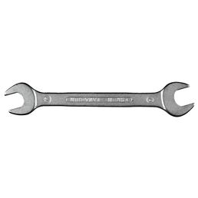 |  | In case of fire:  In case of fire, select extinguishing measures for surroundings.  Cool containers of liquid nitrogen with water spray and, if possible, remove them from the danger zone.  If spilled:  In case of spontaneous release of larger quantities, immediately leave the danger zone; open windows if possible.  Fire brigade to indicate the presence of liquid nitrogen (pressure increase and danger of bursting when heating the storage container).

Accidents and First Aid
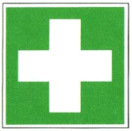 |  | Clothing and shoes that have been infiltrated with liquid nitrogen immediately  take off!  After skin contact: Treat as burn or frostbite. Do not rub but  cover with sterile dressing.  Eye contact: Immediately flush eyes with water for at least 15 minutes.  After inhalation: High concentrations may cause suffocation. The victim notices  Do not suffocate. The injured person should be taken to fresh air using a self-contained breathing apparatus. Keep warm and calm, consult a doctor. In respiratory arrest, artificial respiration.  After contact with clothing: Immediately remove soaked clothing and allow to air dry.

Tests - Maintenance - Disposal
Do not pour into wastewater (risk of damage to the pipe). Let residues of liquid nitrogen evaporate outdoors.

Signatures
Supervisor: Signature:

Town: Date:

