 |  |  | Operating instructions | 

Work equipment – Equipment – Apparatus - Device
Lever Shears

Dangers for humans and the environment
 |  | - Risk of impact from unconfirmed hand lever  - Squeezing / separating fingers or hands  - when accessing the unclothed cutting line,  - by the movement of the stops,  - by the movement of the sheet.  - Noise from falling cuts

Protective measures and rules of conduct
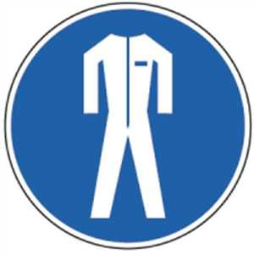  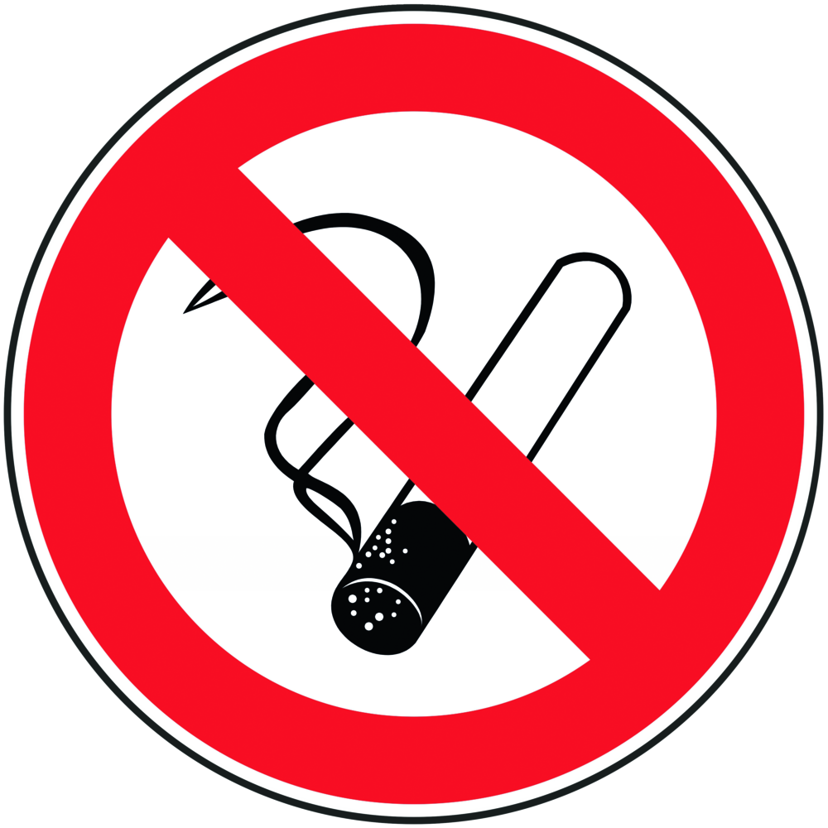   | - Start work on the lever shears only after successful instruction and approval by  the supervising teacher.  - Adjust the hold down to the material thickness.  - Only process the material thicknesses for which the cutting tools are designed.  - Transport and processing of metal sheets only with the appropriate means  (Sheet metal transport clamps, protective gloves, safety shoes).  - The cutting line must be well lit and not covered.  - To combat noise, technical measures should be used, e.g. Use of slides that reduce the height of fall. |  |  |  |  | - pE

Faults and dangers
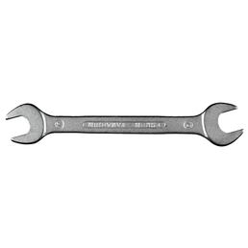 | - In case of damage to the device: Shut down the device and inform responsible persons.  - In the event of breakage, jamming or other abnormalities, the lever scissors must not be used.  - Have the damage repaired by a specialist.

Accidents and First Aid
 | - Keep Calm  - Involve first responders  - Emergency call: 144  - Report accident and fill out accident report.

Tests – Maintenance - Disposal
- Repairs:
Repairs may only be arranged by the responsible teacher.
A repair has to be documented.
- Maintenance:
The maintenance intervals can be found in the manufacturer's operating instructions.
A performed maintenance is to be documented.
- Disposal:
- After completing the shearing work, dispose of any leftovers in the marked collection container

Signatures
Supervisor: Signature:

Town: Date:

