 |  |  | Operating instructions | 

Work - Equipment - Facility – Device
Label Coat, Laboratory Smock

Protection goals
 |  | Laboratory coats are standard equipment in every laboratory.  Recommended are at least knee-length lab coats with long, tight-fitting sleeves  with a cotton content in the fabric of at least 35 percent.  Laboratory coats should protect against contamination with hazardous substances and soiling of one's own clothing or skin.

Use and rules of Conduct
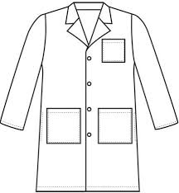   | - The lab coat must be taken off the laboratory and left at the intended place  Hang the hook next to the door - never place the lab coat on the bench.  - Before using the laboratory coat, it must be visually checked to ensure that it is intact, i.e. without holes or cracks.  - Lightly soiled lab coats are collected in the laundry room in a laundry basket and then washed by the cleaner and hung up to dry. The clean coats can be picked up in room  - Laboratory jackets that are heavily soiled and contaminated with hazardous substances must be disposed of properly. |  |  |  | pE

Behavior in case of defects
- Dispose of in case of heavy contamination / contamination with hazardous substances
- In case of holes, cracks or missing buttons, depending on the size of the defect,
- arrange repair
- Dispose of properly
- Replace non-comfortable lab coats
- Clean if dirty

Storage, cleaning and care
- When wearing the jacket, make sure it fits snugly and securely. Close all buttons.
Do not roll up sleeves.

Supervisor: Signature:

Town: Date:

