 |  |  | Operating instructions | 

Work - Equipment - Apparatus -Device
Hydrochloric acid smoking 37%

Dangers for humans and the environment
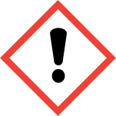  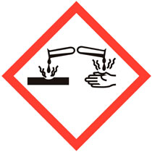 | Observe information of the safety data sheets  Signal word Danger!  Hazard statements (H-phrases)  H290 can be corrosive against Metal.  H314 Causes severe skin burns and eye damage.  H335 May cause respiratory irritation  Safety instructions (P-phrases)  P280 Wear protective gloves / protective clothing / eye protection for prevention.  P301 + P330 + P331 IF SWALLOWED: rinse mouth. DO NOT induce vomiting.  P305 + P351 + P338 IF IN EYES: Rinse cautiously with water for several minutes. Remove contact lenses, if possible. Continue rinsing.  P309 + P310 IF EXPOSED OR DISPOSED: Seek medical attention immediately.

Protective measures and rules of conduct
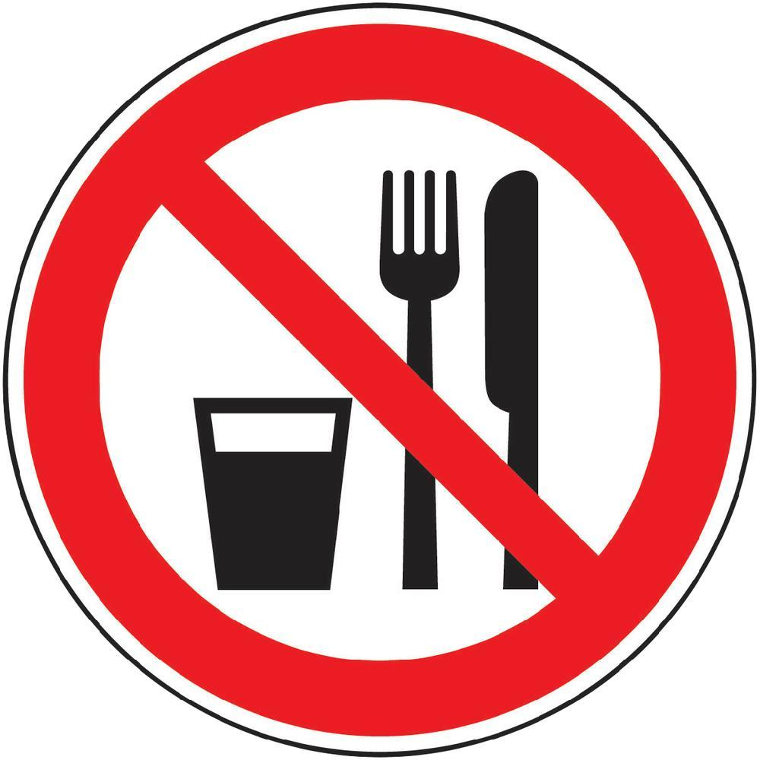  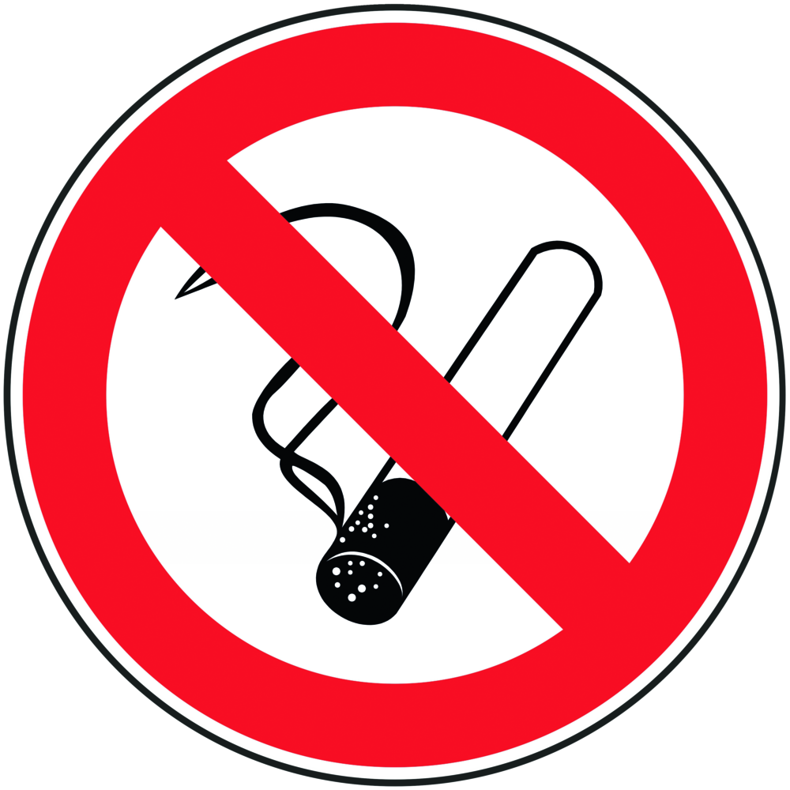 |  | General information  Eating, drinking or smoking is prohibited in all laboratory facilities!  Avoid contact with eyes and skin. |  |  |  | - pE
Personal protective measures
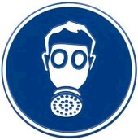
Eye protection: Tightly fitting safety goggles.
Hand protection: nitrile rubber; Thickness: 0.11mm
Body protection: Lab coat
Respiratory protection: Required if vapors and aerosols are generated.
Respiratory mask: Half mask filter class ABEK (as included in emergency kit MUI)
Only work in a fume hood!

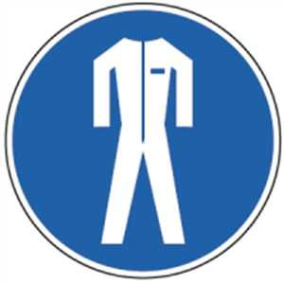

Use and storage
Use:
Only work in the trigger!
Change contaminated clothing immediately
Storage:
Do not store in metal containers.
Keep container tightly closed in a well-ventilated place.
Store at a temperature of + 2 ° C to + 25 ° C.

Transport
Transport of the chemical bottle in the safety bottle container.

Disruptions and Dangers
 |  | In case of fire:  There are no extinguishing agent restrictions for this substance.  Hydrochloric acid is not combustible.  After spilling: Do not breathe vapor / aerosol. Avoid substance contact. Ensure adequate ventilation. Soak up with chemical absorbent and have it disposed of by the university's chemical disposal facility. Purify with water.

Accidents and First Aid
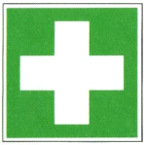 |  | First responders: pay attention to self-protection!  Symptoms may be delayed.  Remove any clothing contaminated with hydrochloric acid.  After inhalation: fresh air. Get a doctor.  After eye contact: Rinse thoroughly with plenty of water and seek medical advice immediately.  After skin contact: Wash off with plenty of water. Remove soiled, soaked clothing immediately. If available, dab with polyethylene glycol 400. See a doctor.  Ingestion: Drink water (maximum 2 drinking glasses), avoid vomiting  (Perforation). Call a doctor immediately. No neutralization experiments.  Most important symptoms and effects, both acute and delayed: Irritation and  Irritation and corrosion, coughing, dyspnoea, cardiovascular disorders,  Risk of blindness!

Tests - Maintenance - Disposal
Recycle empty containers and unusable TRIS by disposing of chemicals at the university.

Signatures
Supervisor: Signature:

Town: Date:

