 |  |  | Operating instructions | 

Work equipment – Equipment – Apparatus - Device
Hot Wire Cutter

Dangers for humans and the environment
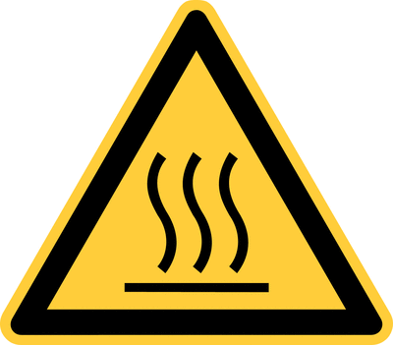  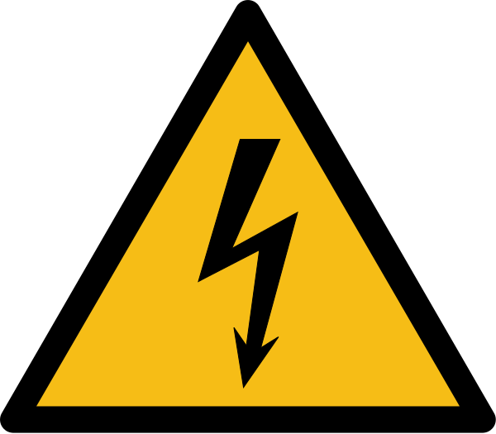  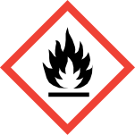 |  | - Risk of severe burns hot cutting wire  - Danger of electric shock due to defective cables  - Danger of fire development on contact of the hot wire with flammable materials or substances  - Risk of cuts due to hot wire  - Potential hazards that may arise from the material being processed when heated, must be read in the relevant safety data sheet or manufacturer's instructions before use.  - The general rules for the handling of electrical equipment apply (see relevant operating instructions)

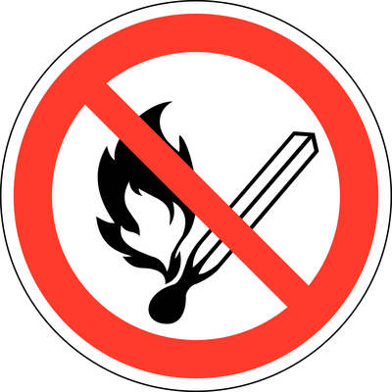
Protective measures and rules of conduct
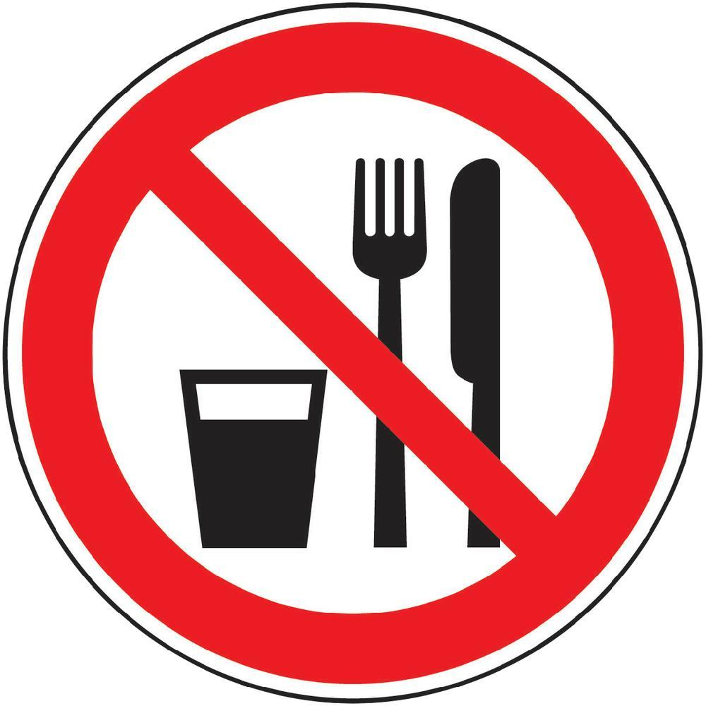  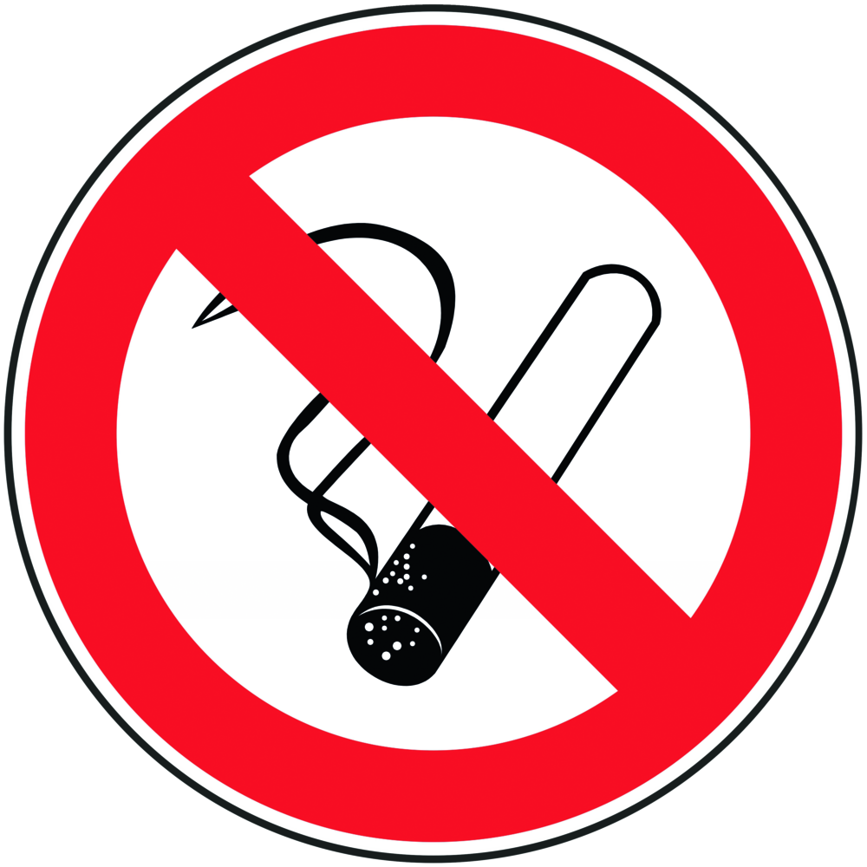 | General information  - An instruction in the operation of the Thermocut device is essential before use. Operating instructions of the manufacturer are available in the laboratory and are to be studied before use.  - The replacement of cutting wire must only be carried out by an authorized person.  - The safety instructions of the manufacturer of the material to be processed must be observed.  - The device must not be used in a wet or damp environment.  - Care must be taken to keep the device free of dust, sand and dirt.  - The device must not be operated unattended  - Ensure sufficient ventilation of the room during operation of the unit.  - No flammable or easily flammable or even explosive substances may be stored or exposed in the vicinity of the device.  - Malfunctions and damage to individual components of the system, in particular to the electrical insulation of live cables - must be reported immediately. The system may not be put into operation in this case.  - The general rules for the handling of electrical equipment apply (see relevant operating instructions).  - NEVER use defective cables  - NEVER pull on the connection cable but only on the plug to disconnect the device from the mains.  - The device may only be operated with mains voltage specified by the manufacturer (see the operating instructions of the device).  - Make sure that there is no water or other foreign objects in the device.  - It is strictly forbidden to eat, smoke or drink while the appliance is in operation  Personal protective measures  No personal protective equipment required unless recommended by the manufacturer of the material to be cut. |  |  |  |  | - pE

Faults and dangers
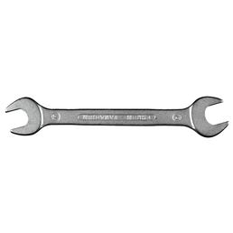 | - Risk of burs due to hot cutting wire when cleaning the device  - Danger of injury / risk of burns when replacing the cutting wire  - Only qualified persons may carry out modifications and repairs to the device

Accidents and First Aid
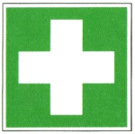 | - First Aider: Pay attention to self-protection!  - Rinse out an open wound, allow it to bleed as far as possible and spray it immediately with  - disinfectant, if necessary top up the disinfectant and leave it to act for at least 30 minutes.  - Cool burns  - If necessary, alert first responder, ambulance or doctor. Inform supervisor (if necessary entry in the association book).

Tests – Maintenance - Disposal
- Clean the appliance regularly after use (ATTENTION: switch off first and allow the wire to cool down!)
- If necessary, replace the cutting wire (ATTENTION: switch off first and allow the wire to cool down!)
- Follow the manufacturer's instructions
- Maintenance and repair work may only be carried out with the permission of the laboratory manager
- Only spare parts that have the same material and design as the original parts may be used for maintenance.
- Observe the manufacturer's repair and maintenance instructions.

Signatures
Supervisor: Signature:

Town: Date:

