 |  |  | Operating instructions | 

Work - Equipment - Apparatus -Device
Hexan

Dangers for humans and the environment
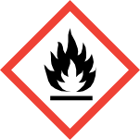  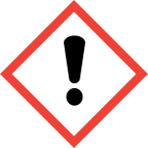  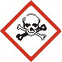  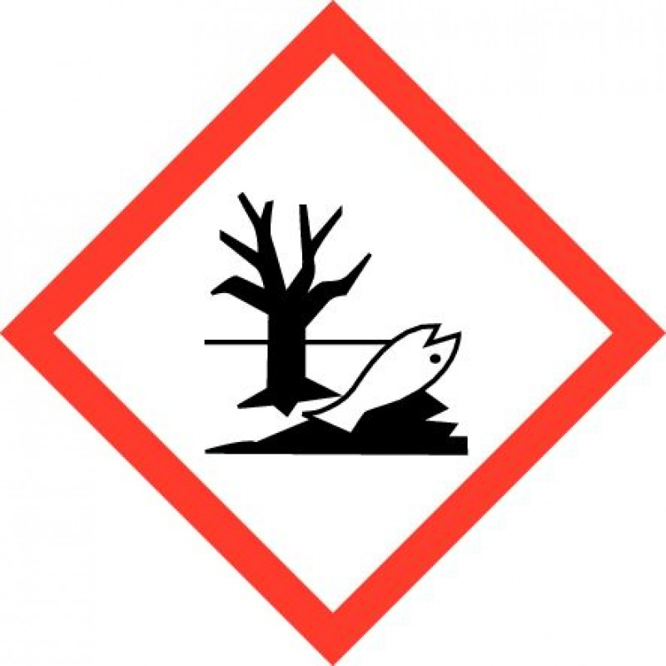  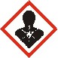 |  | Flammable; Vapors form explosive mixtures with air. Various plastics are dissolved or swollen.  N-hexane is acutely narcotic and chronically degenerating to the peripheral nervous system. The intake is mainly by inhalation. Concentrations above 0.5% lead to dizziness and dizziness after approx. 10 minutes, higher doses are narcotic after initial excitement, whereas sudden death may occur with increased and irregular breathing. It also has an irritating effect on the mucous membranes of the eyes and respiratory tract. Pulmonary edema is possible in severe cases. Chronic exposure to concentrations above 400 ml / m3 produces, depending on concentration and duration, 2-6 months after the beginning of exposure  increasingly muscle weakness and sensation of the legs. After the end of the action gradual regression. Frequent skin contact leads to defatting and eczema. The skin resorption is insignificant. n-hexane is stored in adipose tissue.  Inhalation, ingestion or skin contact may result in adverse health effects. Irritating to respiratory system, eyes, gastrointestinal tract and skin. Temporarily headache, nausea, dizziness, weakness possible. May cause lung damage, brain disorder, nerve damage, muscle atrophy. Ingestion may lead to aspiration into the lungs with subsequent life-threatening pneumonia. n-hexane may affect fertility!  Danger due to accumulation of explosive atmosphere near the ground! In the presence of ignition sources increased risk of explosion! Increased risk of ignition of soaked material (e.g., clothing, clothes). Reacts with strong oxidants with vigorous evolution of heat.  Statements  H225 Highly flammable liquid and vapor.  H315 Causes skin irritation.  H361f Suspected of damaging fertility.  H336 May cause drowsiness and dizziness.  H373 May cause damage to organs through prolonged or repeated exposure.  H304 May be fatal if swallowed and enters airways.  H411 Toxic to aquatic life with long lasting effects.  Safety instructions  P210 Keep away from heat / sparks / open flames / hot surfaces. Do not smoke.  P281 Use prescribed personal protective equipment.  Avoid the release of P273 into the environment.  P308 + P313 IF exposed or concerned: Get medical advice / attention.  P301 + P310 IF SWALLOWED: Immediately call a POISON CENTER or doctor / physician.  P331 Do NOT induce vomiting.

Protective measures and rules of conduct
  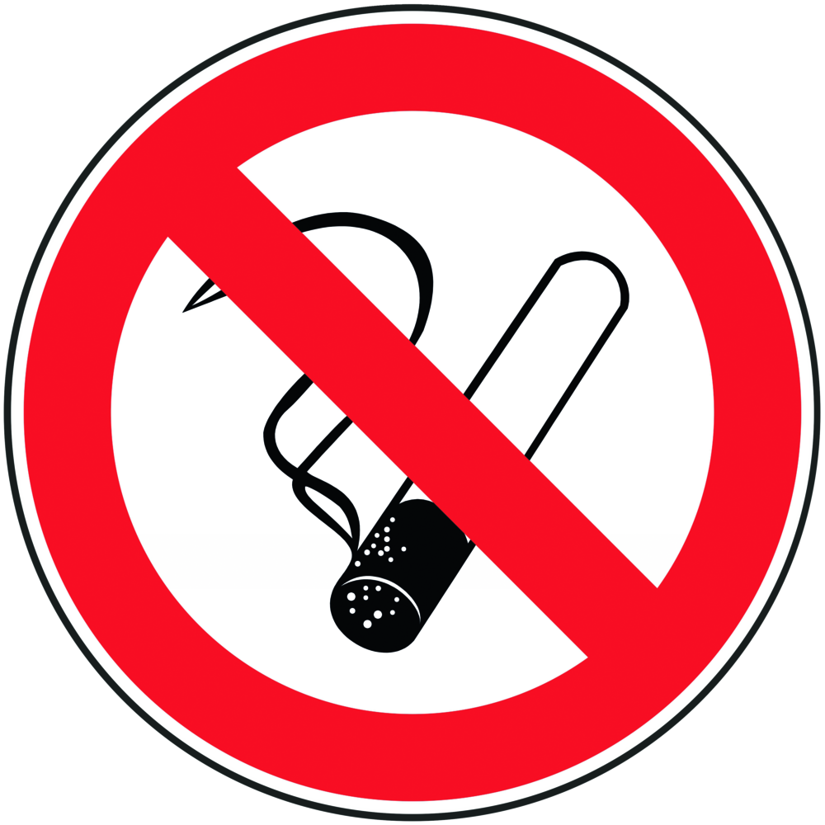 | General information  Working in the fume hood.  Smoking, eating and drinking is prohibited in all laboratories!  Personal protective measures |  |  |  |  | - pE

Be sure to use the necessary technical equipment! (eg fume cupboards and explosion-proof electrical appliances!) Avoid electrostatic charging!
Be sure to wear a cotton smock, goggles and nitrile gloves when handling. (Nitrile rubber / nitrile latex, thickness: 0.4 mm)
Before breaks and after work, wash hands thoroughly.
Open fire is strictly prohibited.



Use and storage:
Keep container tightly closed.
Keep container in a well-ventilated place.
Protect from heat and direct sunlight.
Keep away from ignition and heat sources.
Store in cool, dry conditions in tightly closed containers.
Recommended storage temperature: 15 - 25 ° C

Disruptions and Dangers
 | Absorb after spilling or leaking with absorbent material and as  dispose of hazardous waste.  Extinguishing Media: Carbon Dioxide, Powder, Foam, Water Mist.

Accidents and First Aid
 | After skin contact: Rinse wetted areas with plenty of water.  After eye contact: Rinse with plenty of water with the song open for at least 10 minutes. Ophthalmologist!  After contact with clothing: Take off wet clothing immediately.

Tests - Maintenance - Disposal
Dispose of as special waste (halogen-free solvents).

Signatures
Supervisor: Signature:

Town: Date:

