 | Operating instructions | 

Disposal
Heavy metal waste, solid, Hg-free

Contaminated resources
- Solid Heavy Metals Waste Without Mercury Compounds (For example Compounds of AG, Ba, Co, Cr, Mn, Ni, Pb, PD, SN, Ti)
UN numbers: 3288

Contaminated solids
Solid heavy metal waste excepting Mercury (e.g. substances containing Ag, Ba, Co, Cr, Mn, Ni, Pb, Pd, Sn, Ti) |  |  | - pE

Clippings
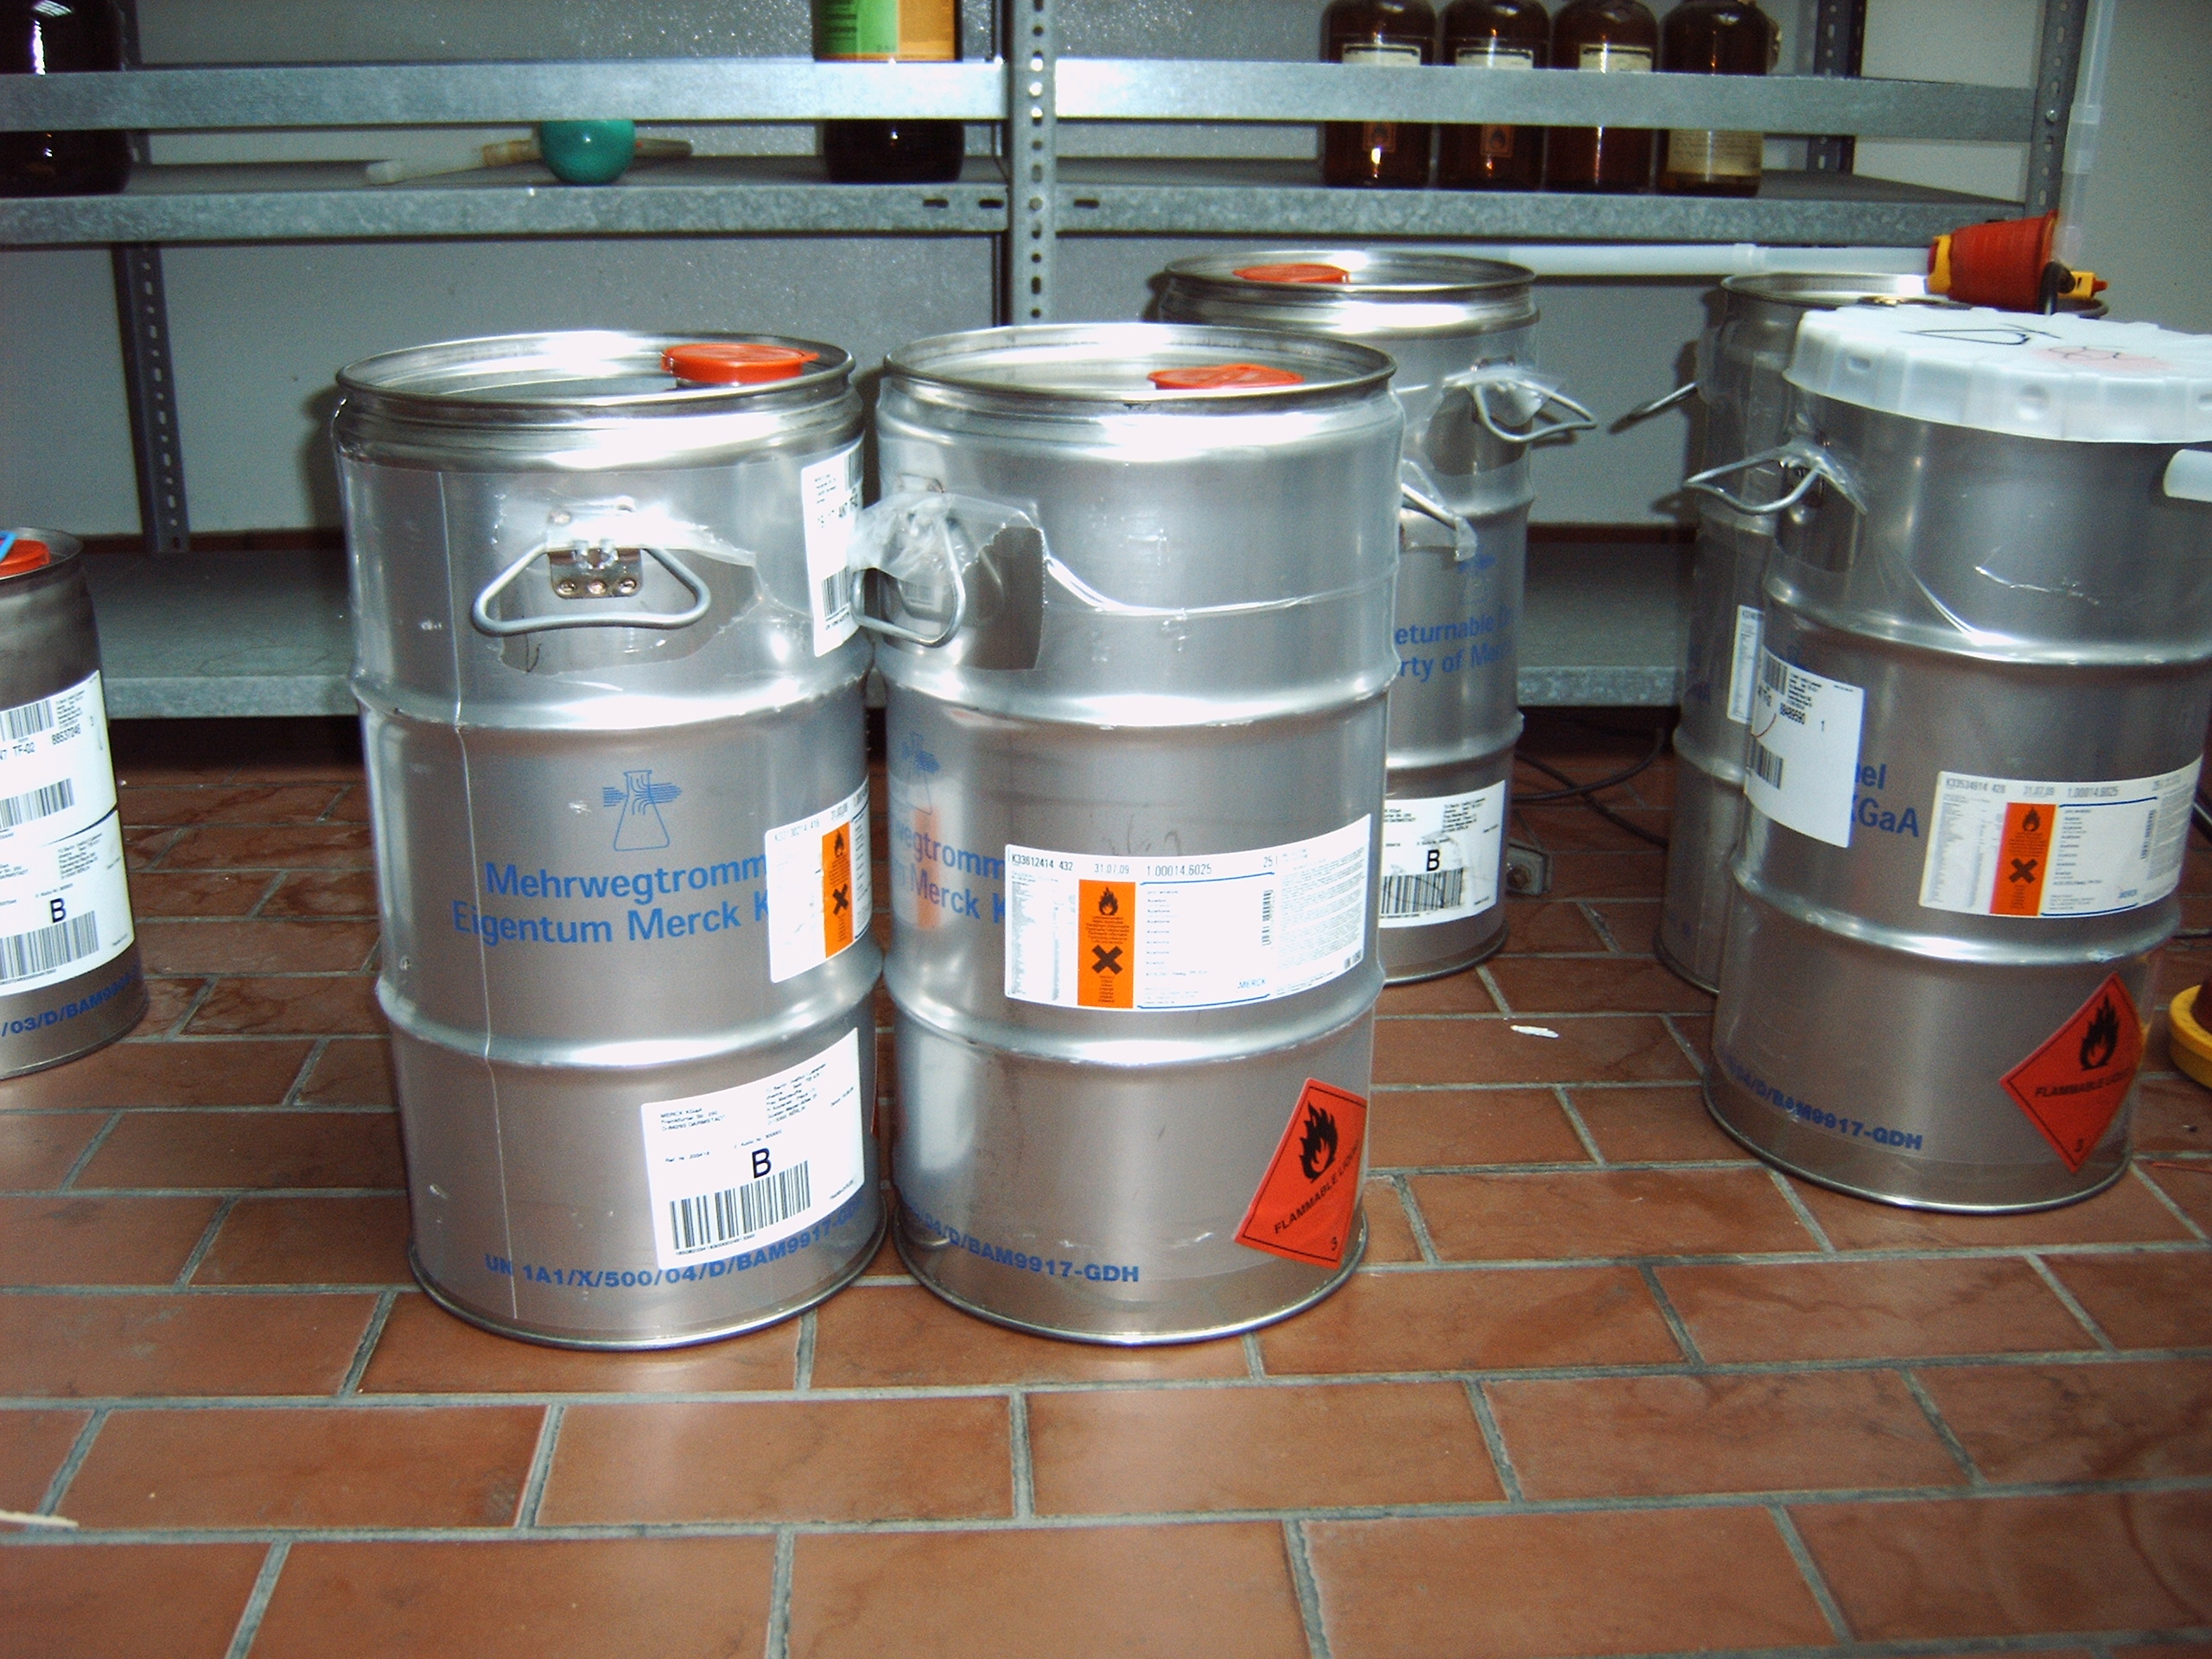
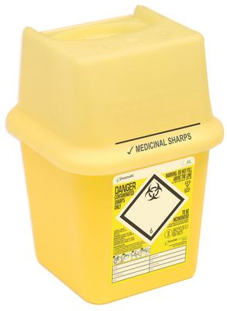
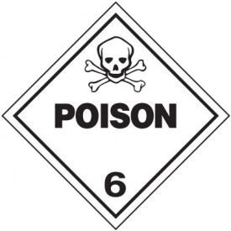
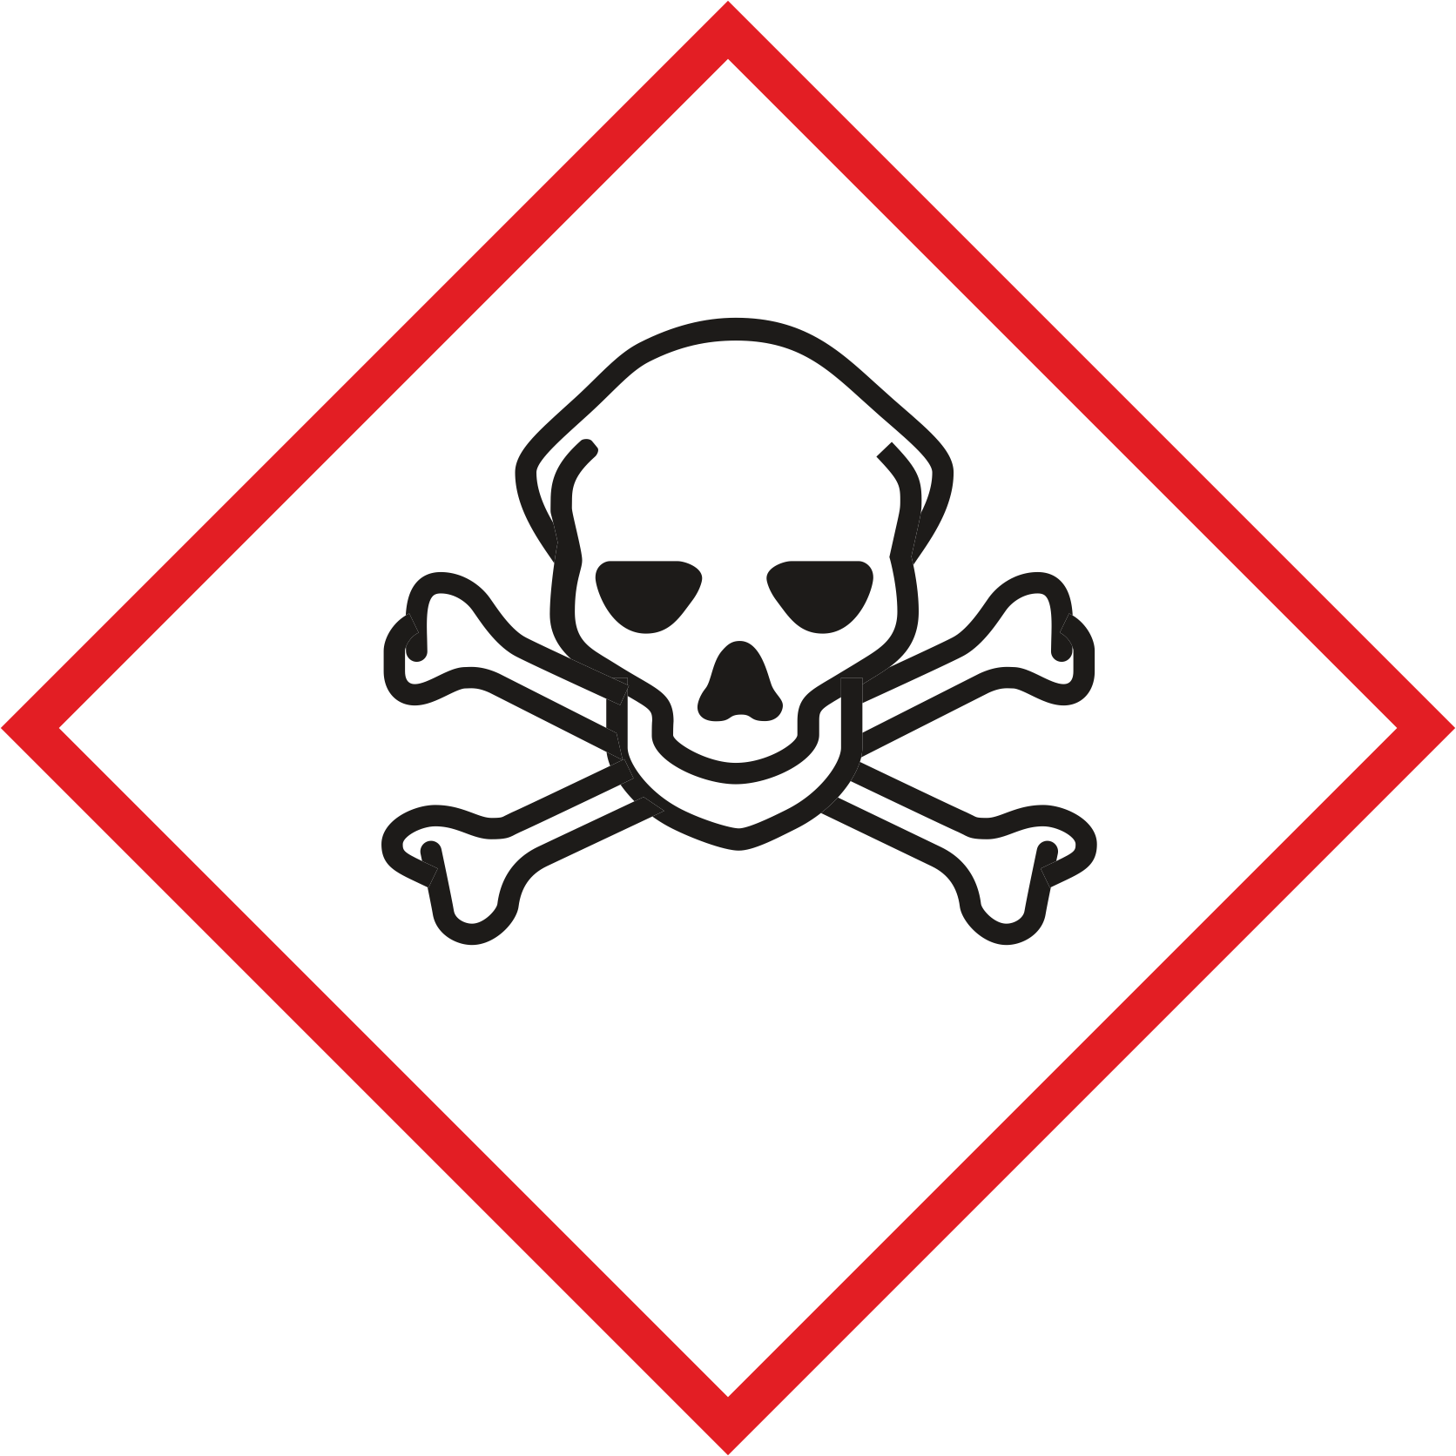

The following substances may not be collected together with this type of waste:
• dissolved chlorine compounds
• organic halogen compounds
• Hg-containing waste

NOT to be collected together with this waste type:
- Other chlorinated solutions
- Halogenated or Hg-containing solutions

Signatures
Supervisor: Signature:

Town: Date:

