 |  |  | Operating instructions | 

Work equipment – Equipment – Apparatus - Device
Handling vacuum, vacuum pumps

Dangers for humans and the environment
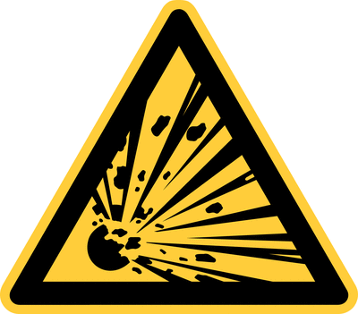 | - Possible implosions due to improper use and / or use of  unsuitable material.  - Pressure load in a water jet vacuum (20 hPa) approx. 1000 g / cm², in a high vacuum  only by 10 - 20 g / cm² more  - Risk of injury from splinters

Protective measures and rules of conduct
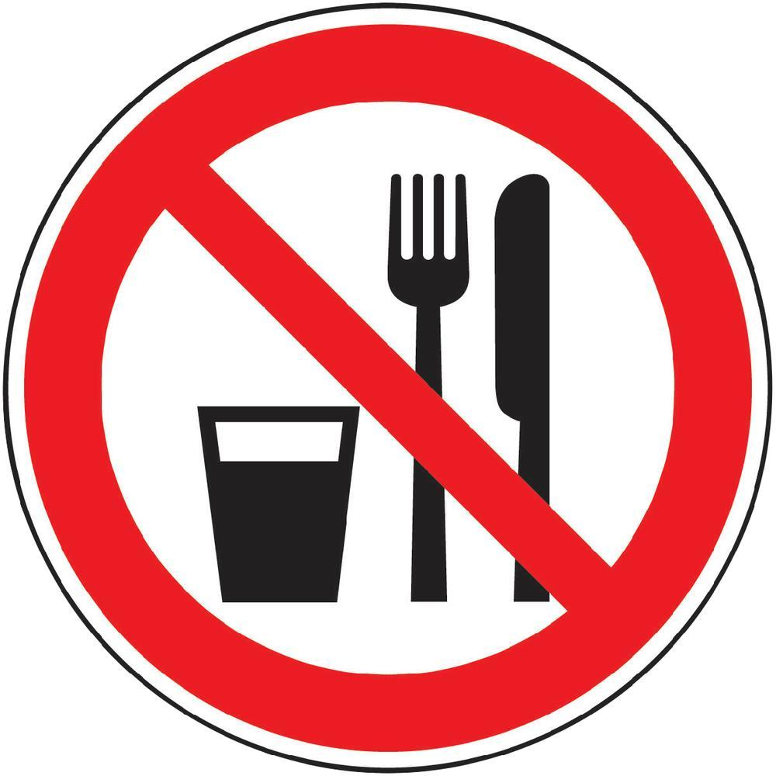  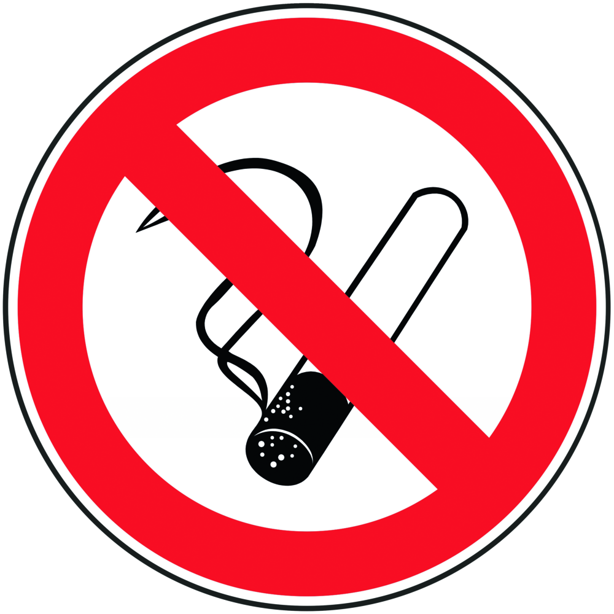 |  | General information  Do not smoke, eat or drink.  Personal protective measures |  |  |  | - pE
- Wear safety goggles, face shield and lab coat.
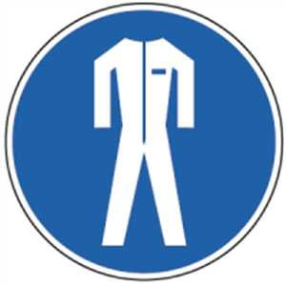
- Use only thick-walled, spherical glass containers (no volumetric flasks, stand-up cylinders, Erlenmeyer flasks)
- Provide anti-fire protection, wrap either wire basket, acrylic shield, protective wall or glassware with adhesive film / plastic net.
- Use boiling boiling capillaries, stones or magnetic stir bars as a result of bumping.

- Fasten the devices tension-free (without tilting).
- Wear protective goggles with side protection and upper eye area cover.

Use:

Read the operating instructions of the corresponding device carefully!
Before evacuation:
Check glass containers for cracks, cracks, "asterisks".
Condensate vapors by means of a cold trap or otherwise discharge them safely.
For vacuum distillations or rotary evaporators:
First evacuate, then heat up
Do not heat evacuated equipment judgments on one side. Set to desired
speed. The rotation begins

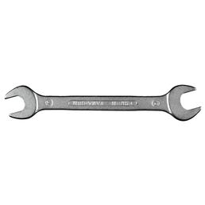
Faults and dangers
In case of failure immediately remove heat sources, then ventilate the equipment and
last stop the pump.

Accidents and First Aid
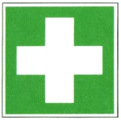 |  | - Bring injured person out of the danger area  - Provide first aid, paying attention to self-protection  - Contact the first assistant (see separate notice board), make an emergency call  - lnstruct rescue personnel  - In the event of injury, only allow glass fragments to be removed by the doctor  - Tinnitus :Ears- ringing your ears or ear whistles after an implosion IMMEDIATELY visit  doctor!!  - Eye contact: In case of eye injury, cover both eyes, ophthalmologist!

Tests – Maintenance - Disposal
- Do not put laboratory glassware made of Duranglas in the glass container, but dispose of it as residual waste.
- The same applies to mirrored glasses (Dewar vessels).

Signatures
Supervisor: Signature:

Town: Date:

