 |  |  | Operating instructions | 

Work equipment - equipment - device - apparatus
General handling of chemicals

dangers for humans and the envirnoment
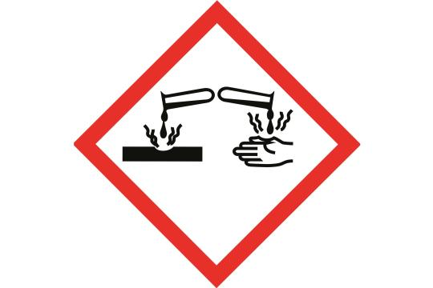  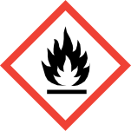  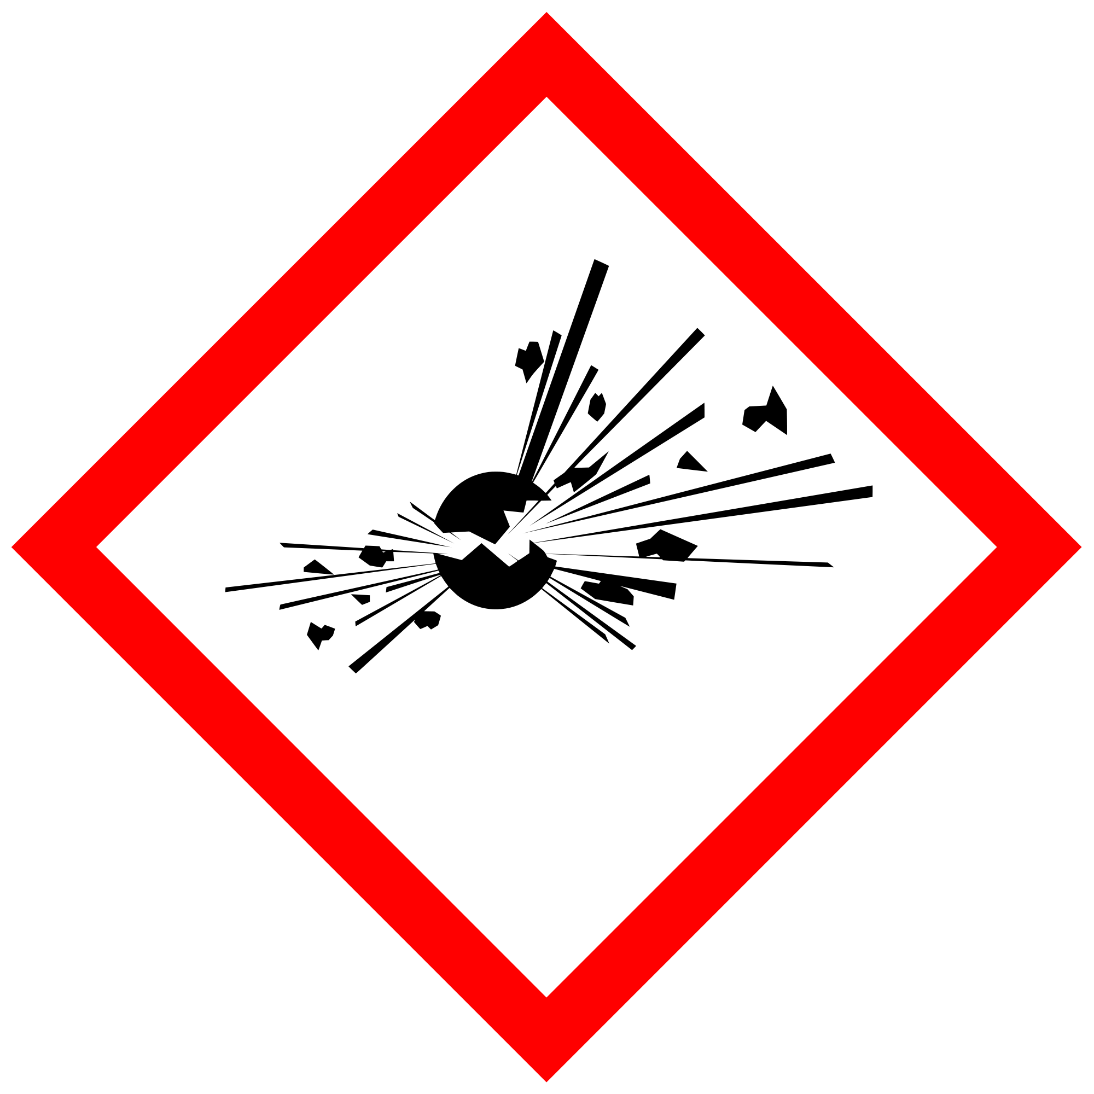  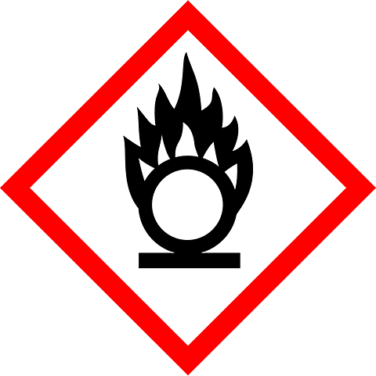  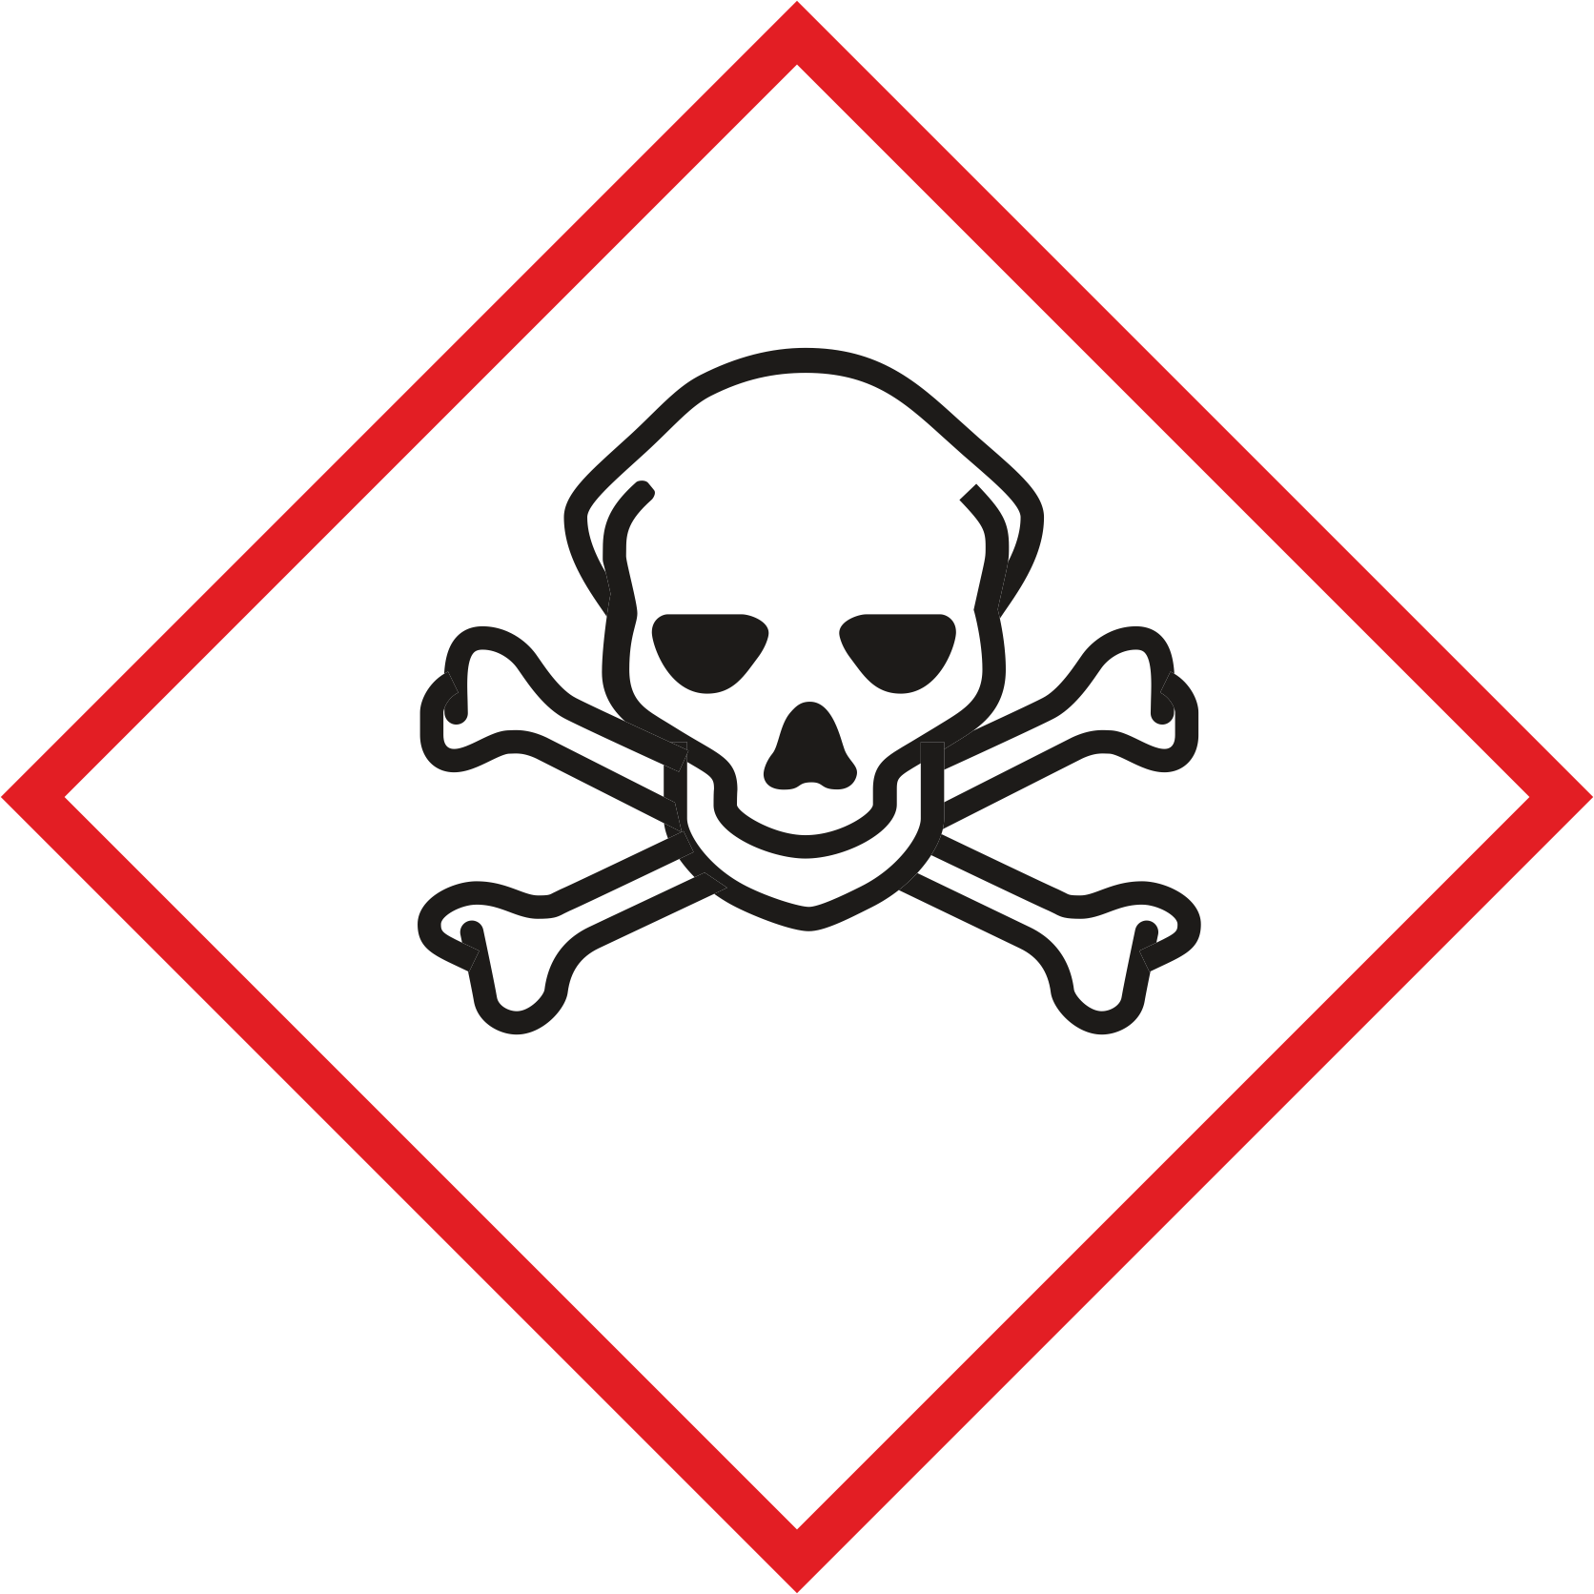  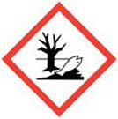  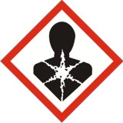  Hazardous substances are solid, liquid or gaseous substances, preparations and products that have one or more hazardous properties, e.g. Chemicals and disinfectants.  Correspondingly great care must be taken when handling these substances.  Anyone handling hazardous substances must be informed of their properties, effects, protective measures to be taken, behavior in the event of danger and possible first aid measures. It must also be known how to dispose of it properly. This information can be found in the safety data sheets and / or operating instructions for the respective hazardous substances.  The handling of substances, the harmlessness of which is not certain beyond doubt, must be carried out in the same way as that of dangerous working substances. (E.g. DAPI, etc.)  Pregnant women and nursing mothers are prohibited from handling hazardous substances.  Danger symbols and hazard drawings | Unstable explosive substances, mixtures and products with explosives, self-reactive substances and mixtures, organic peroxides  E  Flammable, (oxidizable) acting  O  Flammable, self-heating, self-reactive, pyrophoric, organic peroxides  F.F+  acute toxicity  T,T+  Corrosive to metal, skin-corrosive, serious eye damage  C  Endangering water  N  Different health hazards  XN
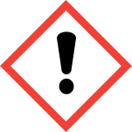  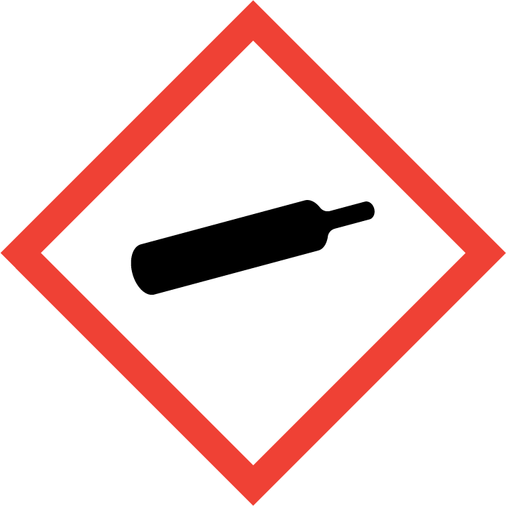  Protective measures  General information  Eating, drinking and smoking in the laboratory is strictly prohibited.  Food must not be kept in the laboratory or in a refrigerator with chemicals. Food and drinks must not be heated in the drying cabinet or other laboratory ovens.  When working openly with gaseous, dusty or hazardous materials that have a high vapor pressure (e.g. the usual solvents), the fume cupboard must always be used.  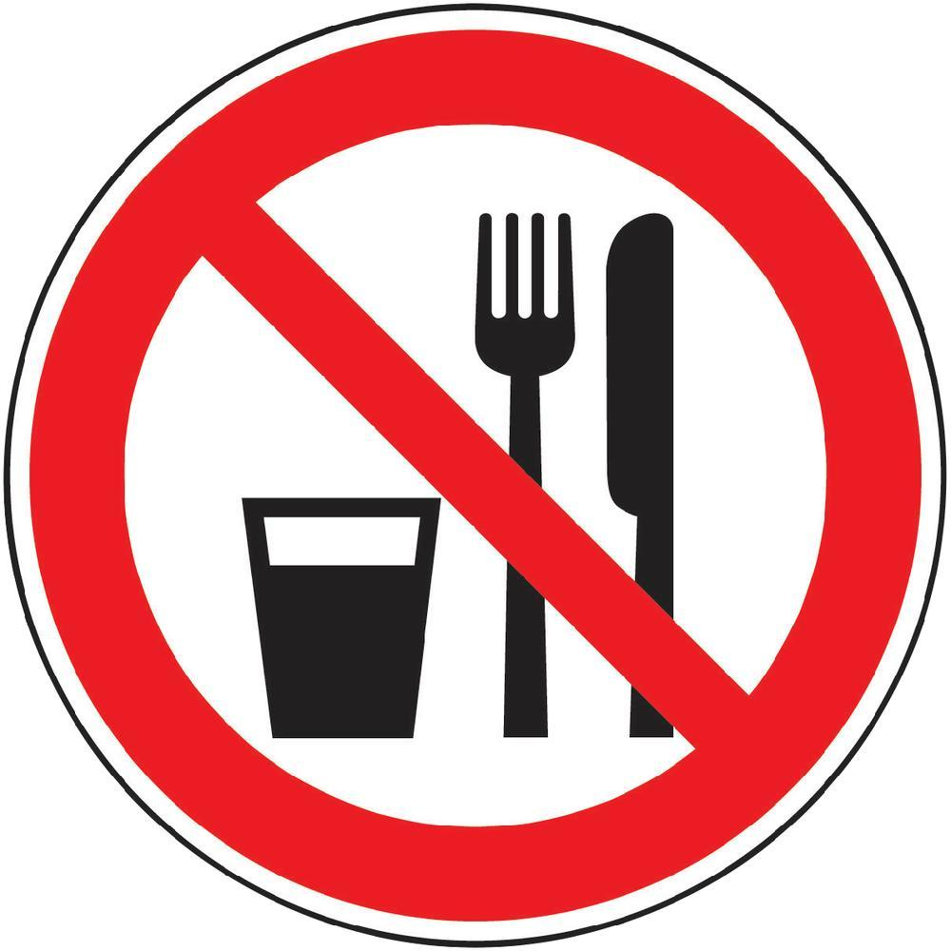  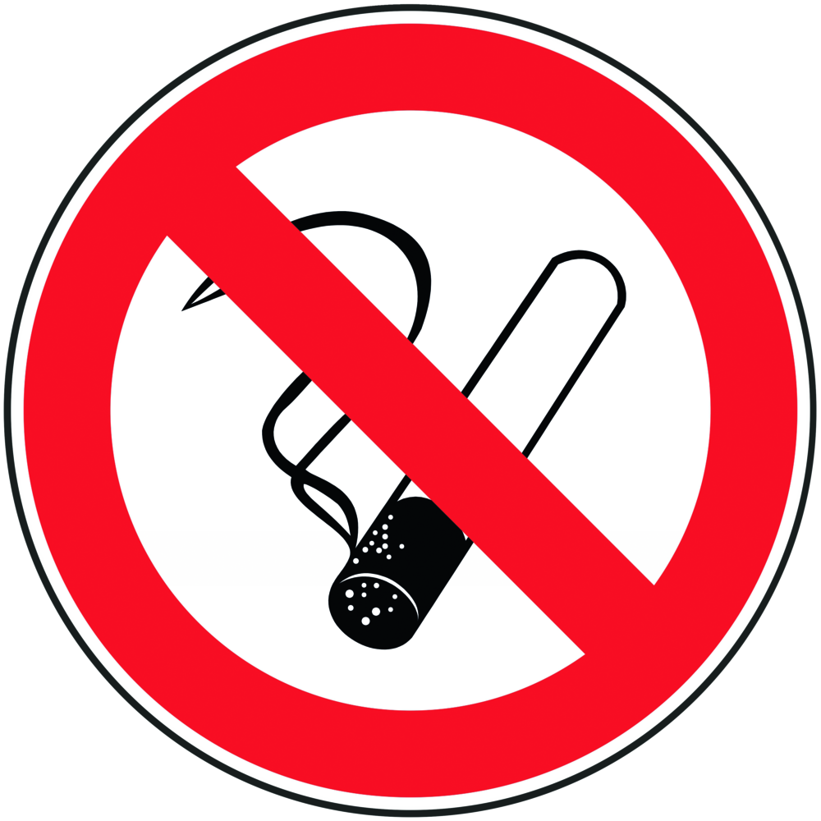  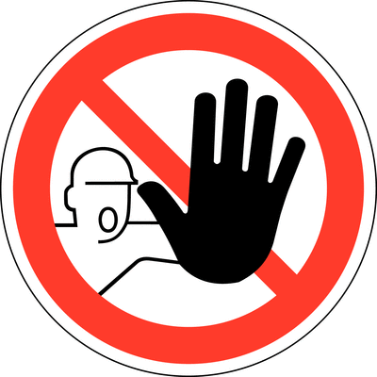  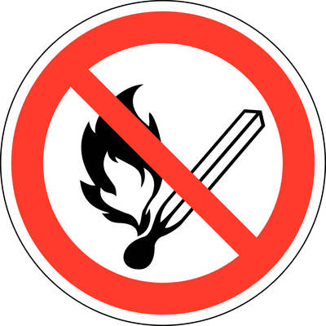  Most important prohibition sign  Personal protective measures  When carrying out dangerous work in laboratories, it is mandatory to wear safety glasses, a lab coat and sturdy, closed and sure-footed footwear. |  | General dangers  Xi  Gases under pressure, compressed, liquefied, frozen liquefied, dissolved  Gases  Eating and drinking prohibited  (applies in all laboratory rooms)  No Smoking  (applies throughout the building)  Unauthorized access is prohibited  (applies to areas or rooms that may only be entered by authorized persons due to special dangers or the special sensitivity of devices)  Fire, open lights and smoking prohibited  (generally applies in the immediate vicinity of highly flammable substances such as organic solvents, etc.)  Do not extinguish with water  (This symbol is found for chemicals that must not be extinguished with water in the event of a fire and in the operating instructions under "Behavior in the event of danger") |  |  |  | - pE
The body protection means provided in the safety advice (P-phrases) and special operating instructions, e.g. Basket glasses, face protection and suitable gloves are to be used. Gloves must not be worn outside the laboratories and must be removed when making calls, opening all types of doors, using water taps, etc.

When handling very toxic, toxic or caustic compressed gases, respiratory protection with a suitable gas filter must be available at the workplace.
Respiratory mask: Half mask filter class ABEK (as included in the MUI emergency kit)
Most important mandatory sign

Use eye protection

Use hand protection



Use protective clothing
This usually means a lab coat

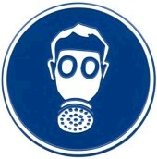
Use respiratory protection
This symbol is also used as a symbol for "working under the fume hood"



Use hearing protection



Use foot protection



Use face protection

Use and storage

Hazardous substances must be stored in accordance with the information in the safety data sheets, operating instructions or on the container itself. The storage temperature must always be observed!
Toxic or dangerous chemicals must not be kept freely accessible.

Recommended procedure (internal research group recommendation)

Before starting laboratory work, the dangers of the chemicals and methods used must be known and appropriate protective measures taken.

Transferring and transportation

The transport of liquids in bottles (from approx. 200 ml) must be carried out using a carrying basket. When transferring chemicals, wear appropriate protective equipment and legibly label all containers and objects.
Disruptions and dangers
Depending on the extent of the dangerous situation, contact the responsible person (laboratory manager) or call 911  Leave room / building if necessary.  In case of fire:  Alarm: Activate fire alarm, make emergency call.  Use only suitable extinguishing agents.  If necessary, wear self-contained breathing apparatus.  After spillage:  Absorb liquid chemicals with chemical absorber and dispose of them Cleaning.  Pick up solids dry and dispose of them for chemical disposal - subsequent cleaning.  If necessary, wear self-contained breathing apparatus.  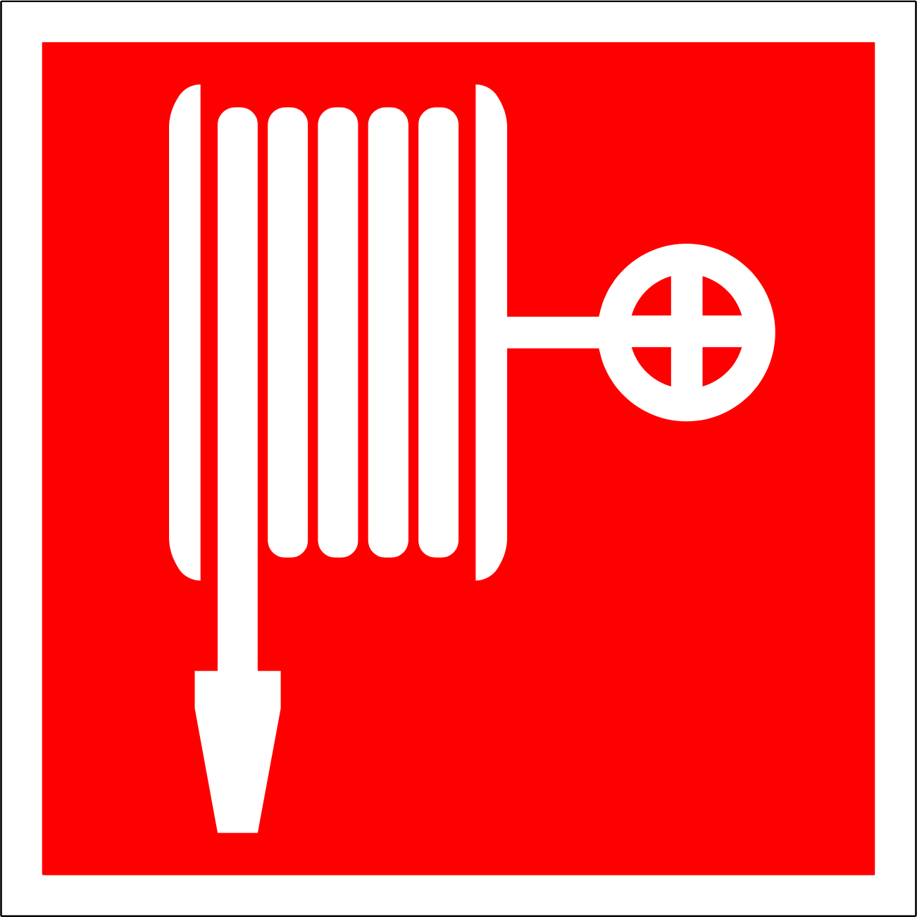  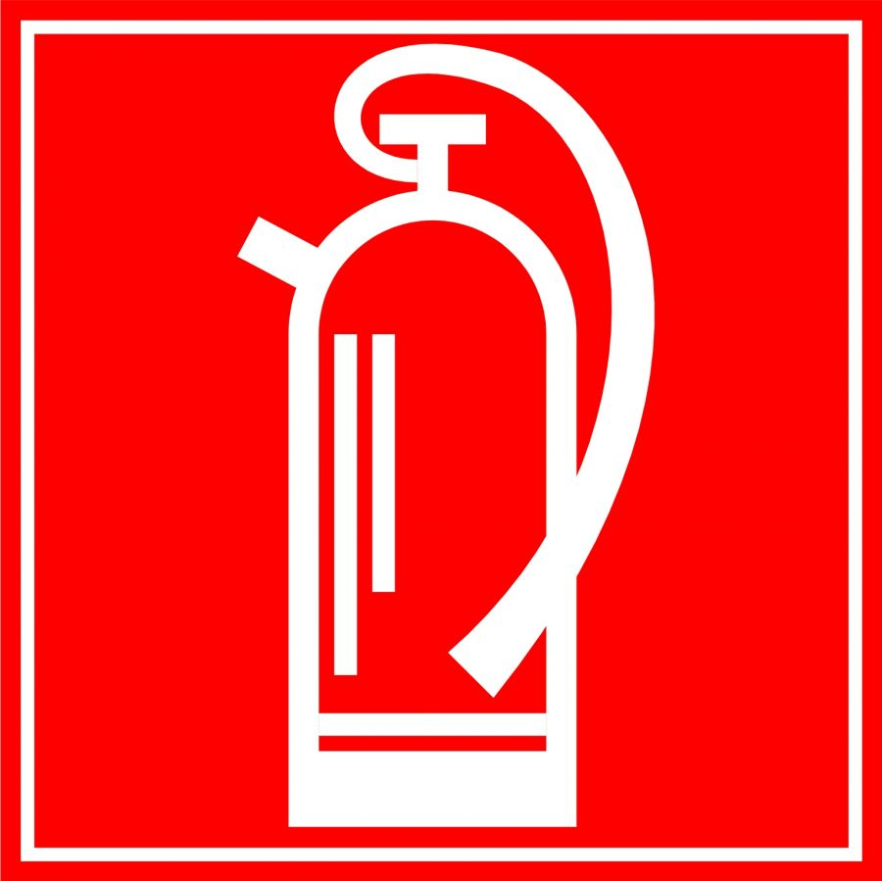  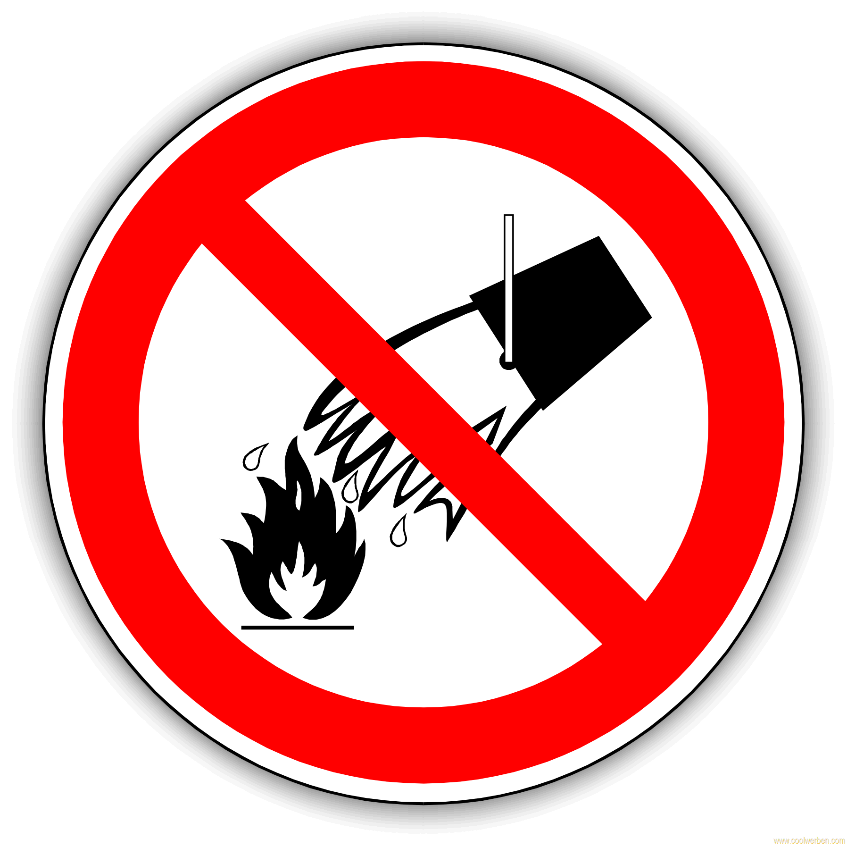  Most important fire protection signs |  | Fire hose  Fire extinguisher  Do not extinguish with water!

Unfälle und Erste Hilfe
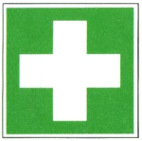 |  | Pay attention to your own safety with all help!  Make the emergency call as soon as possible.  Bring people out of the danger area.  Even if there is a slight contact with hazardous substances, the doctor should be consulted. Tell the doctor the exact name of the hazardous substance, e.g. what acid it is. Bring the safety data sheet of the substance.  If you are unconscious, move to a stable side position, check breathing and circulation and monitor.  Skin: Use emergency showers, wash thoroughly with water for several minutes, remove clothing contaminated with hazardous substances.  Eyes: Rinse under running water for several minutes with the eyelids wide open. See a doctor.  Ingestion: Drink water immediately and repeatedly, if present with activated carbon, avoid vomiting.  Inhalation: supply of fresh air.  Burns: leave cooling with water, face and eye burns unconnected. Arrange for medical treatment.  Important: Every injury during employment must be reported.  The completeness of the first aid kit must be checked once a year.

Tests - maintenance - disposal
Hazardous substances are generally disposed of via chemical logistics. Hazardous substances are collected separately and stored in the chemical room 207 until they are picked up. Hazardous substances and their waste are to be correctly labeled with the hazardous substance description, concentration, working group and responsible contact person. If you have any special questions, please contact Chemicals Logistics

Signatures
Supervisor: Signature:

Place: Date:

