 |  |  | Operating instructions | 

Work equipment - equipment - device - apparatus
Halogen free solvents
These include a. Acetone, acetonitrile, diethyl ether, ethyl acetate, ethanol, hexane, methanol, xylene,
Toluene and its mixtures as well as halogen-free solvent mixtures with low water content.

dangers for humans and the envirnoment
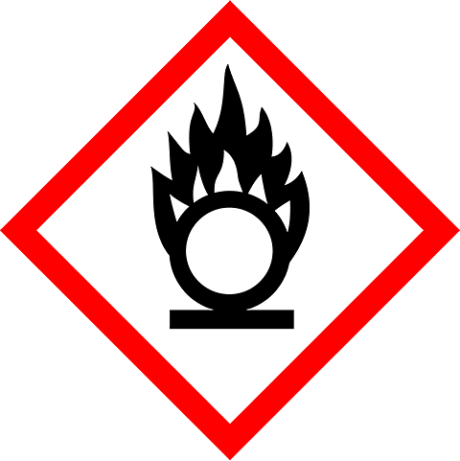  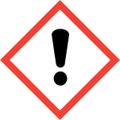  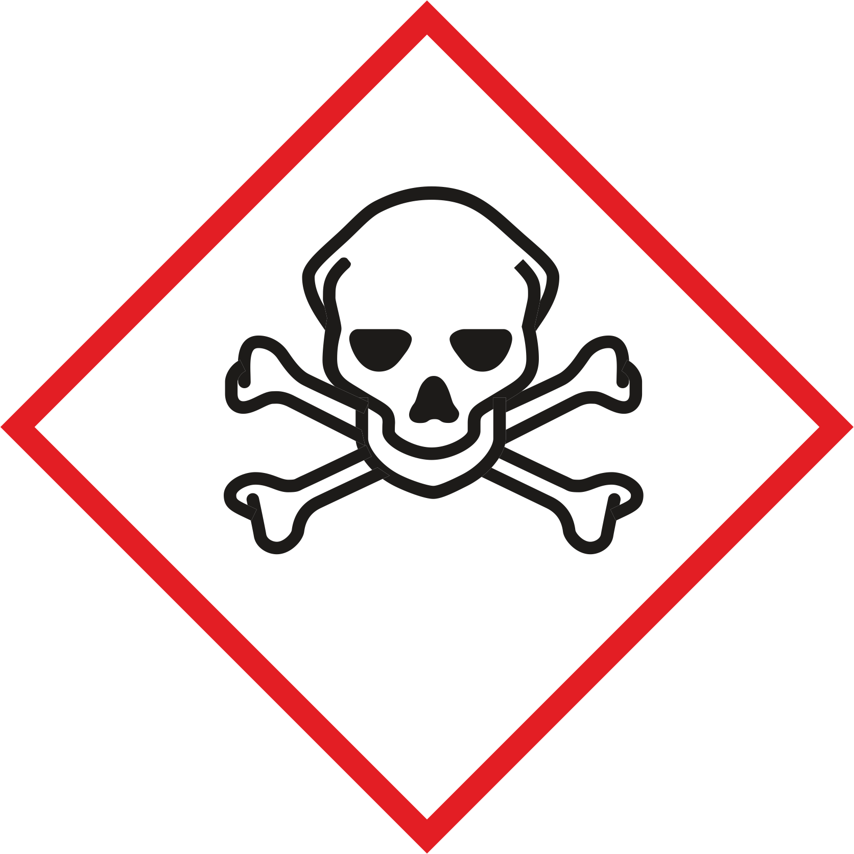  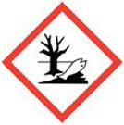  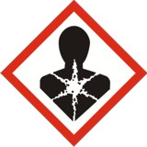 | Organic solvents are usually flammable or highly flammable and volatile. They form explosive mixtures with air. In addition, solvents are often very toxic, carcinogenic and toxic to reproduction.  Among other things, violent and sometimes explosive reactions with acids and bases.  Due to their high vapor pressure, there is an increased risk of absorption through the respiratory tract.  Ingestion by ingestion or through the skin can lead to poisoning  (Signs: dizziness, nausea, vomiting).  There is an additional risk of peroxide formation with ethers. Ether mixed with peroxides tend to explode when heat is applied.  Almost all solvents are very dangerous for the environment (drinking water).

protective measures and rules of conduct
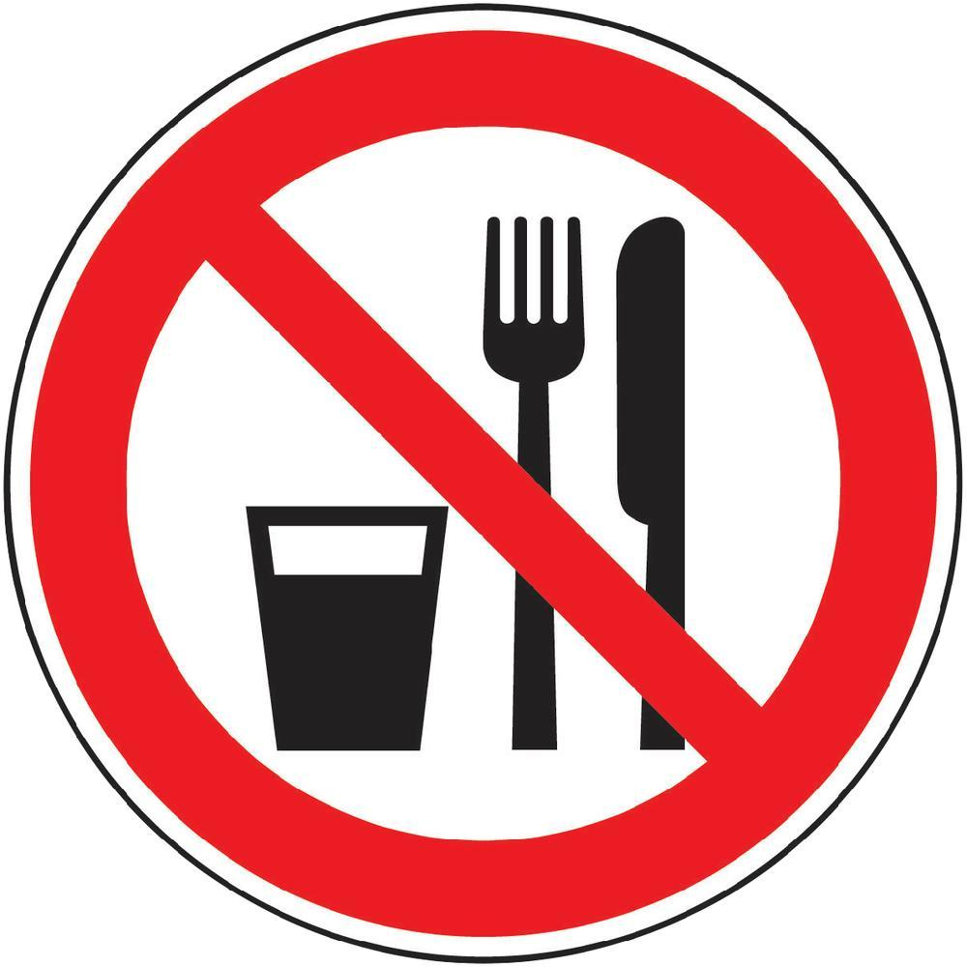  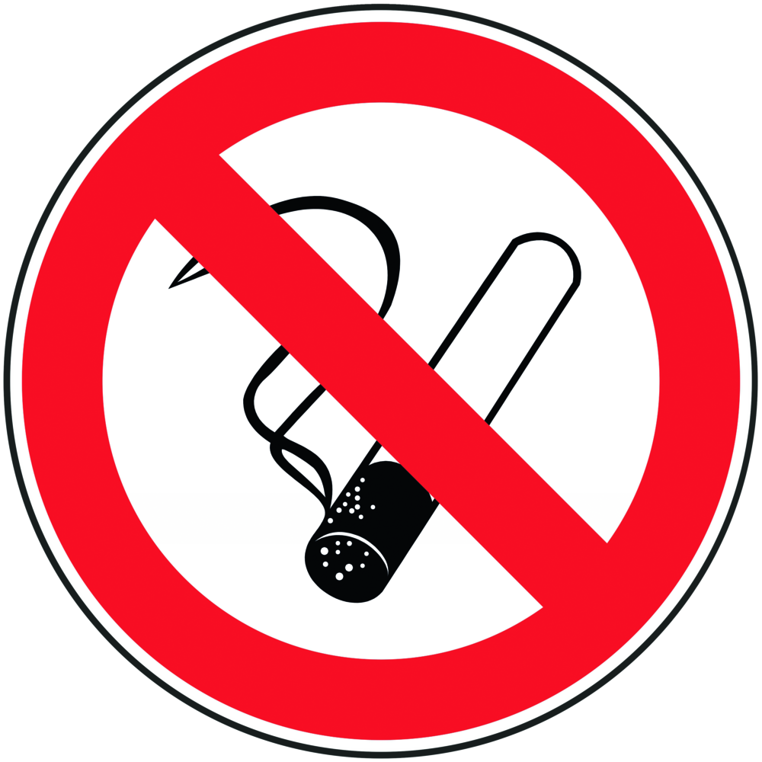 |  | General information  Eating, drinking or smoking is prohibited in all laboratory rooms!  Avoid contact with eyes and skin.  Before using, inform about the special hazard potential of the solvent in question. Read the safety data sheet!  Keep containers and equipment tightly closed; keep flammable solvents away from ignition sources; Keep fire extinguisher ready.  Ensure well-ventilated rooms; Handling of toxic solvents only in fume cupboards.  Take measures against static charging.  Do not let solvents get into the waste water. |  |  |  | - pE
Personal protective measures

Avoid contact with skin and eyes.
Ventilate rooms well. Use extraction at the workplace

Wear safety glasses, lab coat, closed shoes and suitable protective gloves
Observe the safety data sheets for the choice of protective equipment
Hand protection: nitrile disposable gloves, camapren gloves (black)
Latex and neoprene gloves are not resistant!
Viton (R) gauntlets can be used as short-term splash protection.

If necessary, wear flame-resistant overalls and protective work shoes.
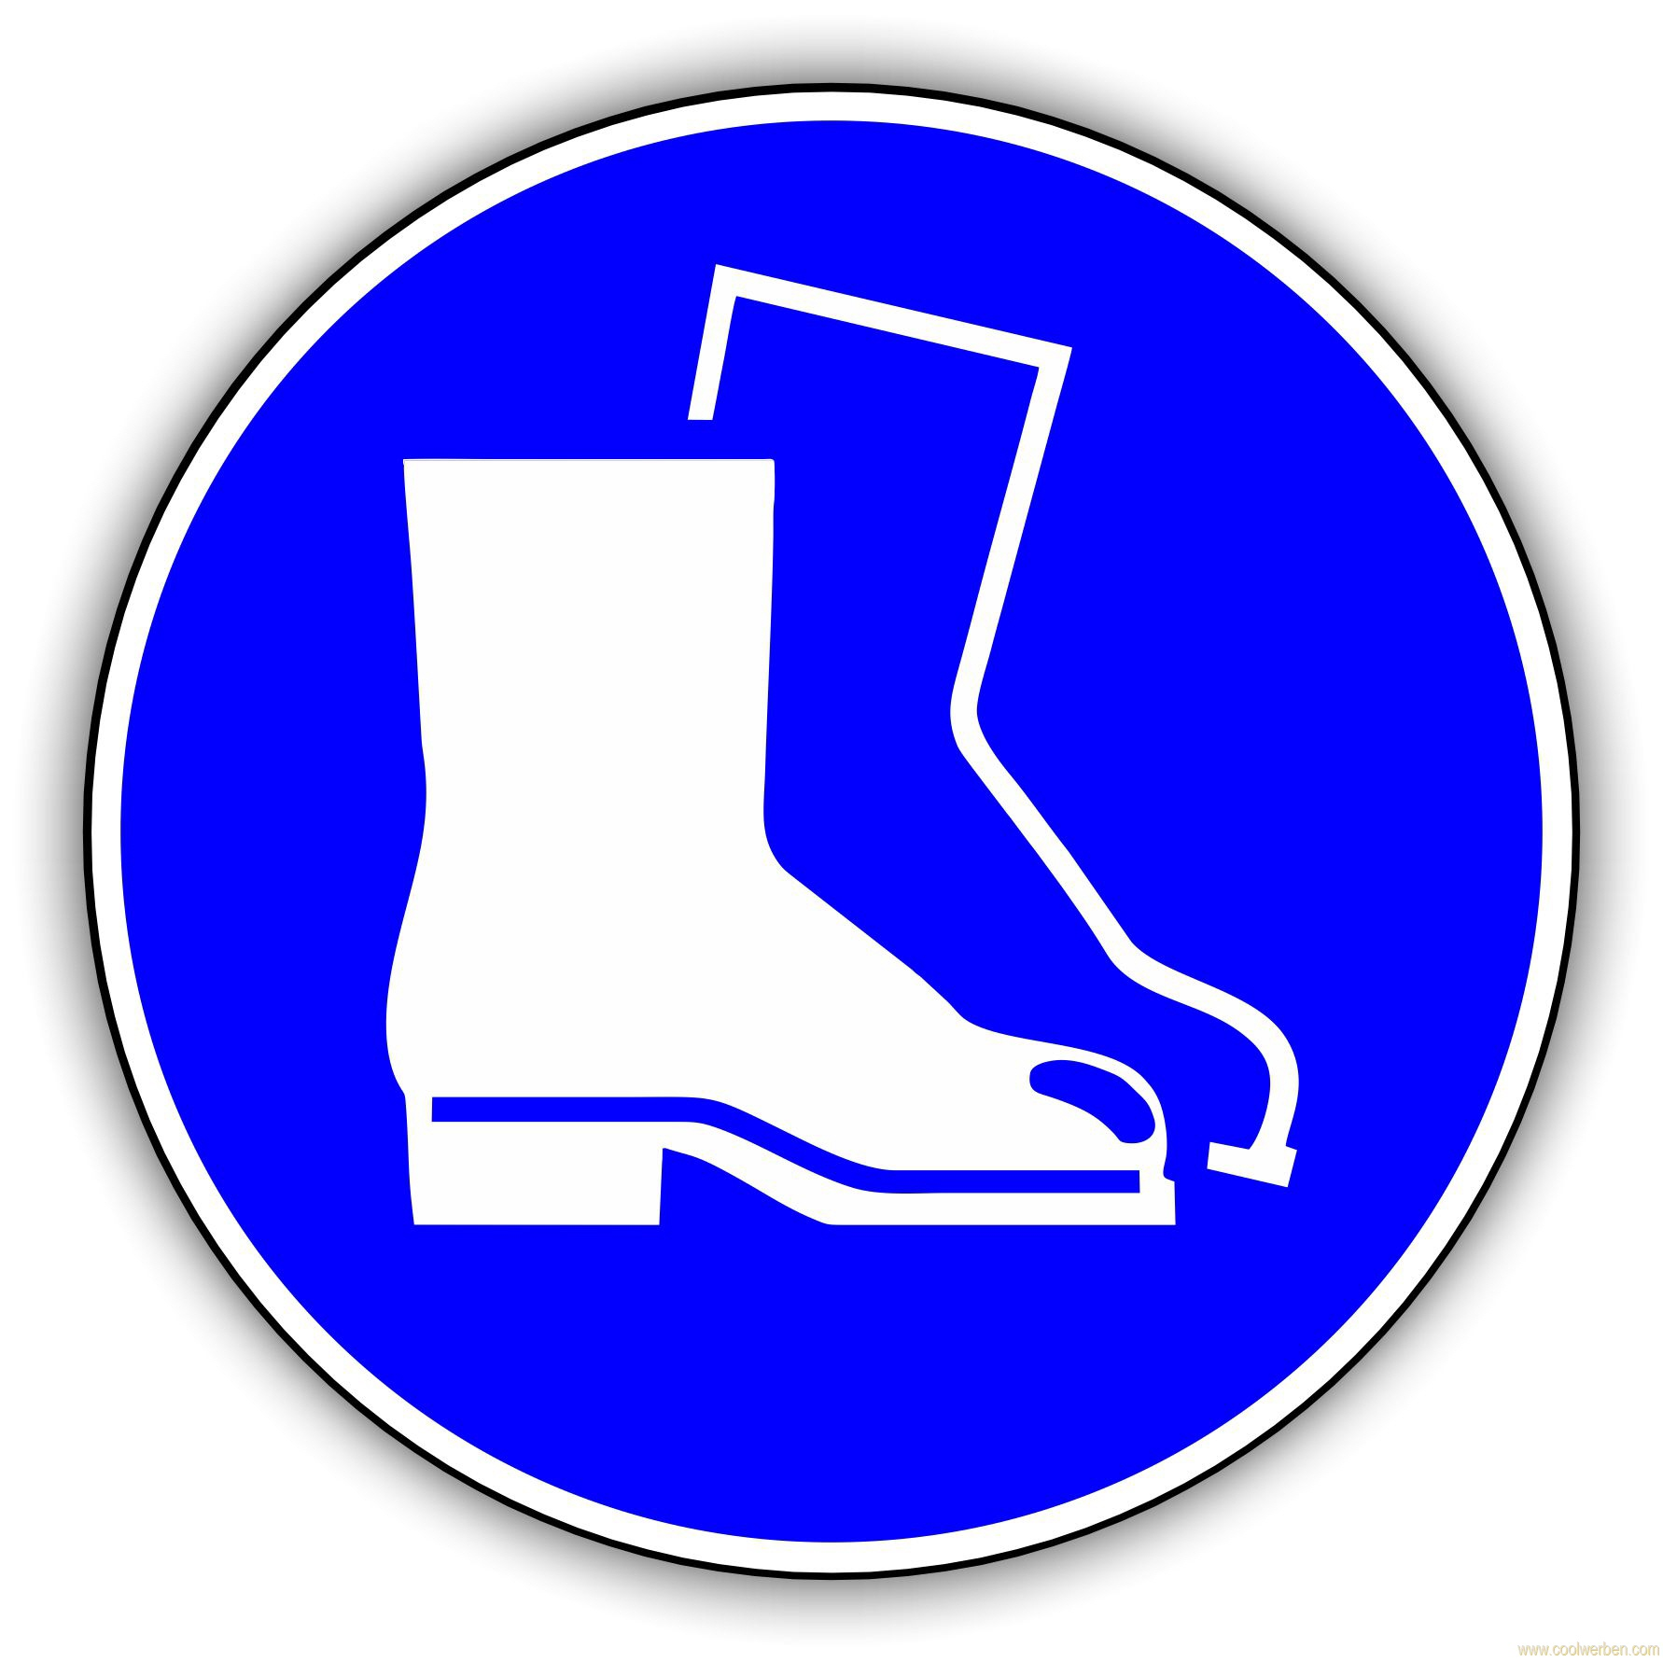



Use and storage

Storage of larger quantities only in specially designed chemical cabinets; Ether only in
Keep containers protected from light.

Transport

Use a drip pan when storing, decanting and processing
If necessary, wear a face shield when decanting (consult safety data sheets).

Disruptions and dangers
 |  | When gases and vapors are released, leave the room immediately, opening windows if possible. Re-entry only under respiratory protection.  Bring unconscious and / or helpless people out of the danger area! Warn endangered people in the vicinity!  In case of fire:  Powder and / or CO2. Do not use water.  Fight fires with CO2 extinguishers. Respiratory protection: ABEK combination filter.  If spilled:  Absorb spilled larger quantities with absorption material (e.g. vermiculite), sweep up and dispose of as special waste in 30 or 60 l barrels / containers. Only enter the danger zone with protective equipment.

Accidents and first aid
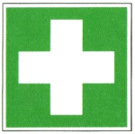 |  | Provide first aid, paying attention to self-protection. Bring injured persons out of the danger area, notify first-aiders, make an emergency call. Instruct rescue personnel. Call an emergency doctor if there is a risk of shock  After skin contact: wash off with plenty of water and soap. Possibly. Polyethylene glycol  (e.g. Roticlean).  After eye contact: Rinse with plenty of water for at least 15 minutes with the eyelid open. Ophthalmologist!  After inhalation: Move to fresh air.  After swallowing: drink plenty of water; Avoid vomiting if possible. Emergency doctor!  After clothing contact: Take off contaminated clothing immediately.  First aider: list next to all phones

Tests - maintenance - disposal
Dispose of residues and waste in a suitable, properly labeled container.

Signatures
Supervisor: Signature:

place: date:

