 |  |  | Operating instructions | 

Work - Equipment - Apparatus -Device
Halogenated organic solvents
z. Chloroform, dichloromethane (methylene chloride), 1,2-dichloroethane, perchlorethylene,
Carbon tetrachloride, trichlorethylene and the like, chlorinated hydrocarbons

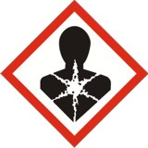
Dangers for humans and the environment
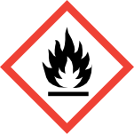  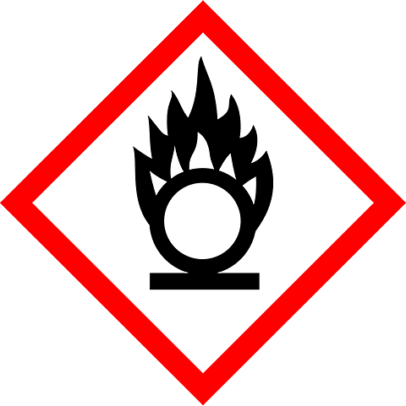  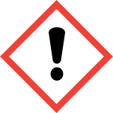  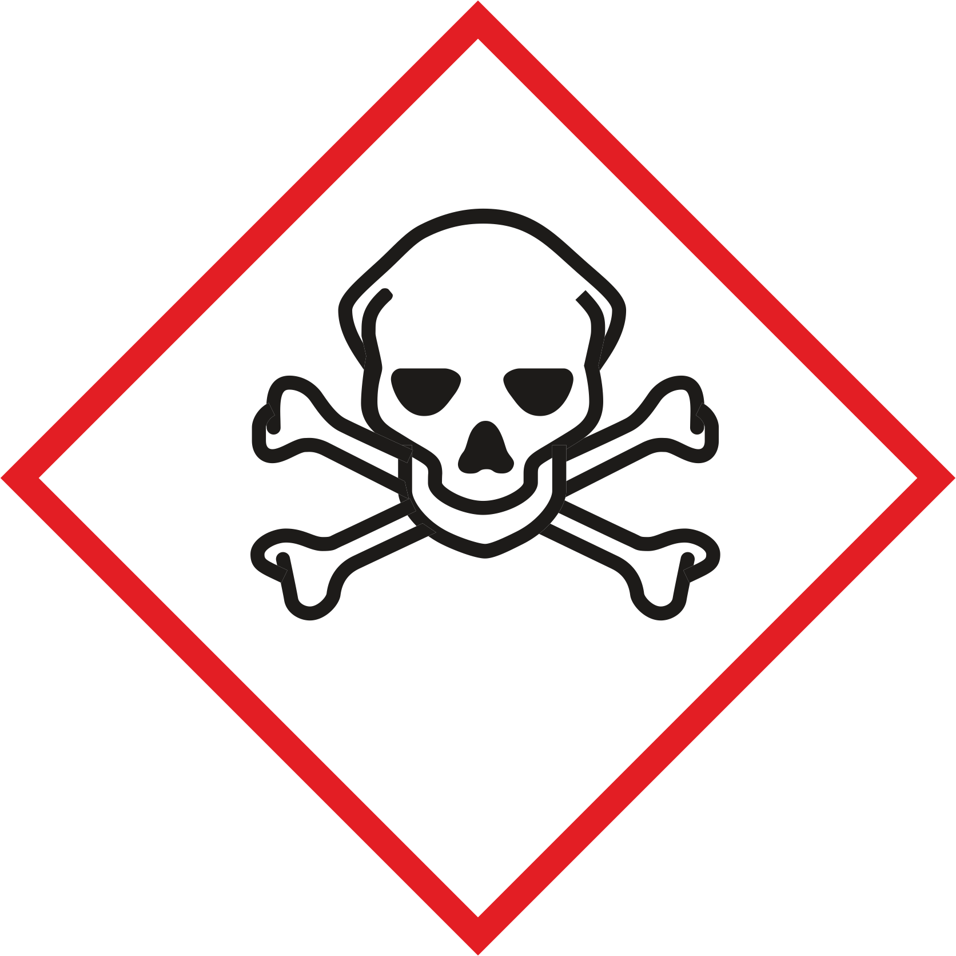  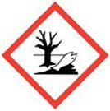 | Mostly non-combustible, characteristic smelling liquids. The vapors are usually heavier than air.Chlorinated solvents are usually flammable or highly flammable and volatile. They form explosive mixtures with air. In addition, they are often very toxic, carcinogenic and toxic for reproduction. Compounds undergo dangerous reactions with alkali metals, alkaline earth metals, powdered metals, nitrogen oxides, alcoholates, alkali diamides, perchloric acid, nitric acid, nonmetal oxides, oxygen, oxygen / liquid, and diaminoethane.  Due to their high vapor pressure, there is an increased risk of resorption through the respiratory tract. Contact with mucous membranes causes severe irritation. The eye is at risk of corneal clouding. Ingestion causes nausea and vomiting. After resorption of large quantities of halogenated hydrocarbons, central nervous disturbances may occur with drowsiness, dizziness, inebriation, hypotension, respiratory and cardiac disorders, and narcosis, as well as liver and kidney damage. The poisoning can be interrupted by a one to three-day interval.  With air in gaseous state with low hydrocarbons  Halogenation degree the danger of explosion.  Almost all solvents are extremely harmful to the environment (drinking water hazard).

Protective measures and rules of conduct
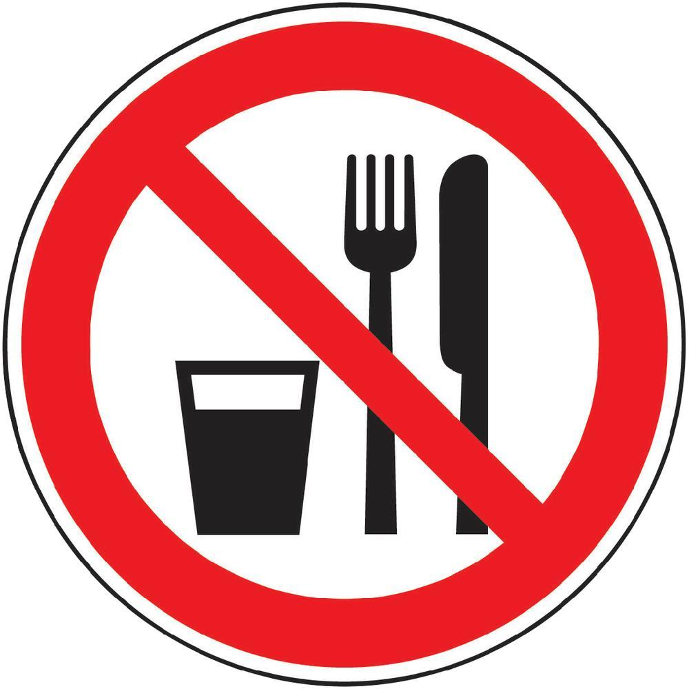  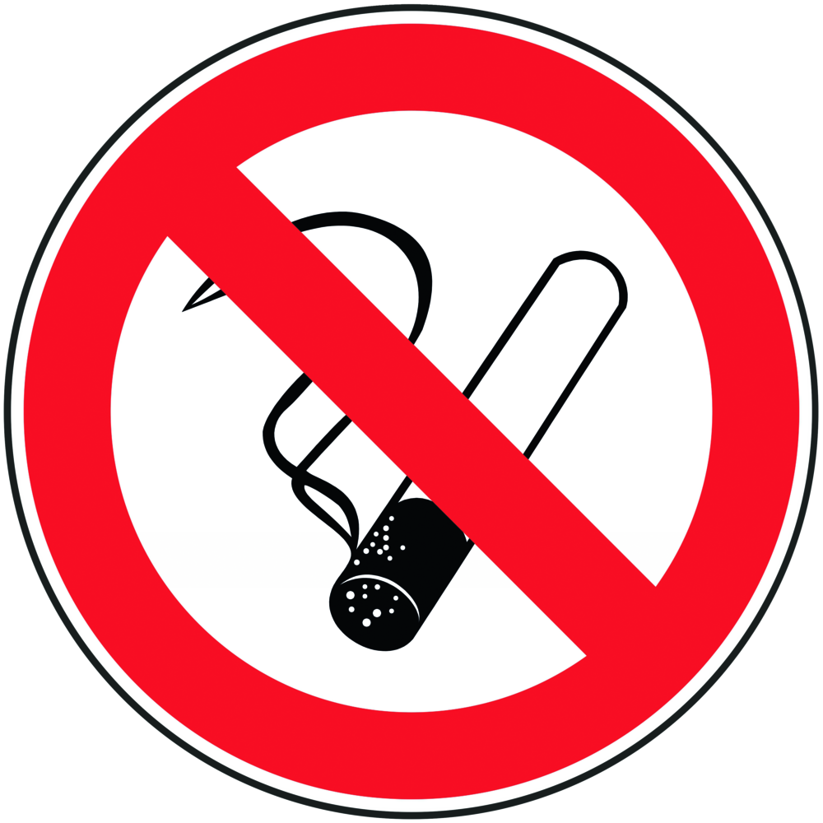 |  | General information  Before use, inform about the special hazard potential of the relevant solvent (read safety data sheet!).  Handling only in well-ventilated rooms, or under the hood.  Take measures against static charge.  Do not use water jet pumps for distillations of dichloromethane and chloroform, and also for the extraction of solids from solutions containing chloroform or dichloromethane, but use membrane pumps for this work.  Keep container and equipment tightly closed and store in a cool place. Protect from sunlight.  Keep flammable solvents away from ignition sources; Keep fire extinguishers ready.  Do not allow solvent to enter the wastewater.  Prevent formation of vapors and mists.  Eating, drinking or smoking is prohibited in all laboratory facilities! Avoid contact with  eyes and skin. |  |  |  | - pE
Personal protective measures
Avoid contact with skin and eyes.
Ventilate rooms well. Use exhaust at work
Wear suitable gloves and goggles or face shield.
Observe safety data sheets for the choice of protective equipment
Preventive skin protection required.
Hand Protection: Nitrile Disposable Gloves, Camapren Gloves (Black)
During laboratory work, always wear a laboratory coat







Use and storage
Storage of larger quantities only in specially provided for this purpose chemical cabinets

Transport
When storing, transferring and processing liquid substances, use collection tray.

Disruptions and Dangers
 |  | In case of fire:  Carbonic acid, foam, use powder as extinguishing agent.  If spilled:  Collect and dispose of fluid with Universal Chemical Absorber. Do not allow to enter drains / waters or soil

Accidents and First Aid
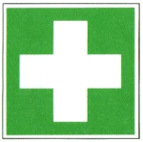 |  | Provide first aid, pay attention to self-protection.  Bring injured persons out of the danger zone, inform the first responder, place an emergency call. Instruct rescue personnel.  Clothing contact: remove soaked clothing immediately and wash with plenty of water.  After skin contact: rinse affected area thoroughly under running water, wash with soap; in case of skin reaction consult a doctor.  After eye contact: Rinse under running water with open eyelid for 10-15 minutes, then consult an ophthalmologist immediately.  After inhalation: supply fresh air, if necessary, give breath; See a doctor immediately.  After ingestion: drink plenty of water, prevent vomiting if possible, consult a doctor

Tests - Maintenance - Disposal
Dispose of leftovers and waste in a suitable, properly labeled container.

Signatures
Supervisor: Signature:

Town: Date:

