 |  |  | Operating instructions | 

Work equipment – Equipment – Apparatus - Device
Grinding machine

Dangers for humans and the environment
 | - Cutting injuries on the workpiece  - Abrasive damage to abrasive belt and grinding wheel  - Fast rotating grinding wheel / belt, trailing grinding wheel / belt  - Breakage of the grinding wheel, tearing of the grinding belt  - Injuries due to flying workpiece or tool parts  - Flying sparks and fire  - Noise development and dust generation  - Risk of entanglement  - Risk of burns on heated workpieces

Protective measures and rules of conduct
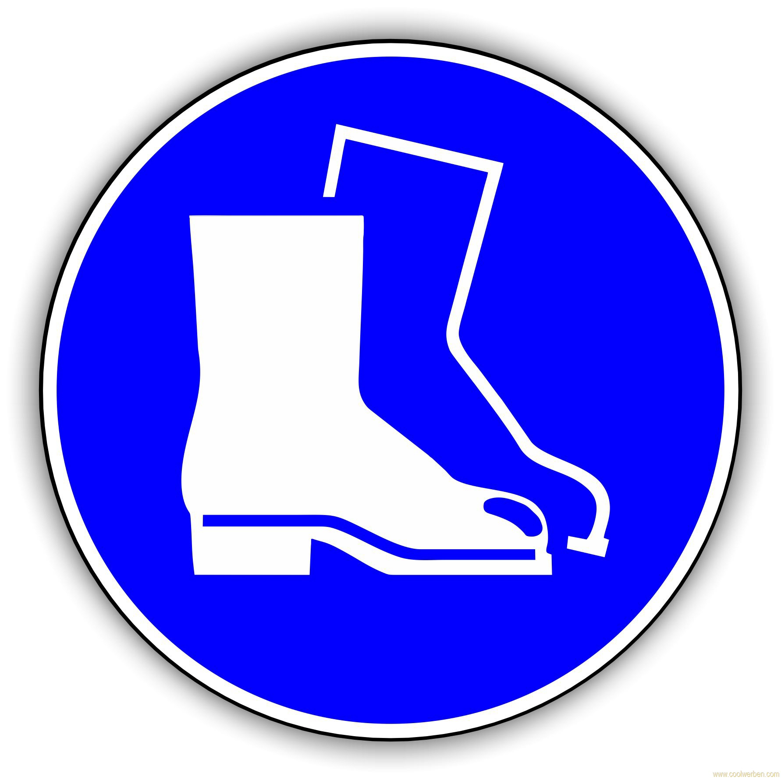  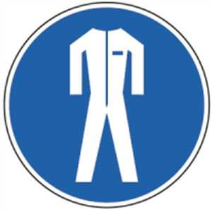  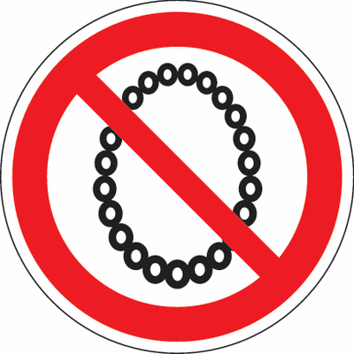  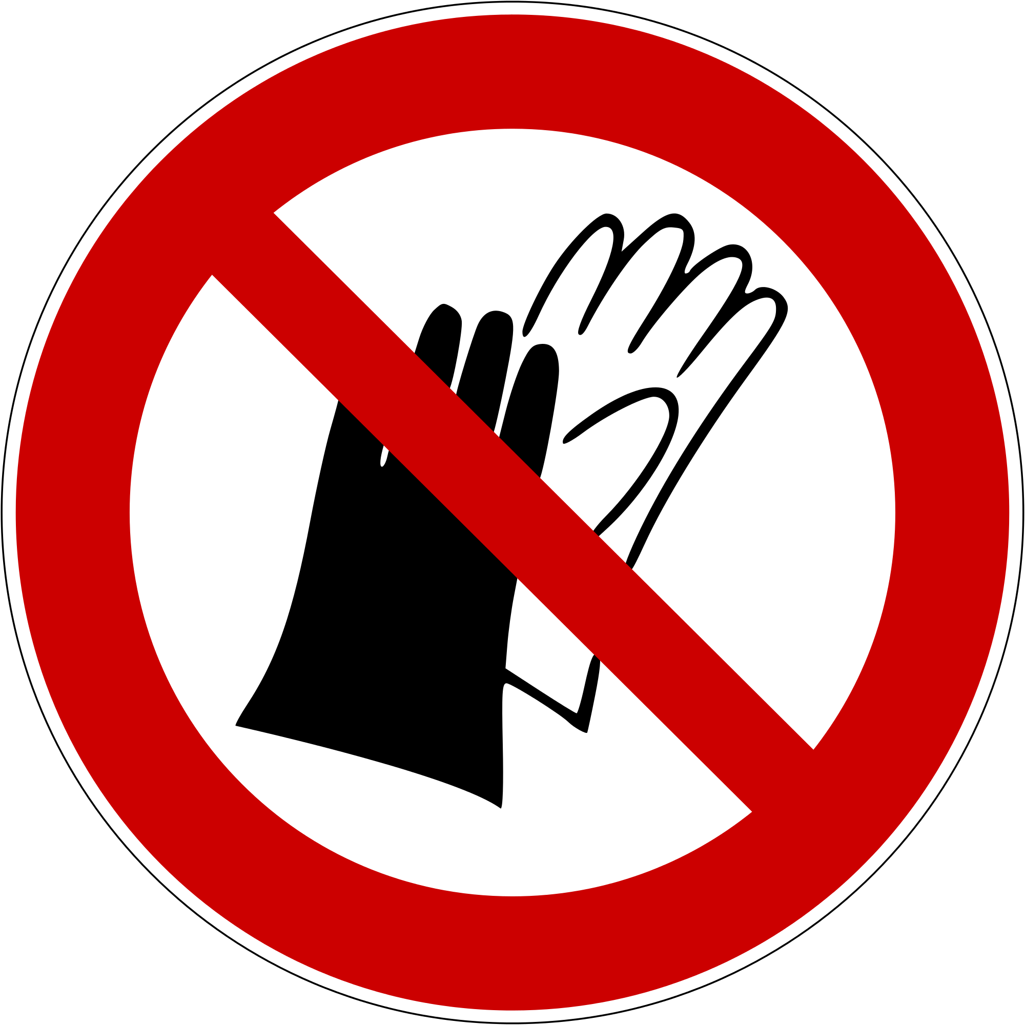 |  | - Operation of the machine only after instruction.  - Wear tight-fitting work clothing, safety shoes, ear protection and safety goggles!  - For long hair wear a hairnet or a suitable cap!  - Wearing jewelery (rings, chains, watches, visible piercings) is prohibited.  - The wearing of gloves is prohibited.  - Removing fire loads in the workplace.  - Before clamping a grinding wheel Crack test by sound sample.  - Clamping a new grinding wheel only by instructed persons.  - After clamping test run of 20 minutes.  - Watch the tape run and center or tension if necessary.  - Check machine for obvious damage.  - Workpiece supports and protective covers must be readjusted regularly.  - Distance between workpiece support and grinding wheel max. 3 mm.  - Attention to follow-up of the machine after switching off! |  |  |  | - pE

Faults and dangers
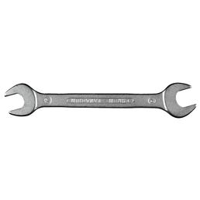 |  | - In the event of faults, abnormalities of the machine, breakage and setting of tools, switch off the machine immediately, secure it against commissioning and inform the supervisor.  - Only eliminate faults when the machine is at a standstill.

Accidents and First Aid
 |  | - Keep Calm  - Observe self-protection; Injured people recover, switch off the system  - Call first responder and, if necessary, emergency doctor. Emergency call: 144  - Provide first aid  - Inform supervisors  - An accident report must be made in the case of accidents and near-misses.

Tests – Maintenance - Disposal
- The machine and the workplace are to be cleaned after use, tools and aids are to be put in the designated places.
- Replace damaged grinding wheels and abrasive belts immediately.
- Repair and repair only by authorized and authorized persons.
- Observe the maintenance schedule of the manufacturer.

Signatures
Supervisor: Signature:

Town: Date:

