 |  |  | Operating instructions | 

Method
Genetic engineering work of safety level 2

Dangers for humans and the environment
Safety level 2 is associated with genetic engineering work with microorganisms and cell cultures that, according to the state of the art, are considered to pose a low risk to human health or the environment.
Hazardous microorganisms 2 and genetically modified organisms (GMOs) that require safety level 2 may cause infections and diseases when exposed to the human body. A sensitizing or toxic potential can not be excluded either.
Ingestion into the body may be by inhalation of aerosols, ingestion of pathogen-containing material to be examined, entry of pathogens into existing or injury-related skin damage, or by spraying the sample through the eye and mucous membranes.
In many laboratory activities (eg transfer, plating, pipetting, vortexing), aerosols (invisible, very fine floating droplets) can arise, which can cause infections when exposed to humans.
Release of GMOs can pollute the environment.

Protective measures and rules of conduct
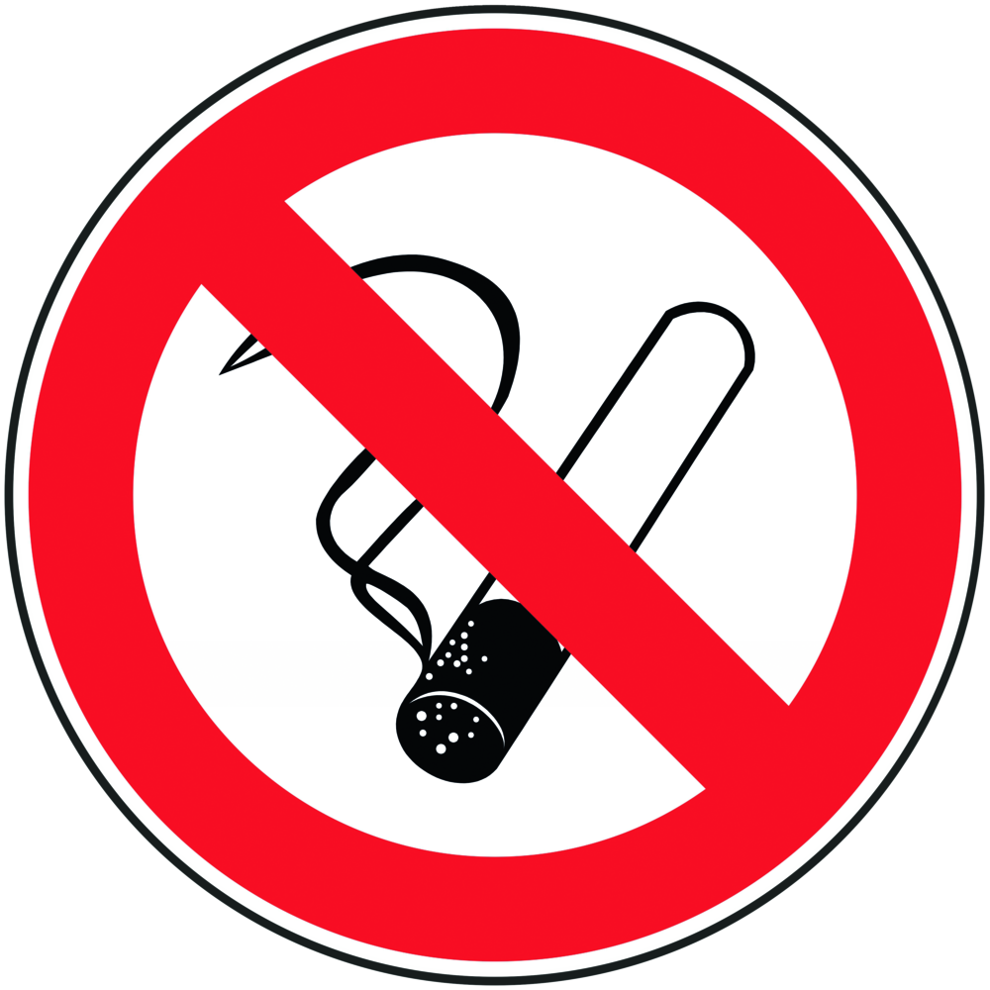  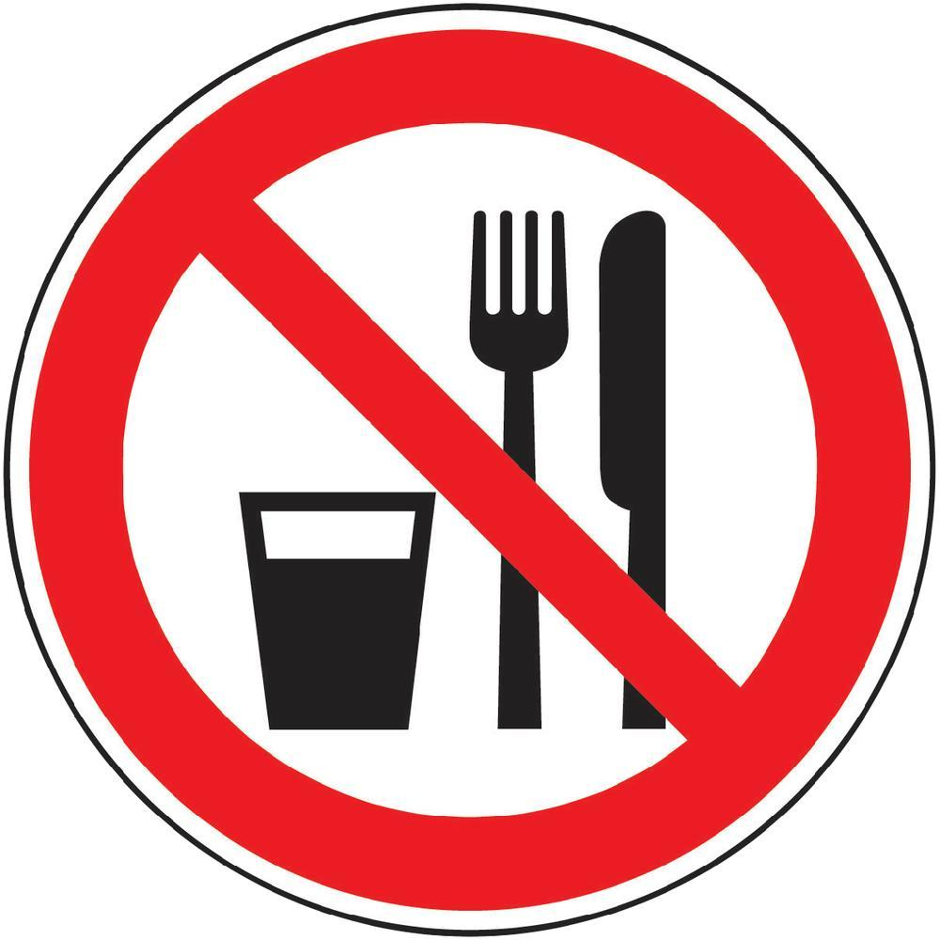 | Activities with genetically modified organisms of risk group 2 may only be carried out in genetic engineering laboratories of safety level 2 or higher.  Only persons admitted to the laboratory by the laboratory manager have access to the laboratory.  In the laboratory, a closed lab coat, sturdy and closed footwear and protective goggles are to be worn. The protective clothing may only be worn in the work area and should be removed when leaving the laboratory. Dirty protective clothing is to be collected for disinfecting cleaning in bags provided with inscriptions ......  When leaving the laboratory and after every skin contact with pathogen-containing material, the hands must be disinfected and washed. Afterwards a hand care according to skin protection plan is to be carried out. Any work likely to cause aerosol formation (eg decanting, plating, serial dilution, pipetting, mixing, vortexing); is performed under a microbiological safety cabinet.  Safety cabinet tidy, clean and tidy keep.  After completing the activities, disinfect the working surface according to the hygiene plan and switch on the UV light. When centrifuging, use tight-fitting centrifuge tubes (screw cap with O-ring).During the direct handling of infectious material one-time protective gloves (type: .....) must be worn. Lubricant contamination (eg on telephone receivers, door handles, fittings, writing instruments and keyboards) should be avoided. Contaminated implements must be autoclaved or disinfected before cleaning.  Pathogenic microorganisms may only be transported internally in labeled, closed and protected against breakage containers. Before leaving the laboratory, disinfect its surface.  Do not eat, smoke, drink, chew gum, or apply cosmetics in the lab.  Mouth pipetting is prohibited. For pipetting use only pipetting aid.  Cleanliness and order in the workplace are top priority. |  |  |  | - pE

Disruptions and dangers
In case of release of genetically modified organisms of risk group 2 in large quantities (eg spilling, breakage of a culture bottle) warn employees, lock up area if necessary and immediately the laboratory manager Mrs. / Mr. ..... Tel. inform the project manager Mr. / Mrs. ..... Tel. ..... as well as the representative for biological safety Mr. / Mrs. ..... Tel. ......
The removal of the dangerous state has to be done under own protection. In this case, at least protective goggles, disposable protective gloves (type: .....) and, if aerosols are present, a particle-filtering half mask FFP2 should be worn.
Absorb liquids with pulp. Immediately spray cellulose or contaminated area with disinfectant ....., allow to act according to the hygiene plan. Afterwards a cleaning according to the hygiene plan has to be carried out.
Windows and doors must be kept closed until the end of the cleaning operation. The access of unauthorized persons is to be prevented.
All contaminated objects (including lab coats) must be collected in suitable containers (closable, disinfectable from the outside, liquid-tight) and autoclaved.

Accidents and First Aid
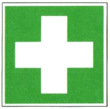 | Take off wet clothing (also underwear) immediately and use again only after disinfecting cleaning.  Rinse open wound, let it bleed as far as possible and spray immediately with wound disinfectant, if necessary, top up the disinfectant and allow to act according to instructions, however, for at least 30 minutes.  In the case of splashes in the eye, rinse thoroughly with the eye shower. Then drop in eye drops (disposable vial .....).  If pathogen-containing material gets into the mouth, spit immediately and gargle thoroughly with freshly prepared 1% hydrogen peroxide solution.  Injuries must be reported immediately to the responsible supervisor and entered in the book.  In case of intensive contact (eg., Ingestion, Inhalation, Incorporated by injuries) seek medical advice.

Proper disposal
Periodically clean and disinfect, sterilize or autoclave contaminated equipment and instruments according to the hygiene plan.
Collect all contaminated disposable waste in the designated waste containers and, if necessary, autoclave at the latest before the weekend.

Signature
Supervisor: Signature:

Town: Date:

