 |  |  | Operating instructions | 

Method
Genetic engineering work of safety level 1

Dangers for humans and the environment
 | Safety level 1 is to be assigned to genetic engineering work which, according to the state of the art, does not pose a risk to human health and the environment in compliance with the rules of conduct described in this operating manual. The genetically modified organisms of risk group 1 used in safety level 1 are unlikely to pose an infection risk to humans. However, a sensitizing or toxic potential can not be ruled out.

Protective measures and rules of conduct
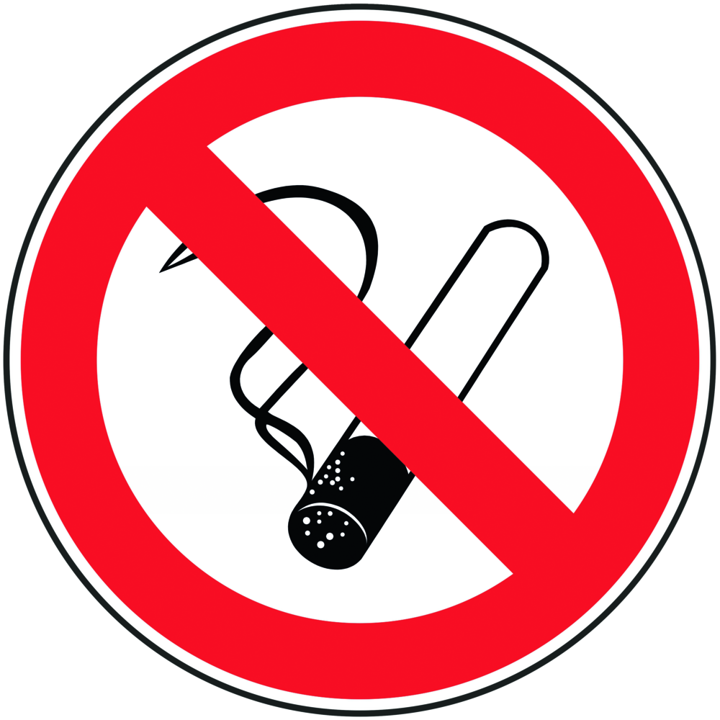  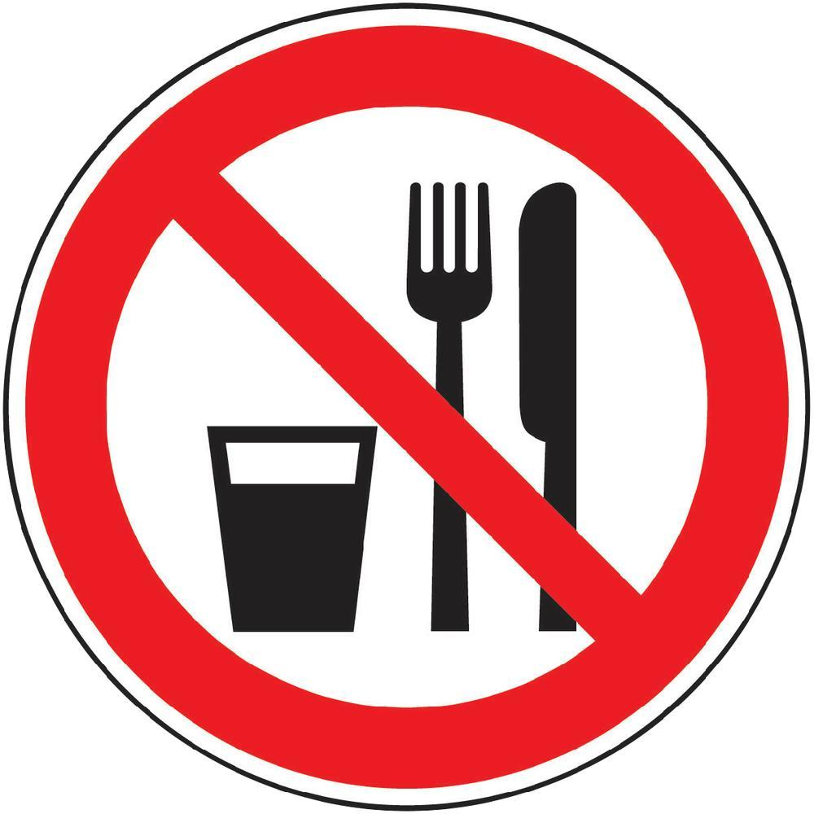 |  | - Activities with genetically modified microorganisms of risk group 1 may only be  - carried out in the genetic engineering laboratory of safety level 1 or higher.  Keep lab coat closed, sturdy and closed footwear and goggles. Take off the  - lab coat before leaving the lab.  Mouth-pipetting is prohibited. For pipetting use only pipetting aid.  For all work processes, make sure that aerosol formation is avoided.  The doors and windows of the workrooms should be closed during work.  Syringes, cannulas and scalpels should only be used if absolutely necessary.  - Insert used cannulas directly into the cannula waste containers, never put them  - back in the protective covers.  Keep the workplace tidy and clean.  Wash hands with soap and water after finishing work. Then skin care  - according to skin protection plan.  Do not eat, smoke, drink, chew gum, or apply cosmetics in the lab. |  |  | - pE

Disruptions and dangers
- In the event of release in large quantities and concentration (eg spilling, breakage of a culture bottle) warn employees and the project manager Mr / Ms .... Tel .... as well as the representative for biological safety Mr / Mrs. Tel. ... inform immediately.
- Clean contaminated objects or surfaces immediately or wipe them up wet. If provided for in the hygiene plan, disinfect accordingly.
- Use wood pulp for wiping and vacuuming.
Accidents and First Aid
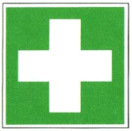 |  | - Wash open wound, let it bleed as far as possible and spray it with disinfectant ………….  - In the case of splashes in the eye, rinse thoroughly with the eye shower.  - Then drop in eye drops (disposable vial .....).  - Injuries must be reported to the supervisor and entered in the book.  - In case of intensive contact (eg., Ingestion, Incorporated by injuries) consult a doctor.

Proper disposal
Waste containing genetically modified organisms should preferably be autoclaved, otherwise inactivated with disinfectants.

Signature
Supervisor: Signature:

Town: Date:

