 |  |  | Operating instructions | 

Work equipment – Equipment – Apparatus - Device
Gas welding

Dangers for humans and the environment
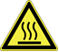  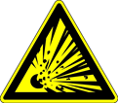 | Fire and explosion hazard  - inhalation of welding fumes  - Dangers to eyes and skin due to UV rays  - Danger due to hot surfaces

Protective measures and rules of conduct
   |  | - Check the device and hoses for defects before use (also valid for the inspection labels).  - Switch on the suction device before starting work and adjust it if necessary  - Protect hoses from damage and prevent standing gas cylinders from falling over  - Wear personal protective equipment and ensure a safe condition:  - Apply skin protection according to skin protection plan  - Wear welding gloves with cuffs (without metal rivets),  - Wear protective goggles with a matched protective filter  - Wear protective sleeves, gaiters, aprons made of flame retardant material or a welder protective suit. Wear appropriate safety shoes in the area  - Make sure that welding assistants wear personal protective equipment  - Take anti-glare measures for others (eg close the curtain)  - Close taps before coupling the welding hoses and at the end of the work.  - Only use welding and soldering equipment after instruction  - Only transport gas bottles with the protective cap screwed on  - When starting up, first open the oxygen valve slightly.  - Secure or remove combustible materials  - When finishing work, first close the burner valve  - Do not bring oxygen bottles and their fittings into contact with oil or grease  - At the end, bend the welding rods due to risk of injury.  - Pay attention to further fire and explosion hazards |  |  |  | - pE

Faults and dangers
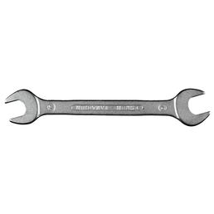 |  | - Defects on the gas bottles and hoses must be reported immediately  - In case of fire, carry out a fire test

Accidents and First Aid
 |  | - The (first responder informing)  - Provide immediate injury  - Emergency call: 144

Tests – Maintenance - Disposal
- Only repaired by instructed and instructed persons
- Clean workplace after work
- Regular inspection of gas cylinders and hoses

Signatures
Supervisor: Signature:

Town: Date:

