 |  |  | Operating instructions | 

Work equipment – Equipment – Apparatus - Device
Handling pressurized gas container / gas cylinders

Dangers for humans and the environment
- Inhalation of inert gases may cause drowsiness or even respiratory arrest. The affected persons should be taken to the fresh air as soon as possible and artificially ventilated if necessary. In the open air, the person is warm and calm.
- If a corrosive gas comes into contact with the skin or eyes, flush the affected area immediately with plenty of water, duration of the flushing for at least 15 minutes.
- Gas cylinders are under high pressure (up to 200 bar) and as the valve is the weakest point of a gas cylinder, its protection with a valve protection cap is obligatory. If a gas bottle is damaged by tearing off the valve so that its high-pressure content suddenly escapes, it can fly around like a bullet and also penetrate concrete walls.

Protective measures and rules of conduct
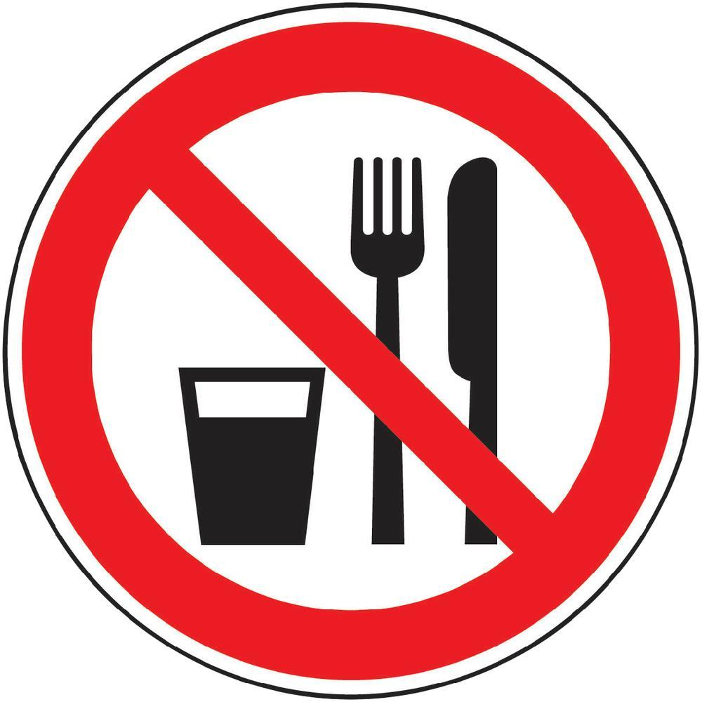  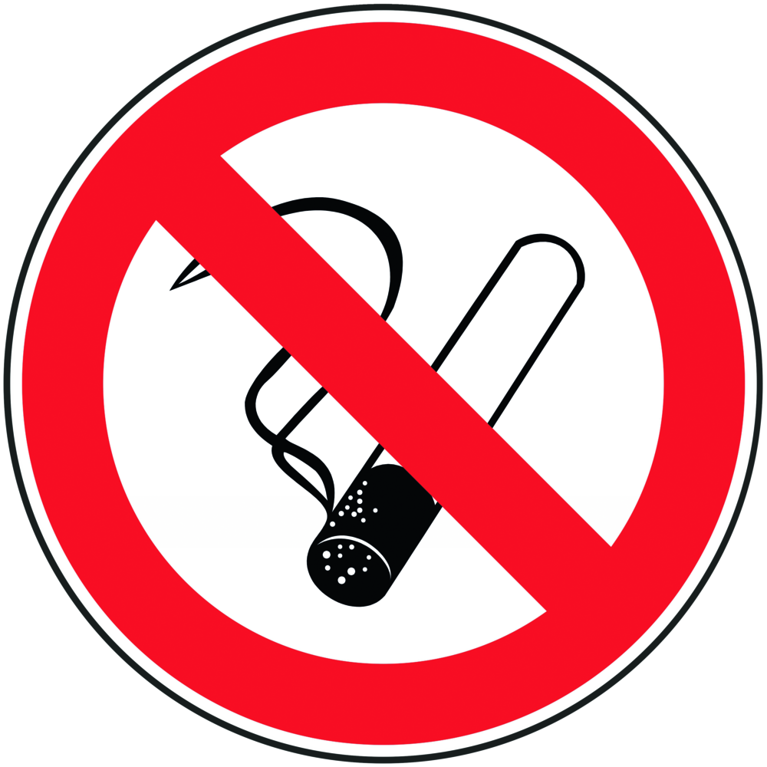  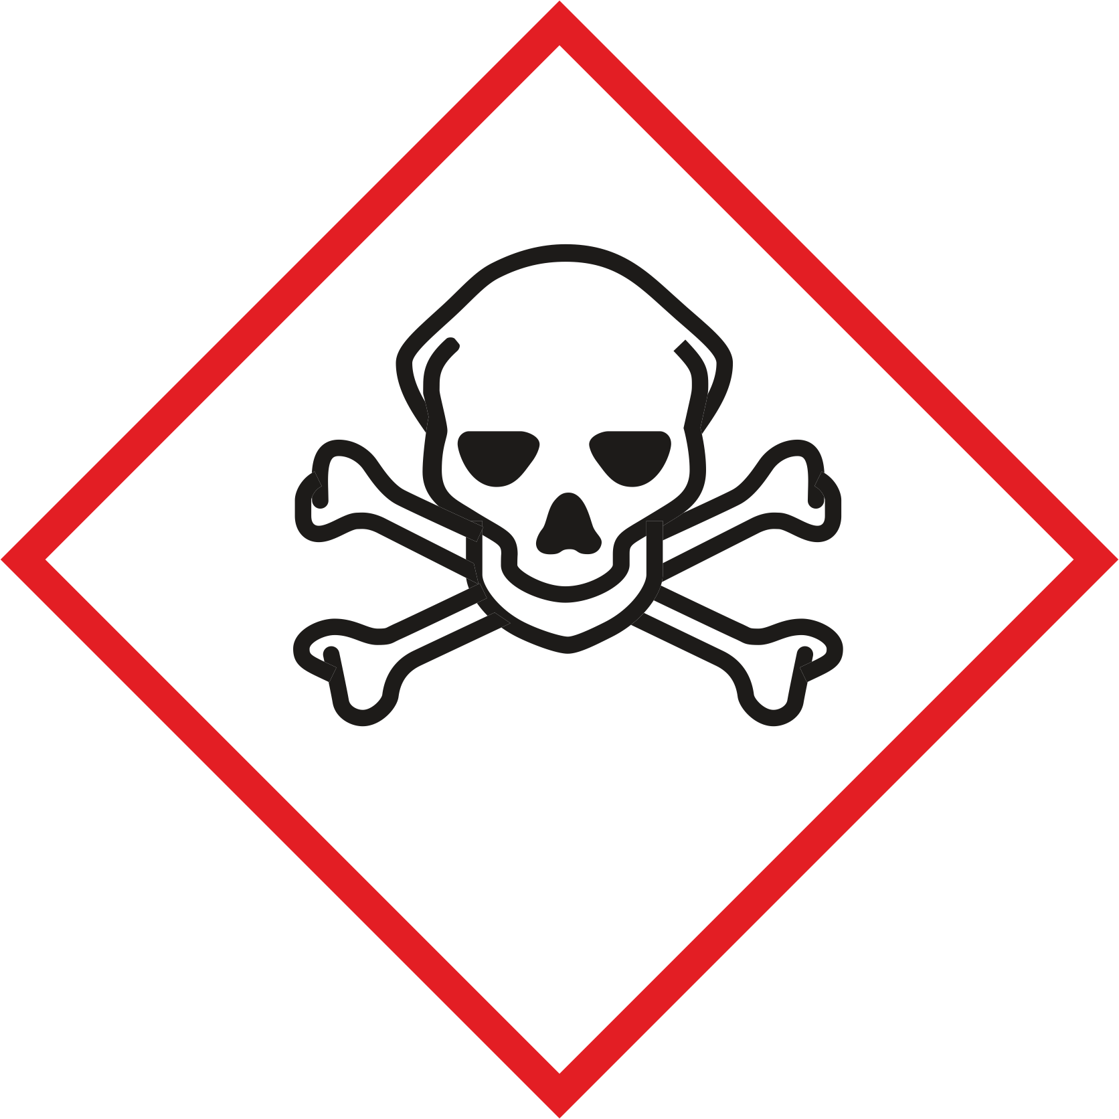  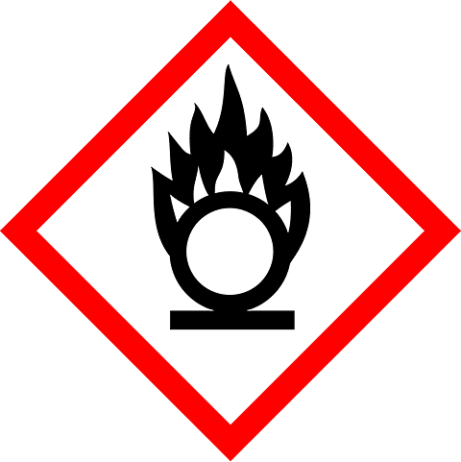   |  | General Information  Prohibition of smoking, eating, drinking, etc.  Obtain information on special properties (pressure, maximum removal quantity flammability, toxicity, explosion limits, material compatibility, possible reactions)  Transport of compressed gas containers with closed valve and screwed-on protective cap (without connected valves!) - see Transport and storage Protect containers against excessive heating by radiators or open flames  Before commissioning (ie. before connecting the compressed gas tank), check the dangerous goods / hazardous substance label to avoid confusion with the gas type or mixture concentrations. The existing markings must not be removed or damaged. Full and empty gas cylinders are to be marked so that there is no possibility of confusion!  Ensure adequate ventilation; in case of toxic gases, use a fume cupboard if necessary, observe the density of the gases (heavier or lighter than air)  Before opening the compressed gas tank valve, make sure that the sampling system is connected gas-tight and flushed if necessary, and that the downstream pressure regulator is depressurised. Before the first commissioning and later periodically, a test of the entire gas supply system for tightness is carried out  In order to avoid too much cooling of the cylinder valve and the pressure reducer, the removal quantity must be adjusted according to the type of gas and the dimensions of the valves. A frozen cylinder valve should only be carefully thawed with warm water, warm towels, or warm gas.  Transport and Storage  Use only suitable devices for transport (for example, bottle trolleys)  The route to which the gas bottles are to be transported should have neither unevenness nor tripping hazards. Take the path in advance to prevent possible risks.  The transfer of the gas cylinder into and out of the car is identified as a handling risk and should therefore be done with the utmost attention.  Gas cylinders should never be moved by just one employee. Another person must be present to open fire doors and help with the movement of the car. If you have any doubt about the location of the gas cylinder, please contact the laboratory manager (s) for assistance.  Almost all major gas cylinder accidents are caused by people trying to catch a falling gas cylinder. A solid cylinder can weigh 70kg. Never try to catch a falling gas cylinder.  Gas cylinders should only be moved between the floors if necessary. A passenger lift may be used, but only the secured gas cylinders alone without the presence of humans.  Storage rooms must have at least sufficient ventilation openings. Gas storage must be  protected against unauthorized access / access.  Compressed gas containers must not be stored in traffic routes, garages, passages, passageways, corridors, staircases and, in particular, not in escape routes. If possible, they should be secured against overturning when lying down and stored lying down only with adequate protection against rolling away.  Gas cylinders must not be stored together with flammable substances (paper, wood, flammable liquid); certain safety distances must also be taken into account here.  Compressed gas containers are to be protected from the effects of the weather (especially rain, snow and sun). In the vicinity of heat sources, the distance should be so large that the surface temperature of the bottle does not exceed 50 ° C.  Compressed gas containers are to be secured against falling over!  Gases with special properties  oxygen  Use only approved and approved materials for oxygen. All parts of the system (especially with manometers, fittings and screw connections) must be kept free of oil and grease and must be marked accordingly. Observe special hazards when indoors and comply with specific regulations  Flammable and self-igniting gases  Extremely important is the tightness of the system. In particular, measures for explosion protection must be observed. All easily ignitable substances must be removed from the range of possible flame formation.  Before putting pressurized gas containers with flammable and self-igniting gases into service, flushing with an inert gas shall remove all air from the system or any other oxidizing gases from the entire sampling system; vice versa, this also applies to decommissioning: All residual gas must be diluted with inert gas to the point of being safe.  Toxic gases  Extreme care requires the handling of toxic gases and gas mixtures with toxic components. Prior to handling such gases, it is necessary to provide the necessary expertise of the operator. The tightness of the system is the top priority. If possible, use a suction system. Take respiratory protective equipment with you or keep it at hand. Remove purge gas from separate bottle to prevent carryover. The function of the non-return valves must be checked regularly and purge gases must be routed via suitable restraint systems. |  |  |  | - pE

Protective measures
Wear safety goggles, safety shoes, and lab coat.

- Use

Read the operating instructions of the corresponding device carefully!
Operating pressure regulators and changing gas cylinders
Correct bottle change

- Close the cylinder valve on the empty container by turning the handwheel clockwise
- Relax the adjusting spring of the cylinder pressure regulator by unscrewing the handwheel in a clockwise direction, whereby the control cone closes the pressure regulator by the spring closing pressure.
- Only then loosen the union nut on the cylinder valve; Attention should be paid to the threading "right" or "left".
- Before connecting the new gas cylinder, check the annular gasket on the regulator for cracks, grooves or other deformations and, if necessary, replace it with suitable material.
- The union nut is first hand-tightened, then tightened with a suitable open-end wrench.
Operation of pressure regulators

- By slowly opening the cylinder valve, the high pressure part of the pressure regulator is flooded
- After just one turn, the valve is fully open.
- The connection should be checked for leaks with a leak detection spray, and in case of leakage do not attempt to seal the connection by tightening the union nut more tightly. Rather, the connection is to be solved again and replace the seal.
- Then set the desired working pressure again by turning the handwheel on the adjusting spring.

Faults and dangers
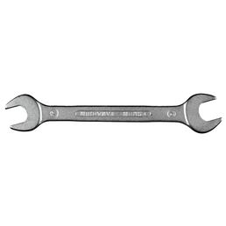 |  | In case of failure, immediately remove heat sources, then ventilate the equipment and finally switch off the pump.

Accidents and First Aid
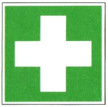 |  | Bring injured person out of the danger area  • Provide first aid, paying attention to self-protection  • Inform first responders (see separate notice board), send emergency call  • instruct rescue personnel  • In the case of injuries, only allow broken glass fragments to be removed by the doctor

Tests – Maintenance - Disposal
Only instructed personnel may handle or work with pressurized gas containers. The
Instruction must be repeated regularly (at least once a year).

Signatures
Supervisor: Signature:

Town: Date:

