 |  |  | Operating instructions | 

Work equipment – Equipment – Apparatus - Device
Fotometer

Dangers for humans and the environment
  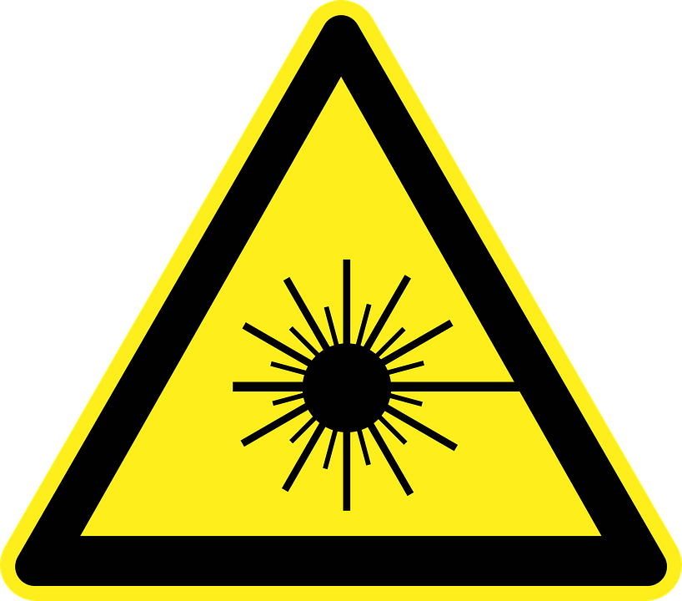 |  | - Deuterium lamp - danger from UV light  - Danger of combustion at the deuterium lamp and its environment.  - The general rules for handling electrical appliances apply (see relevant operating instructions).

Protective measures and rules of conduct
  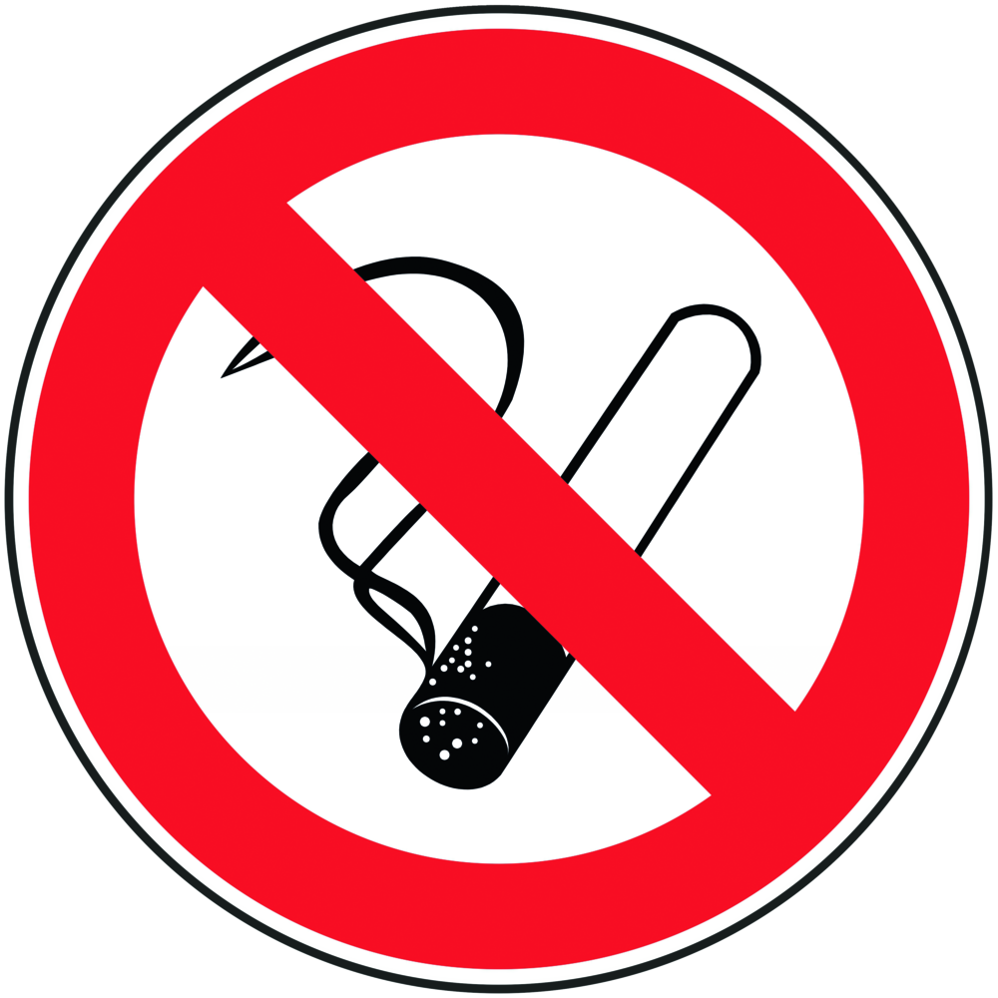   | - General information  - Eating, drinking or smoking is prohibited in all laboratory facilities!  - Never look into the switched-on deuterium lamp!  Personal protective measures  - During laboratory work, always wear a laboratory coat.  - Wear UV protection glasses when the deuterium lamp is exposed.  - Allow all parts to cool before placing the deuterium lamp or parts in the  - Adjusts or replaces the surroundings of the lamp.  - Wear laboratory gloves and goggles  Use  - Constant use temperature (between + 15 ° C to + 35 ° C)  - Constant humidity (between 20% - 80%)  - Do not expose to direct sunlight  - Do not pour liquids over the spectrometer!  - There must be enough space around the device for free air circulation.  - Under the device, a layer of thick filter paper can be laid out to absorb any escaping liquids.  - Leave samples in the measuring chamber for the duration of the measurement only.  - Wipe off any spills or spills immediately, being careful not to scratch the windows.  - Keep all optical parts clean and protect against scratches!  Use of the cuvettes:  - Always touch the cuvettes on the dull sides  - Protect cuvettes from scratches or damage!  - Do not use harsh detergents  - When filling, be careful to trap small air bubbles  - When measuring cold liquids, ensure that condensed water can precipitate!  - Fill the cuvettes far enough so that the meniscus is just above the light beam in order to be able to compensate for any pressure increase in the cuvette. |  |  |  |  | - pE
Recommended procedure (internal research group recommendation)
Clean quartz glass cuvettes with acetone. Switch on photometer and PC, a short self-test of the device takes place. Start program "lambda 20". Cover samples in the cuvettes cover and set in the sample holder. Put in the first place the reference, filled with the respective solvent. The matte sides show forward / backward. Select the respective method on the PC, set the parameters, confirm with "setup".
Start the measurement with "Start". For values above 1.2, the sample must be further diluted, as the Measurement is otherwise inaccurate.

Faults and dangers
 | - Service work and repairs may only be performed by service technicians authorized by the manufacturer.  - If safe operation can no longer be guaranteed, pull out the mains plug and secure the device against being restarted.

Accidents and First Aid
 | - First Aider: Pay attention to self-protection!  - If necessary, alert first responder, ambulance or doctor.

Tests – Maintenance - Disposal
The device should be kept clean and dust-free.
Maintenance may only be performed by authorized personnel.

Signatures
Supervisor: Signature:

Town: Date:

