 | Operating instructions | 

Disposal
Formaldehyd solution

Contaminated resources
Other organic solvents, washing liquids and mother liquors

Contaminated solids
Other organic solvents, washing liquids and mother liquors (e.g. Formaldehyde) |  |  | - pE

Clippings
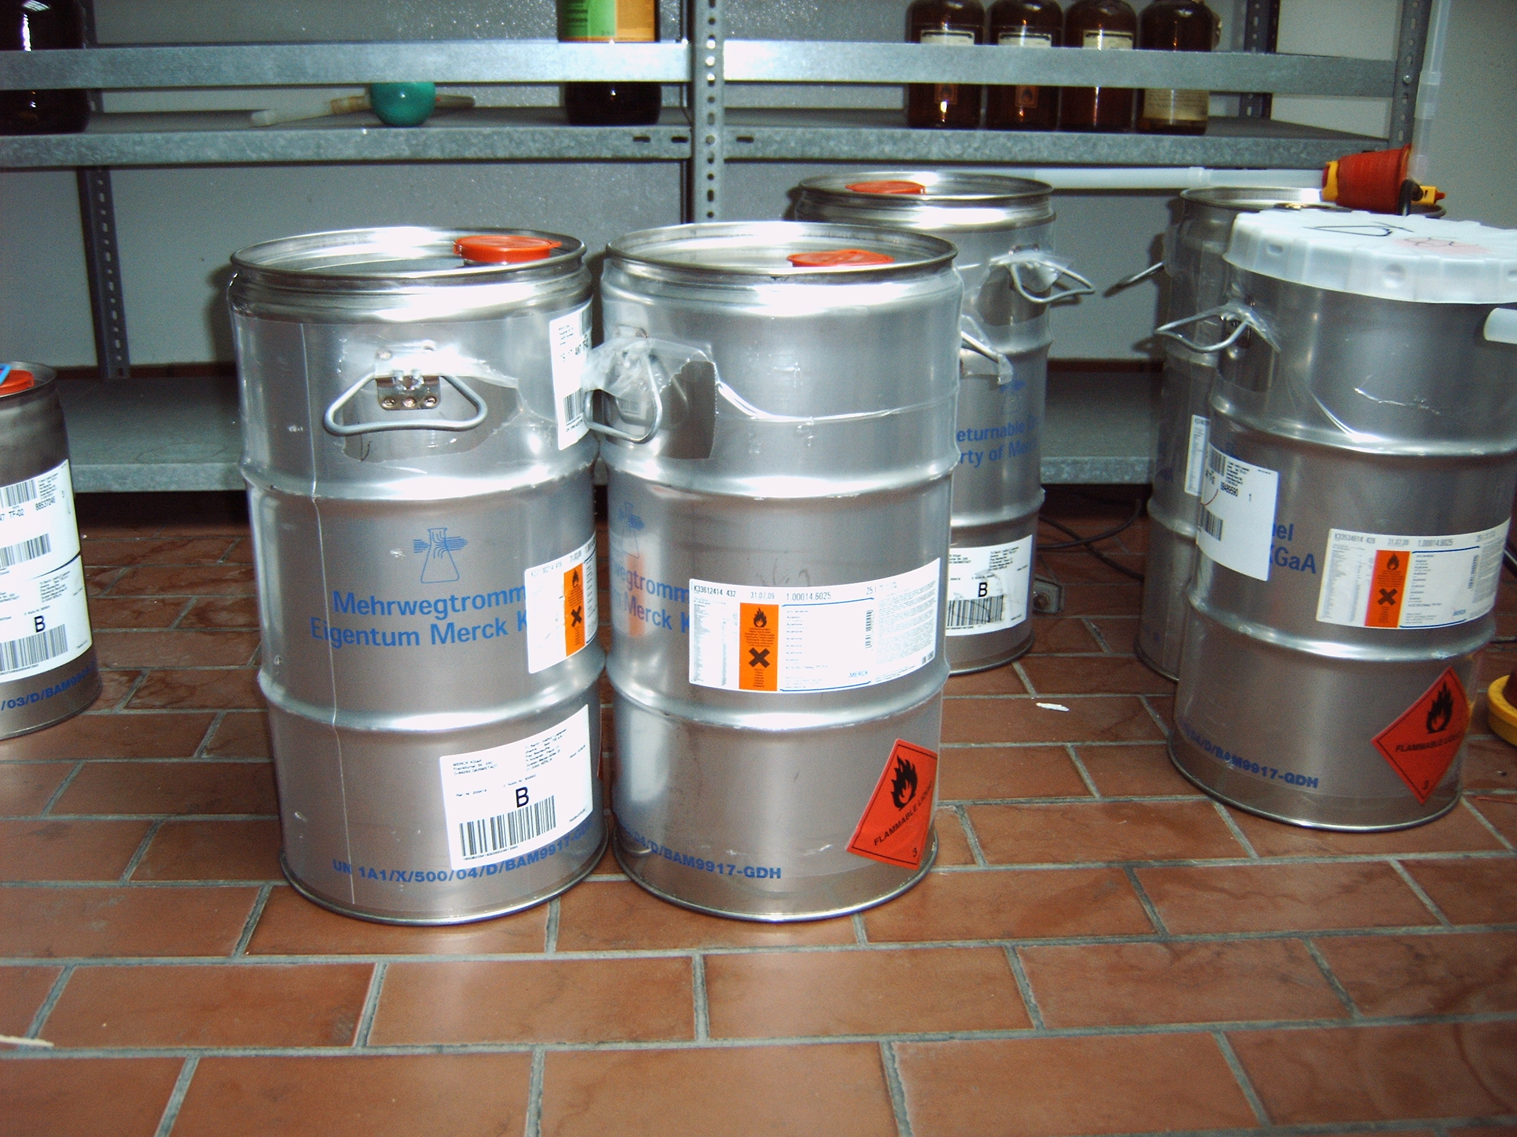
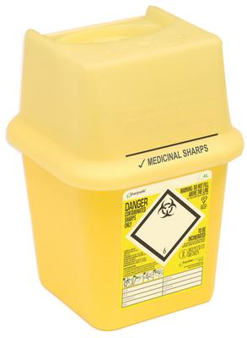
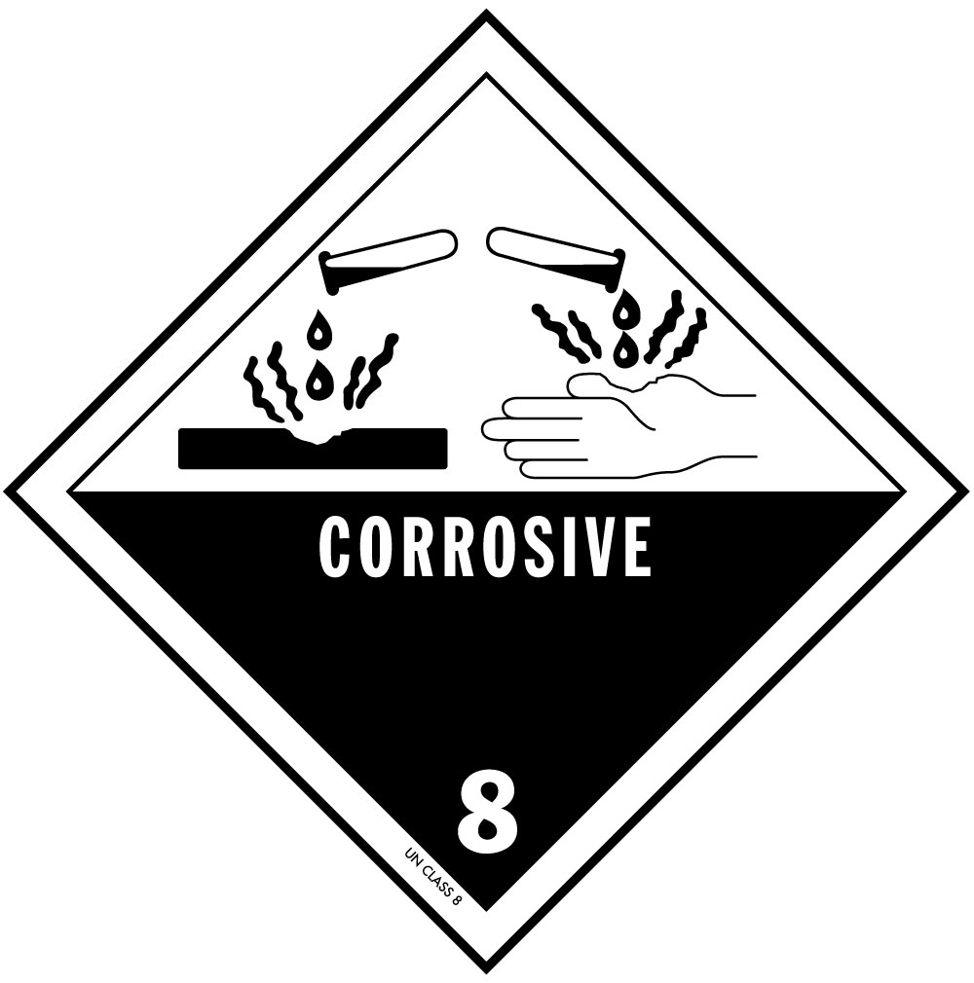
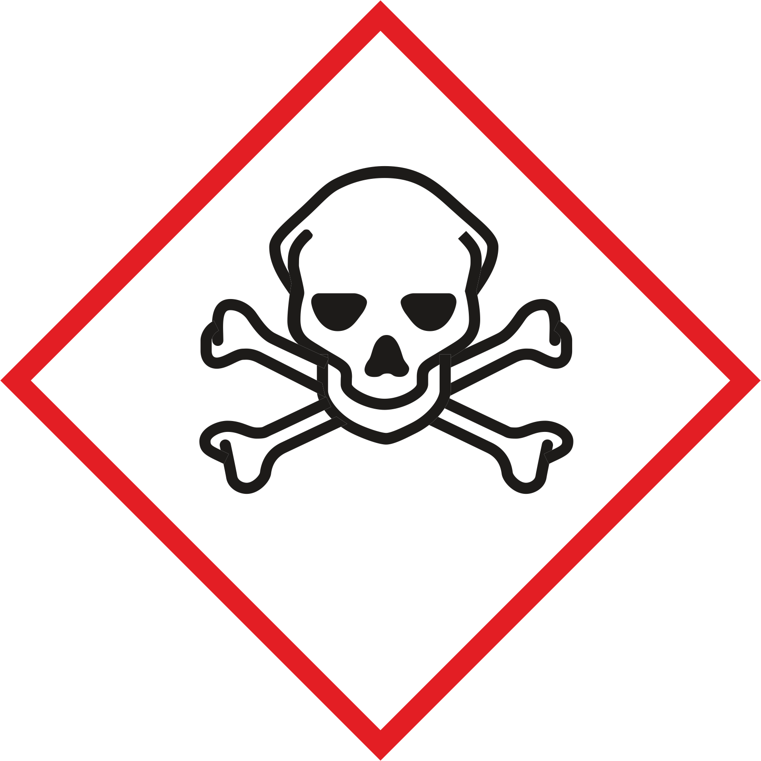
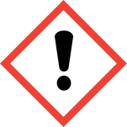

NOT to be collected together with this waste type:
- Other chlorinated solutions
- Dissolved chlorine compounds
- Halogenated or Hg-containing solutions
- Oxidizing acids (e.g. HNO₃)

Signatures
Supervisor: Signature:

Town: Date:

