 |  |  | Operating instructions | 

Work - Equipment - Apparatus -Device
Fixing agent for light microscopy

Dangers for humans and the environment
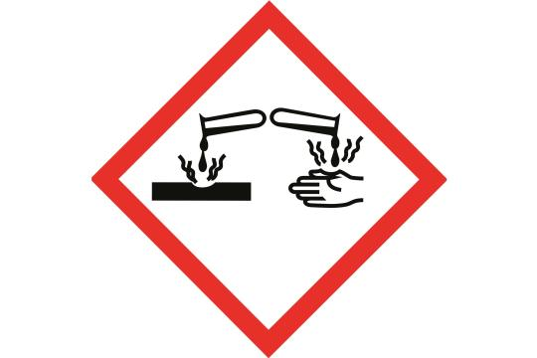  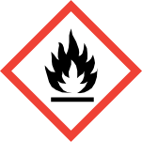  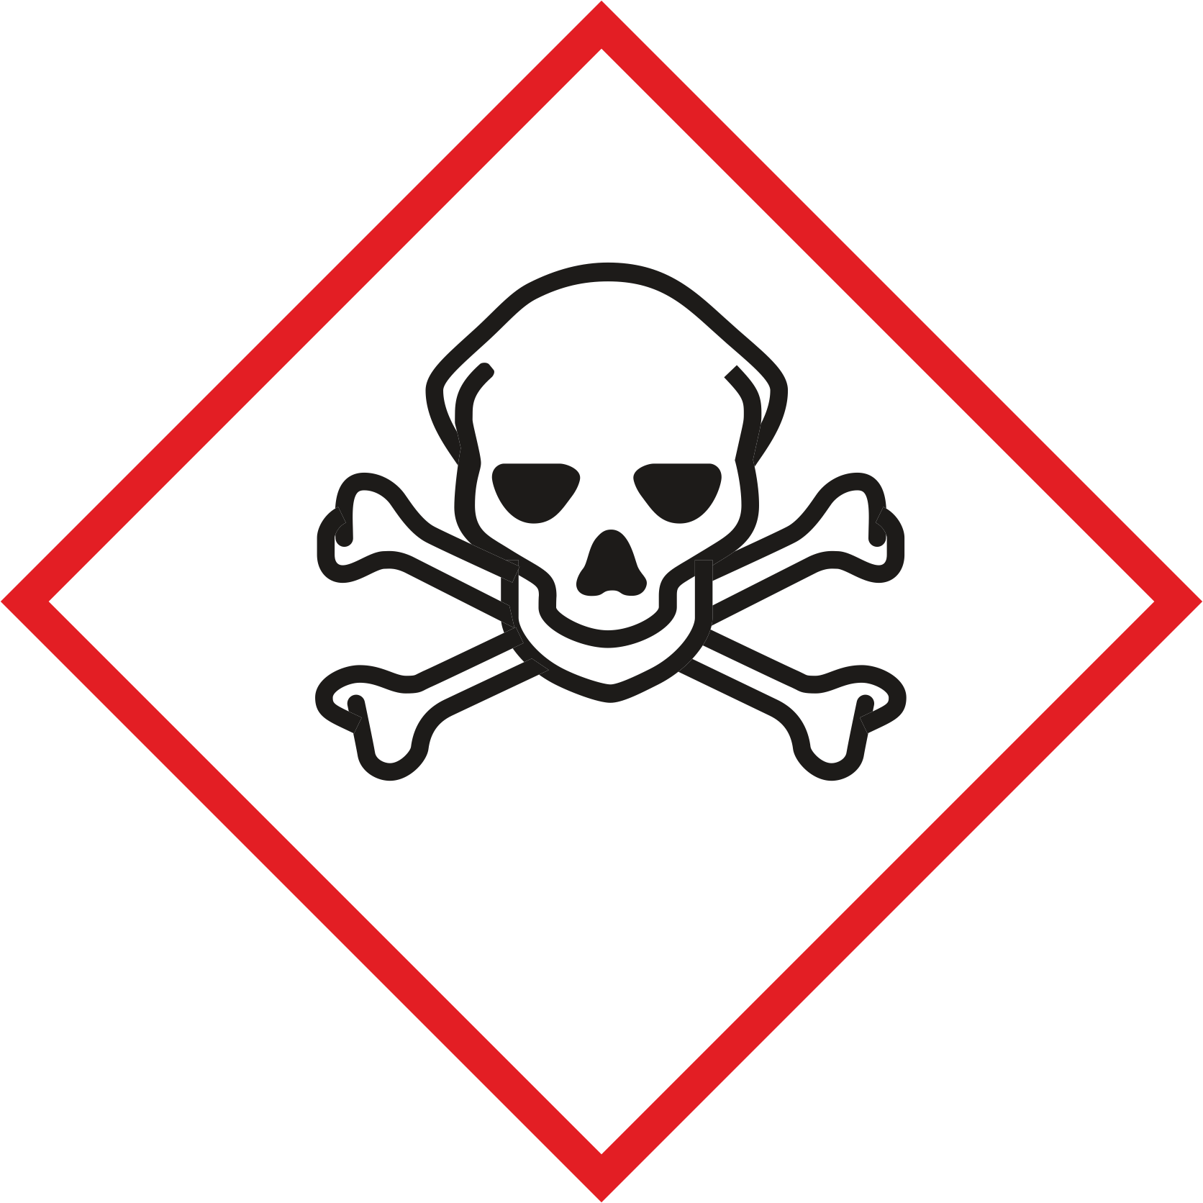  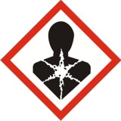  Formaldehyde solution: T, C, Xn, Xi  Propionic acid: C  Ethanol: F  Mixing ratio 90T Ethanol 50%: 5T Formaldehyde: 5T Propionic acid  chem. formula and details for the individual chemicals see Safety Data Sheets  Protective measures and rules of conduct | formaldehyde  Toxic if swallowed, in contact with skin, Inhalation  Severe burns to the skin and eyes  propionic  Severe burns to the skin and eyes  Flammable liquid and vapor  ethanol  Highly flammable vapor and liquid in higher concentrations
Disruptions and Dangers    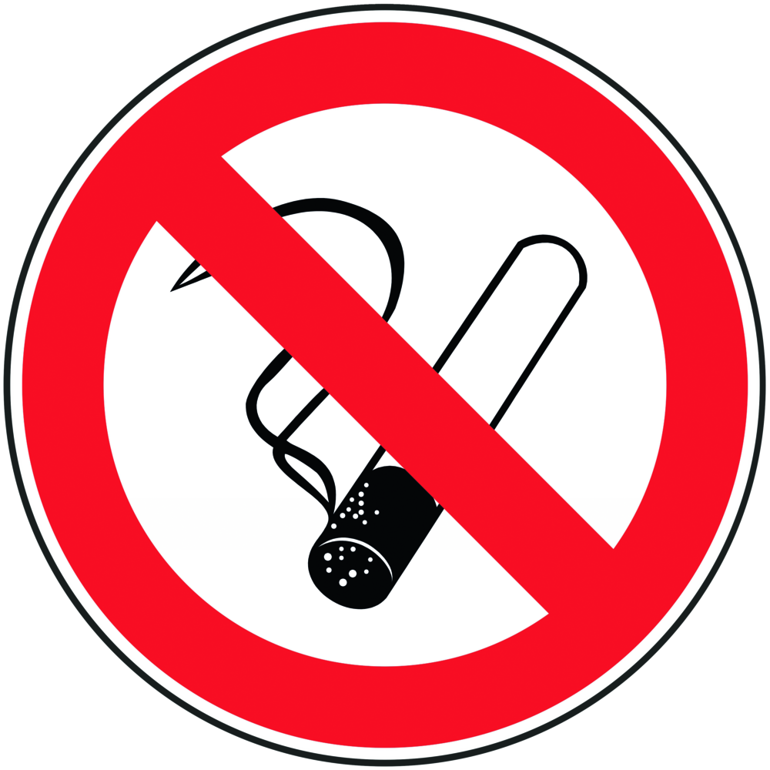  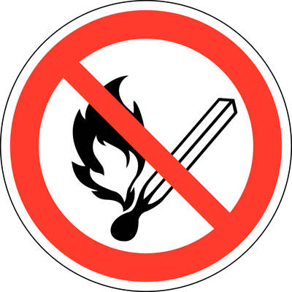  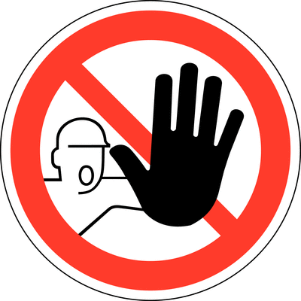  Persönliche Schutzmaßnahmen  Bei gefährlichen Arbeiten in Laboratorien ist das ständige Tragen einer Schutzbrille, eines Labormantels, sowie festen, geschlossenen und trittsicheren Schuhwerks Pflicht. |  | General information  Preparation of the fixing agent under the trigger.  Open storage bottles with formaldehyde and propionic acid only under the hood.  Do not inhale vapors. Avoid skin contact  Keep liquids away from open flames, hot surfaces and sources of ignition  The general rules of conduct for chemical work apply (prohibition of  Smoking, drinking, eating)  Required protective equipment:  safety goggles  Gloves (nitrile rubber, blue)  Lab coat |  |  |  | - pE


Use and storage:
Fixing mixture in small quantities (1L) can be stored in the laboratory
The storage bottles for formaldehyde and propionic acid must be stored in a ventilated chemical cabinet.

Production of the fixative and fixation of plant material
For the production of 1L FPA50 (trigger, gloves, goggles, lab coat)
- Fill 800 ml of ethanol 50% (EtOH) in Schott bottle
- Add 50 ml of formaldehyde solution and then 50 ml of propionic acid with a graduated cylinder.
- Add the remaining 100 ml EtOH 50% with the same graduated cylinder
- Rinse cylinder well with well water first, then with A.dest.
Transfer plant material to sample container (type depends on the sample size:
Eppendorf tubes - scintillation vials - 4-edge containers ...) and cover well with fixative solution
(Gloves, goggles, lab coat).
For an optimal fixation effect, the container should only be filled loosely with plant material.
Leave plant material in the fixation medium until further processing, at least 24 h.
Store specimens in a well ventilated, cool room.
Transfer fixed plant material to petri dish containing 70% ethanol for further analysis

Disruptions and Dangers
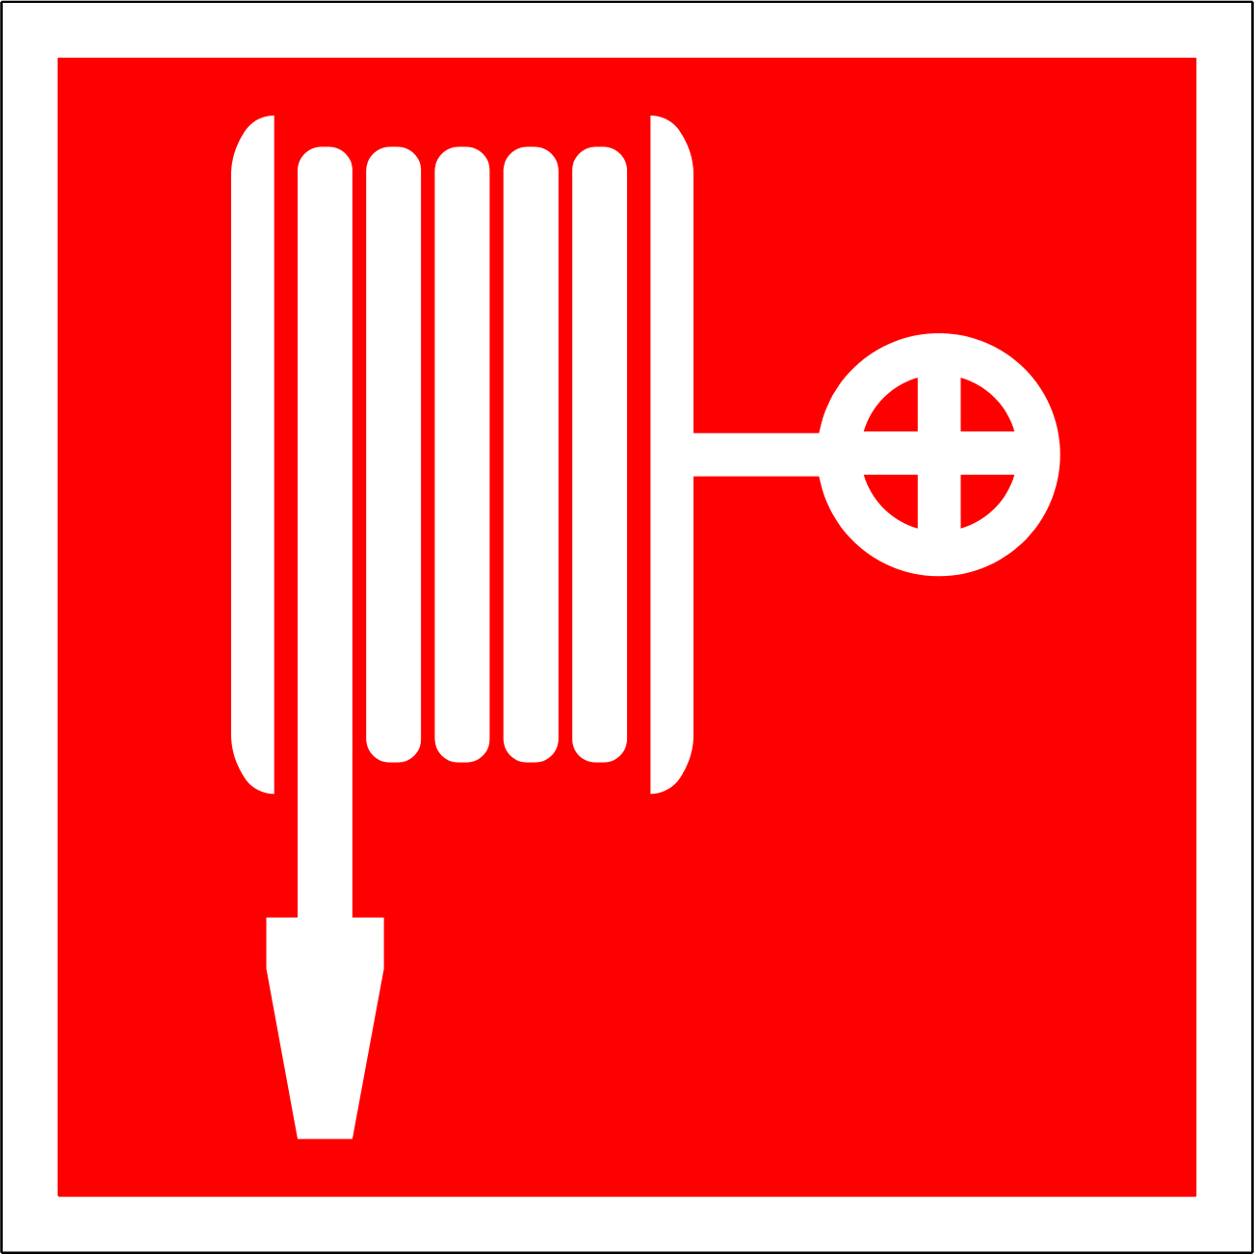  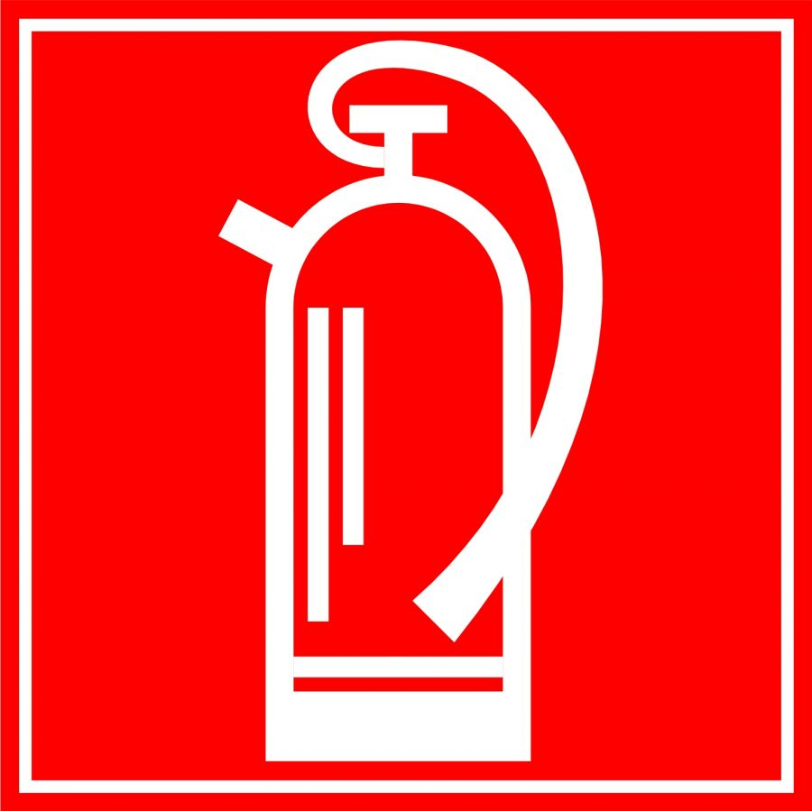 |  | Suitable extinguishing agents  Water, carbon dioxide, foam, dry powder,  Unsuitable extinguishing media: none  For formaldehyde and propionic acid, the formation of hazardous combustion gases or  Vapors possible; Vapors are heavier than air.

Accidents and First Aid
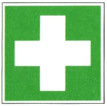 |  | For formaldehyde and propionic acid  After inhalation: fresh air, consult a doctor.  After eye contact: Remove contact lenses, rinse thoroughly with plenty of water for at least 15 minutes, consult an ophthalmologist immediately  After skin contact: rinse with plenty of water, remove contaminated clothing  Ingestion: Rinse mouth with water, drink water immediately (max 2 glasses), DO NOT induce vomiting, do not attempt neutralization, seek medical advice immediately

Tests - Maintenance - Disposal
Do not empty used fixative into pour; marked with "FPA50-used"
Collect canisters and dispose of chemicals.

Signatures
Supervisor: Signature:

Town: Date:

