 | Operating instructions | 

Disposal
Equipment contaminated

Contaminated resources
(e.g., filter materials, wipes, silica gels, activated charcoal, small empty metal and plastic containers with chemical stains, pipettes, gloves, TLC plates, films, microbiological culture media, electrophoresis containing ethidium bromide)

Contaminated solids
(e.g. silica gel, TLC-plates, celite, contaminated gloves or glassware, charcoal, ethidiumbromide contaminates gels, empty contaminated chemical bottles, pipettes, needles and syringes) |  |  | - pE

Clippings
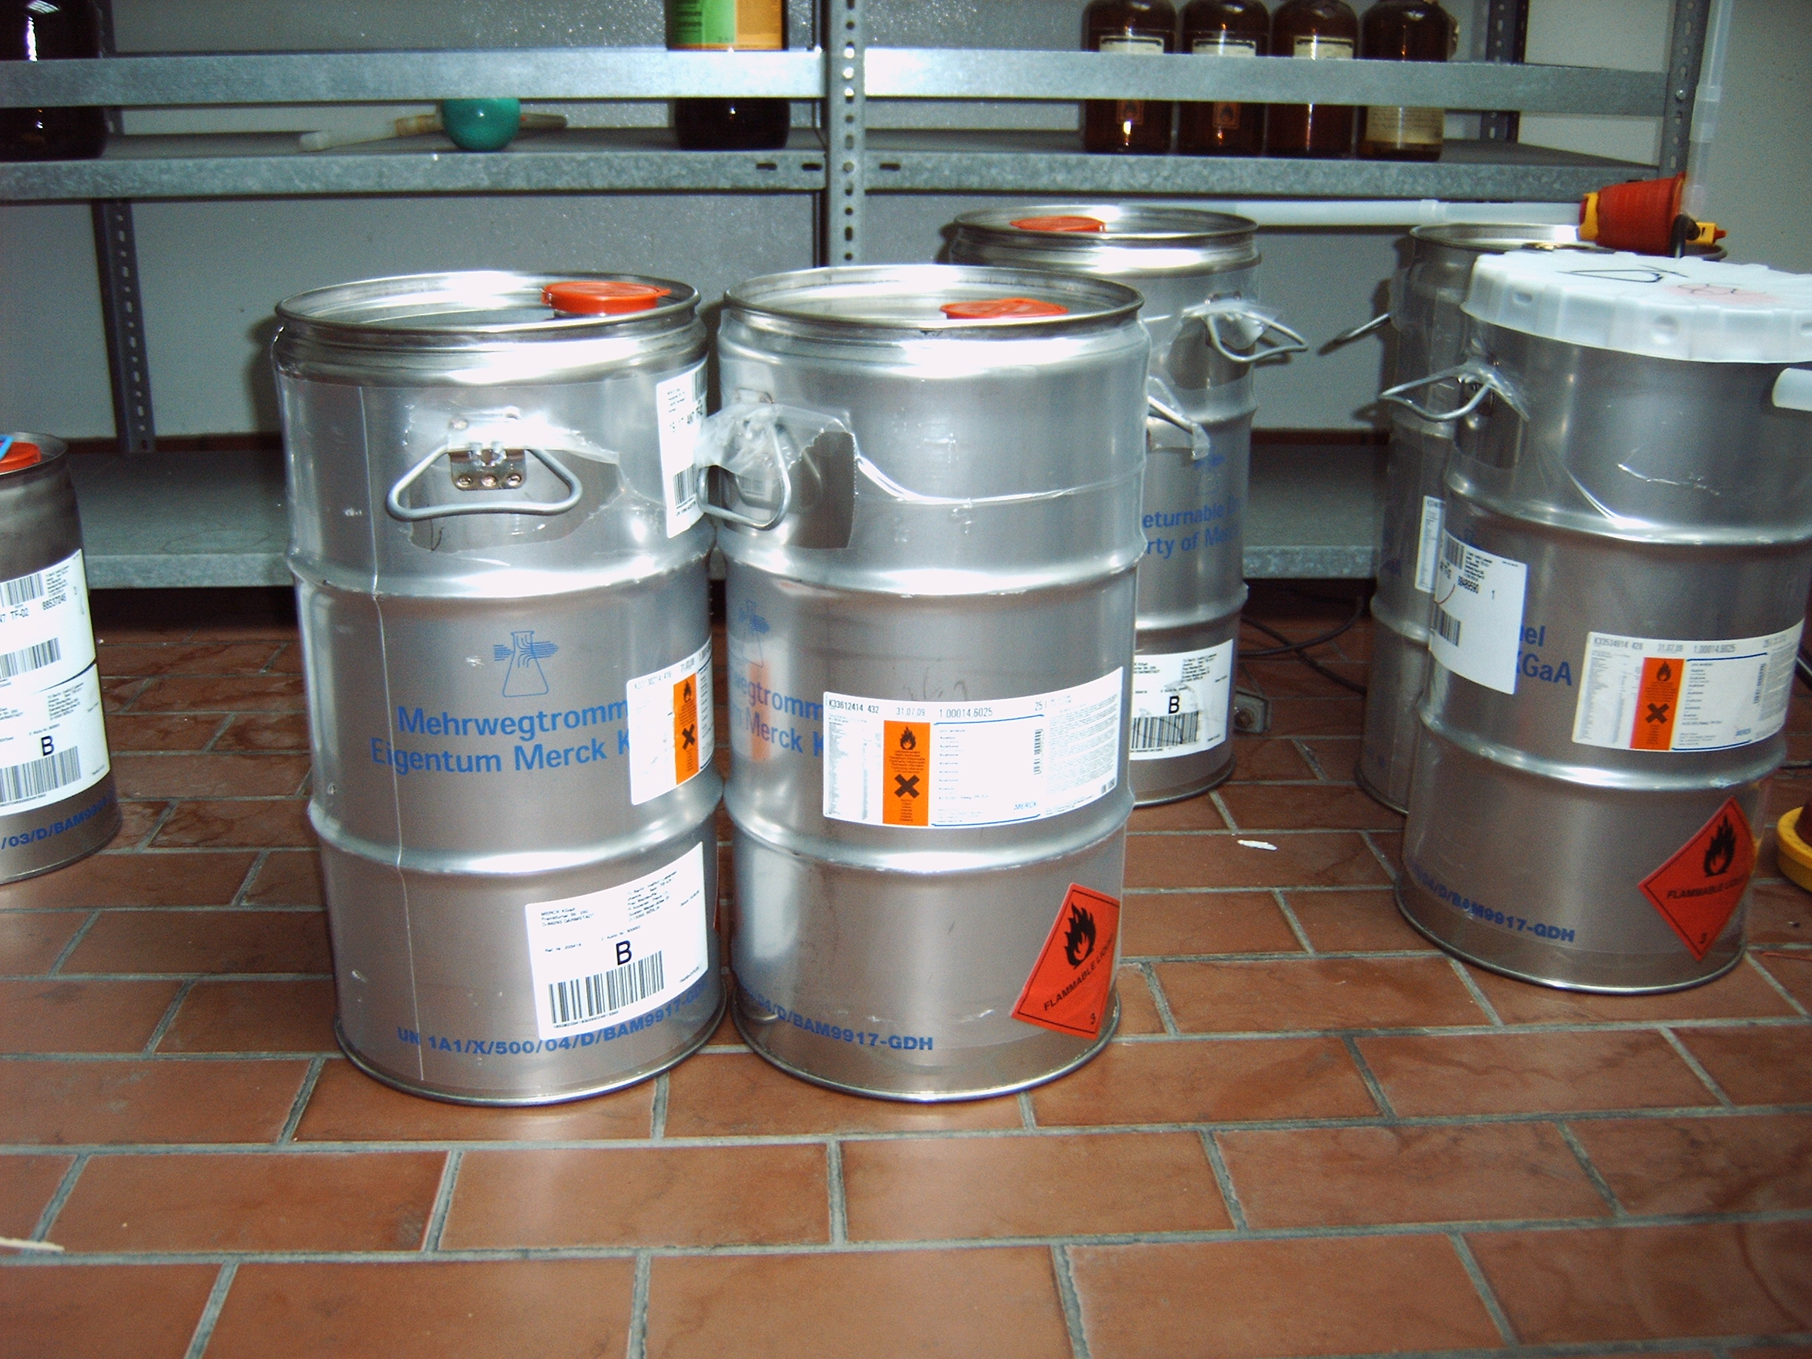
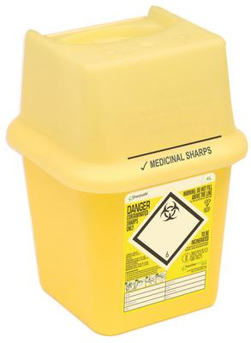
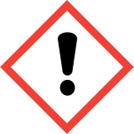
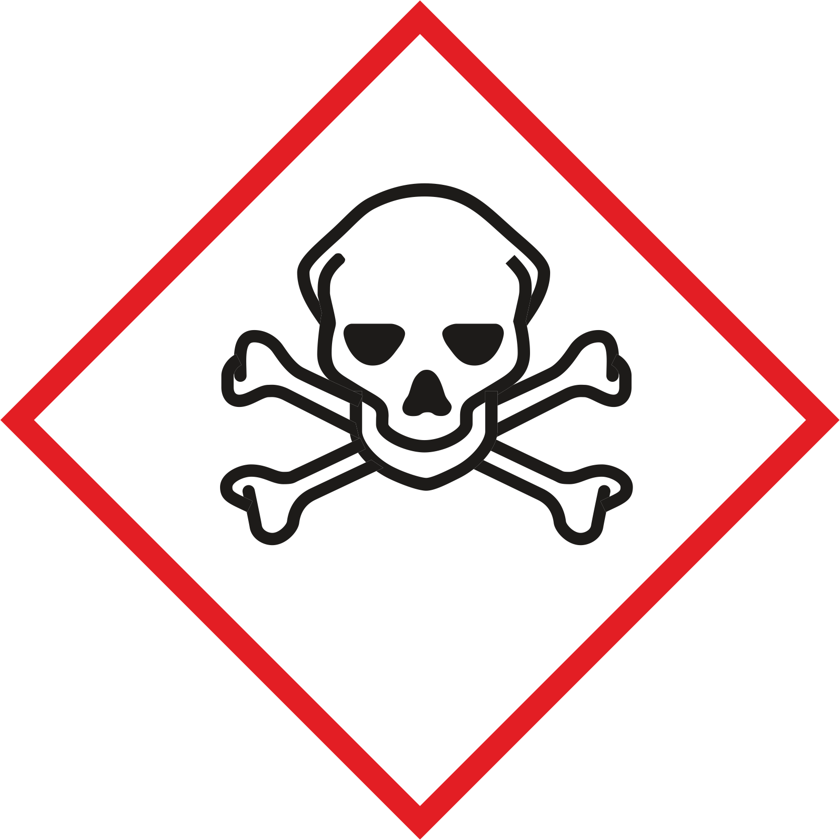
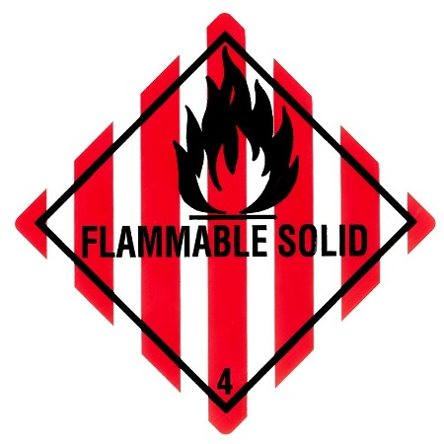

The following substances may not be collected together with this type of waste:
• liquids or pasty substances, solutions
• old laboratory chemicals
• Mercury-containing waste
• aerosols, cans
• Glass, ceramics, except small parts

Signatures
Supervisor: Signature:

Town: Date:

