 |  |  | Operating instructions | 

Work equipment – Equipment – Apparatus - Device
Electric welding

Dangers for humans and the environment
- Infrared or ultraviolet radiation (arc), flare of the eyes
- Flying sparks, danger of fire, burning of the skin
- Electric shock
- Welding of containers: Danger due to residues of the ingredients!
- Welding fumes: health hazard during welding work on high-alloyed workpieces, metallic coatings, paint coatings, plastic coatings, contamination by oils, greases or residual
solvents etc.

Protective measures and rules of conduct
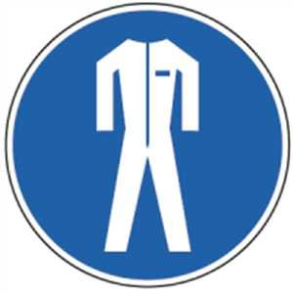 | - For welding work in areas with a fire and explosion hazard, obtain a welding permit  - Remove or cover combustible parts from the environment  - Provide fire extinguishers  - Check the welding generator, cable, electrode holder and ground terminal for defects before use  - Establish good conductivity between earth cable and workpiece  - Switch on the suction device before starting work and adjust if necessary  - Always place the burner in an insulated position (if possible, remove the electrode residue)  - Protect cables against damage, use cables with insulated couplings  - Do not clamp the welding wire holder and inert gas welding torch under the arm and place it only on insulating shelves  - Position protective gas bottle securely and secure against falling over  - Observe the operating instructions "Electrical welding under increased electrical hazard" when welding under increased electrical hazard  - When welding containers with flammable liquids, empty container completely and fill with water  - Use protective shield or protective shield with welding protection filter, wear sweat-proof gloves and clothing, also for welding assistants  - Switch off the welding machine before connecting the welding cables  After completing the welding work, ensure a fire station |  |  |  |  | - pE

Faults and dangers
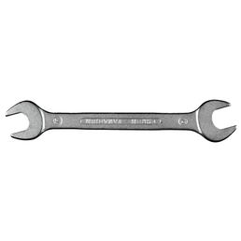 | - In case of defects, do not use the device and inform the supervisor  - If the extraction system fails, discontinue work and inform supervisors

Accidents and First Aid
- Keep Calm
- Involve first responders
- Emergency call: 144
- To report an accident
- In the event of a power accident:
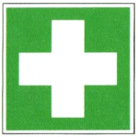
- Disconnect the power and remove the injured from the circuit
- In case of respiratory or cardiac arrest initiate resuscitation and alert the emergency physician

Tests – Maintenance - Disposal
- Performing maintenance work only by authorized specialist personnel
- Replace damaged insulating jaws and welding wire holder immediately
- Change the wire reels only when they are de-energized

Signatures
Supervisor: Signature:

Town: Date:

