 |  | Operating instructions | 

Work equipment – Equipment – Apparatus - Device
Electrical installations, equipment and lines in the office and in the laboratory

Dangers for humans and the environment
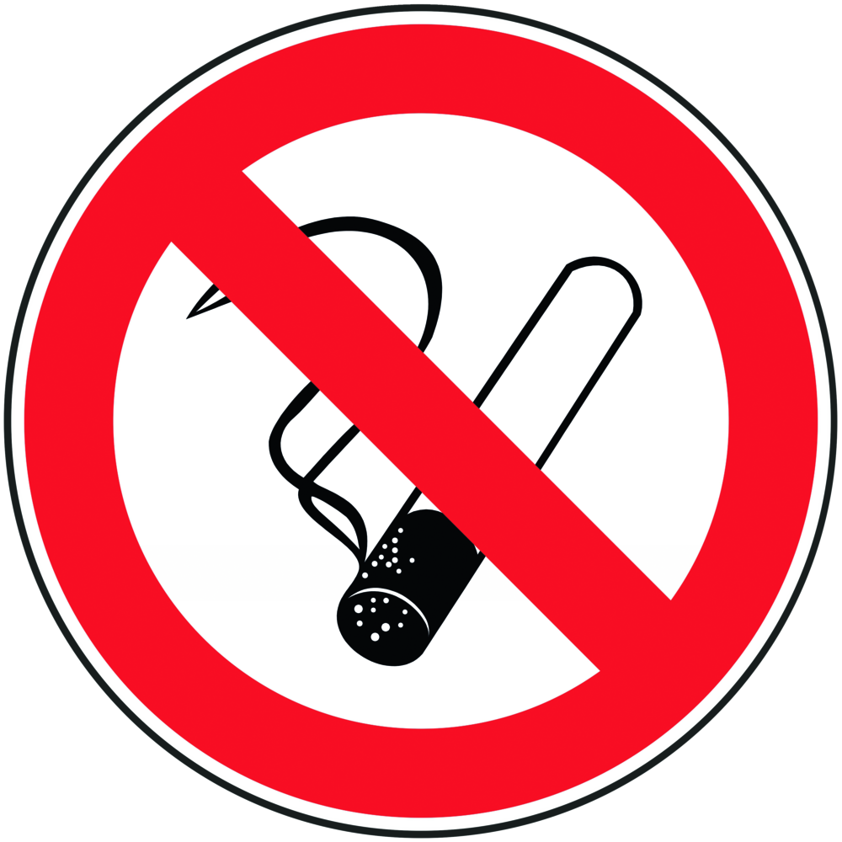  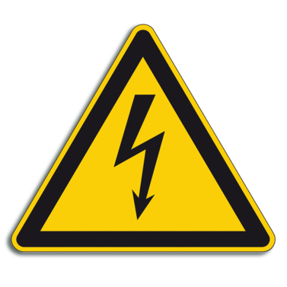   | CAUTION – ELECTRICITY  - Risk of fire due to defective electrical cables  - Risk of electric shock, device must not get wet during operation.  - Danger to life due to electric current during electric shock.  - Health consequences (possibly time-delayed): Injuries, burns, damage to internal organs, cramps, respiratory arrest, cardiac arrhythmia, ventricular fibrillation, cardiac arrest and internal burns.  - In principle, all devices may only be used in accordance with the instructions in the manual and after proven training.  Protectid rules of conduct  - Eating, drinking or smoking is prohibited in all laboratory facilities!  - Safety data sheets and operating instructions for the respective working substances,  chemicals and methods must be verifiably read and adhered to.  - Before using a new device, read and follow the instructions for use.  - Familiarize yourself with the safety features before starting work, especially with the location of the EMERGENCY STOP switch or fuse.  - Before use, check the electrical equipment , equipment and wiring for proper condition.  - Report damage and unusual conditions immediately to supervisors and professionals. Do not use the devices and secure against unintentional operation.  - Only operate electrical devices on correct protective contacts.  - Do not handle unsecured cables and device components.  - Existing safety devices – Use fuses.  - All cables must be insulated.  - DO not lay cables over traffic routes and do not use cable bridges.
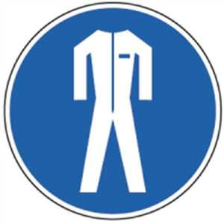 | - Do not hang objects on electric cables.  - Do not pull the plug out of the socket by the connecting cable.  - Do not connect multiple sockets in a row, do not overload extension lines.  - Lay the cables in such a way that squashing points or damage caused by sharp edges are avoided.  - Do not use devices when wet, even with wet hands.  - Before switching on an electrical appliance, make sure that all safety measures have been taken.  - Do not carry out any repairs on electrical devices, systems or devices yourself  - Only use the original power plugs for the respective device.  - Personal protective equipment  Depending on the risk potential of the work or method to be performed on the device, the PSA must be connected!  • lab coat  • Protective gloves  • Safety goggles |  |  |  | - pE

Faults and dangers
 | - In case of visible damage, do not operate the device.  - In the event of a fault, immediately unplug the power cord and switch off the fuse.  - Inform superiors.  - Repair and repair must be carried out exclusively by specialist workshop or customer service.

Accidents and First Aid
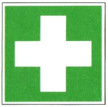 | - Before starting work, find out where bandages, fire blankets, etc. are stored.  - First self-protection - secure device, system, accident site.  - Do not touch the device  - Switch off the fuse  - Never touch a person who has electric current flowing through them.  - Provide first aid. Cool burns with water, immediately initiate cardiopulmonary resuscitation  - if there is no breathing and no pulse.  - If there is no respiratory and circulatory arrest, bring the victim to the stable side position  - Report an accident by emergency call  - Inform first responders, security specialists and supervisors  - Seek medical attention even in the event of an apparently electric shock!  In case of fire: keep calm! Pay attention to self-protection! Call fire department over 122!  Employees warn! Combat fire with powder, CO2 or foam extinguishers!

Tests – Maintenance - Disposal
- Maintenance and repair work may only be carried out with the permission of the working group management.
- Repair and repair must be carried out exclusively by specialist workshop or customer service
- Disposal via waste collection points or specialist dealers.

Signatures
Supervisor: Signature:

Town: Date:

