 |  |  | Operating instructions | 

Work equipment – Equipment – Apparatus - Device
Edge Bank

Dangers for humans and the environment
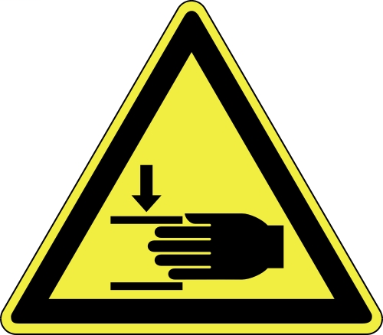 | - Risk of severe cuts due to sharp edged metal sheets  - Bruising by moving up and down the bending beam or through the upper beam  - Jumping out of improperly clamped workpieces  - Clamping clothes when clamping workpieces

Protective measures and rules of conduct
  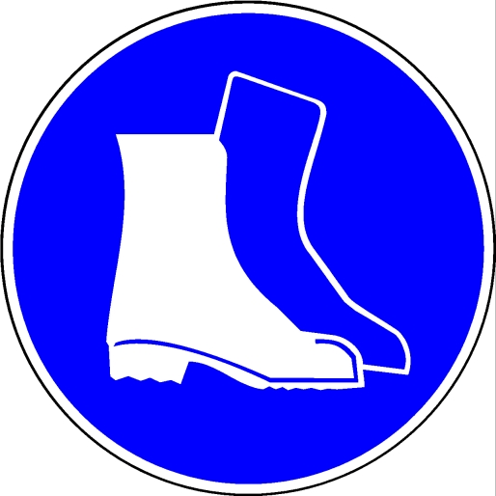   |  | - The operating instructions of the manufacturer must be observed!  - Never override safety devices (for example, to clear jammed workpieces)  - Do not exceed the prescribed thicknesses or bending radii  - Keep the workplace clean and tidy. Store workpieces to be machined only in the immediately required quantity in the work area  - Pay attention to the distance of the hands when setting the workpieces  - Stepping out of the swivel range of the bending beam  - Wear tight fitting clothes  - Scarves, watches, hand and arm jewelery are not allowed  - wear gloves (against cuts)  - Working with two people only after consultation with the responsible person  - Do not put your hands in the danger area |  |  |  | - pE

Faults and dangers
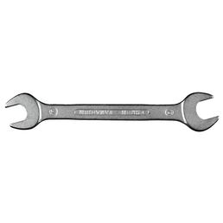 |  | - Secure the device in the event of damage to the device or its protective equipment  - Have damage repaired by qualified personnel only

Accidents and First Aid
 |  | - secure the device  - Inform first responders  - Provide immediate injury  - Emergency call: 1

Tests – Maintenance - Disposal
- Repair only by authorized and qualified persons
- After maintenance, the protective equipment must be checked.
- Clean the machine after work

Signatures
Supervisor: Signature:

Town: Date:

