 |  |  | Operating instructions | 

Work equipment – Equipment – Apparatus - Device
Drying Ovens

Dangers for humans and the environment
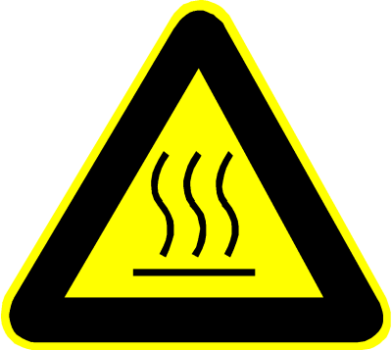  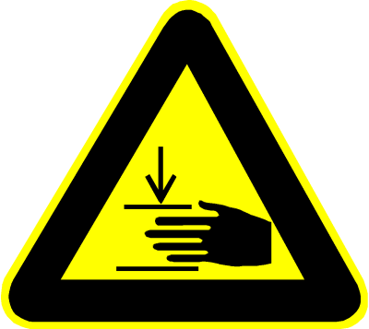   |  | There are hazards due to:  - Risk of burns from fingers and hands on hot surfaces.  - Danger of crushing the fingers when pushing in the hordes or when closing the door.  - Irritation of the respiratory tract due to dust formation, especially with dried material.  - Irritation of the respiratory tract due to substances contained in the product, e.g. Solvent.  - Possibly. Irritation of the skin in direct skin contact with the dry matter.  - Risk of explosion in the presence of flammable solvents  - Risk of fire in combustible dry matter due to spontaneous combustion  - Slipping hazard due to spilled product.

Protective measures and rules of conduct
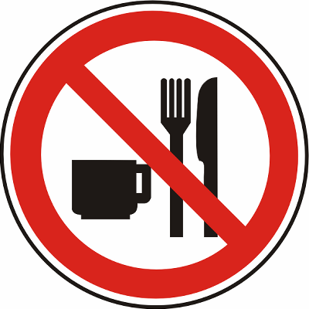 | - The employees must be instructed in the handling of the drying oven.  - Wear mandatory PPE (basis: risk assessment).  - Take care when handling the substances to be dried, if necessary observe BA hazardous substances.  - Pick up spilled product immediately and dispose of according to the operating instructions.  - Clean and care for hands after contact with the product (see skin protection plan).  - Extract exhaust air from the drying oven as far as possible to the outside, if necessary clean it with an exhaust air scrubber.  - Always close the drying oven well.  - For drying with flammable solvents, use only Ex-protected technical equipment.  - Observe Ex protection guidelines. |  |  |  |  | - pE

Faults and dangers
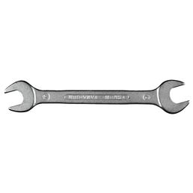 | - Do not use the drying oven in case of defective or faulty extraction.  - Only rectify faults in the electrical heating by qualified electricians.  - Do not use the drying oven in case of defective or faulty extraction.  - Only rectify faults in the electrical heating by qualified electricians.

Accidents and First Aid
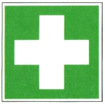 | - In case of skin contact with the product to be dried, rinse with plenty of water, consult a doctor if necessary. Injured skin increases the health risk significantly.  - Depending on the type of injury, provide first aid as far as possible, call for help if necessary.  - Instruct assistants and point out special dangers.  - Emergency call: 144

Tests – Maintenance - Disposal
- Regularly check drying oven for proper condition (see manufacturer's recommendation).
- Dispose of drying cabinets only after sufficient cleaning in accordance with legal regulations (electronic waste).

Signatures
Supervisor: Signature:

Town: Date:

