 |  |  | Operating instructions | 

Work equipment – Equipment – Apparatus - Device

Drills

Dangers for humans and the environment
 | - Danger due to high-speed spindles, drill chucks and drills.

Protective measures and rules of conduct
 |  | - Pay attention to the lining of the drive.  - Wear tight fitting clothes, turn sleeves inwards. Protect long hair.  - Drop rings, chains, watches or similar items before starting work.  - Firmly clamp or place workpieces during drilling.  - Support long workpieces. Never wear gloves.  - Only use clamping devices with concealed or countersunk screws.  - Never clamp in or out while the machine is running  - Use protective goggles when drilling brittle materials.  - Move past a non-starting drilling spindle.  - Only clean the machine at standstill.  - For column drills:  - Use only stable drill stands with a return spring matched to the weight of the drill.  - Recognize the machine table after height adjustment |  |  |  | - pE

Faults and dangers
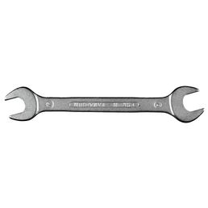 |  | - In case of danger, switch off the device (pull out the mains plug if necessary).

Accidents and First Aid
 |  | - Carry out emergency measures at the scene of the accident.

Tests – Maintenance - Disposal
- Observe the operating instructions of the manufacturer for maintenance and servicing.
- Have repairs carried out by qualified persons only.

Signatures
Supervisor: Signature:

Town: Date:

