 |  |  | Operating instructions | 

Equipment - Apparatus - Device
Double - grinders

Dangers of environment
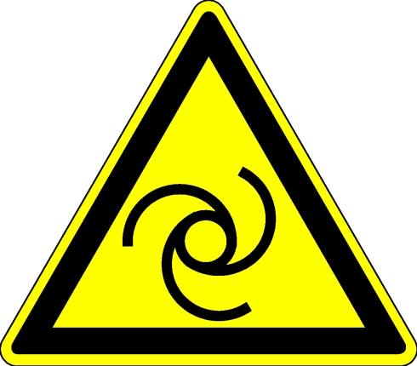  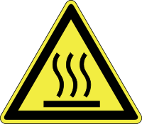  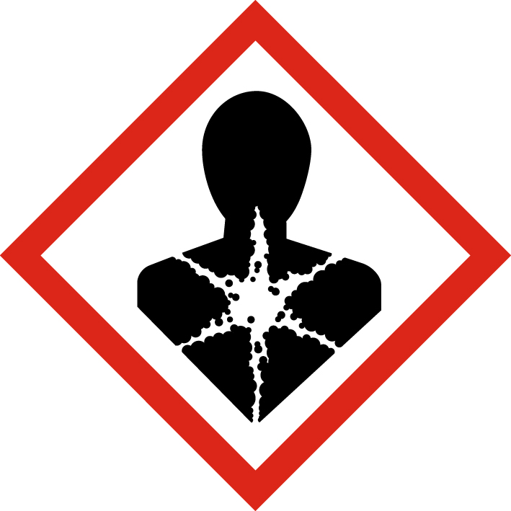 | - Workpieces may heat up during processing - danger of burns  - Injuries due to abrasive disc breakage or defective abrasive belt  - Eye injuries from worn materials  - Foot injuries caused by falling workpieces  - Hand injuries due to sharp-edged surfaces  - Hearing damage due to noise  - Machine caster  - Collection of clothing and / or hair, gloves  - flying sparks, danger of fire  - Health hazard due to the formation of dusts (see material properties)

Protective measures and rules of conduct
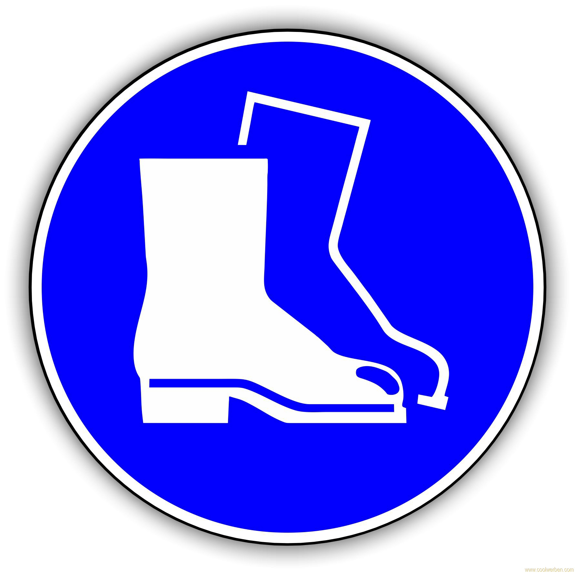  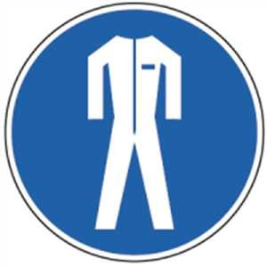     |  | - The operating instructions of the manufacturer must be observed!  - Wear protective goggles and shoes suitable for the area  - Depending on the materials and activities, additional dust mask and ear protection must be worn  - The clamping of a suitable grinding wheel / belt may only be carried out by instructed employees. After each new clamping a test run of ~ 20 minutes is to be carried out.  - Workpiece supports and protective covers must be adjusted regularly. The distance between the grinding wheel / sanding belt and the workpiece support must not exceed 3 mm, between the grinding wheel and the sanding hood at most 5 mm. If necessary, wear only suitable gloves.  - Wear tight fitting clothes  - Wear hairnet for long hair  - Take fire protection precautions. For example, remove flammable substances / materials |  |  |  | - pE

Disruptions and dangers
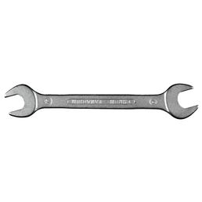 |  | - In case of malfunction or damage to machinery or protective equipment  - Switch off the machine and secure against unauthorized restarting  - Have damage repaired by qualified personnel only

Accidents and first aid
 |  | - Keep Calm  - observe self-protection; Injured people recover, switch off the system  - Call first responder and, if necessary, emergency doctor. Emergency call: 144  - provide first aid  - Inform supervisors  - An accident report must be made in the case of accidents and near-misses.

Tests - Maintenance - Disposal
- Repair only by authorized and qualified persons
- For setup, maintenance and care work, disconnect or secure the machine from the mains
- After maintenance, the protective equipment must be checked.
- E-check, depending on the model, annually or every four years by a trained electrician (stationary or mobile machine)

Signatures
Supervisor: Signature:

Town: Date:

Signatures

